Unidentified Human Remains Intake Form

Unidentified Human Remains (UHR) Evidence Information
Evidence Item #:
Collected By:
Collector’s Initials:
Date Collected:
Time Collected:
Approximate Physical Location of Evidence When Collected in Regard to the Entire Scene (e.g., GPS coordinates, reference landmarks):

Evidence Item Description:

Current Storage Location of Evidence Item:
Use the ruler template (or a similar measurement tool) on the next page to photo document the UHR for reference purposes. Also use the ruler template on the next page to photo document the sample collected (e.g., cutting, swabbing) from the UHR to approximate the measurement of the sample being tested.
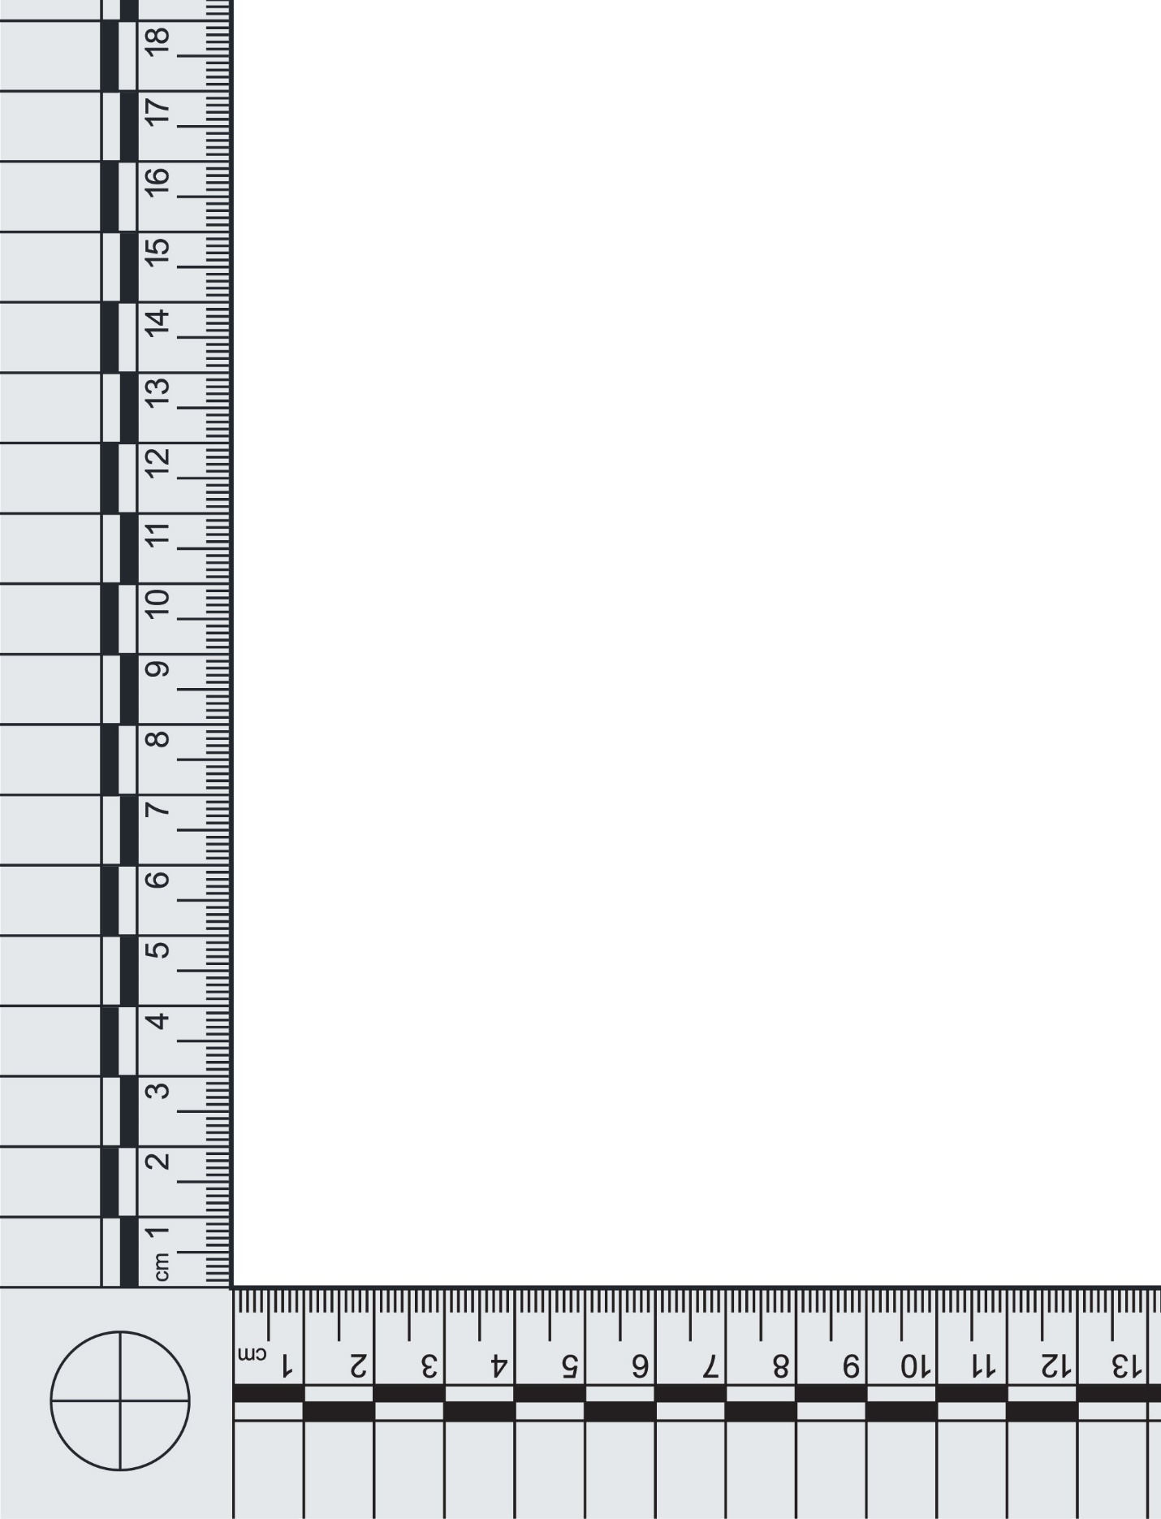
Evidence Item # or Sample ID:
UHR Sample Collection Information
Sample ID or Sample Barcode(s):
[Place barcode(s) here]
Sampled By:
Analyst’s/Technician’s Initials:
Date Sampled:
Time Sampled:
Amount of Sample Used for Testing:
Use the diagram below to circle the approximate anatomical location of the UHR sample collected. Use the note box below to specify any additional relevant details such as the specific location from which the UHR sample was collected.
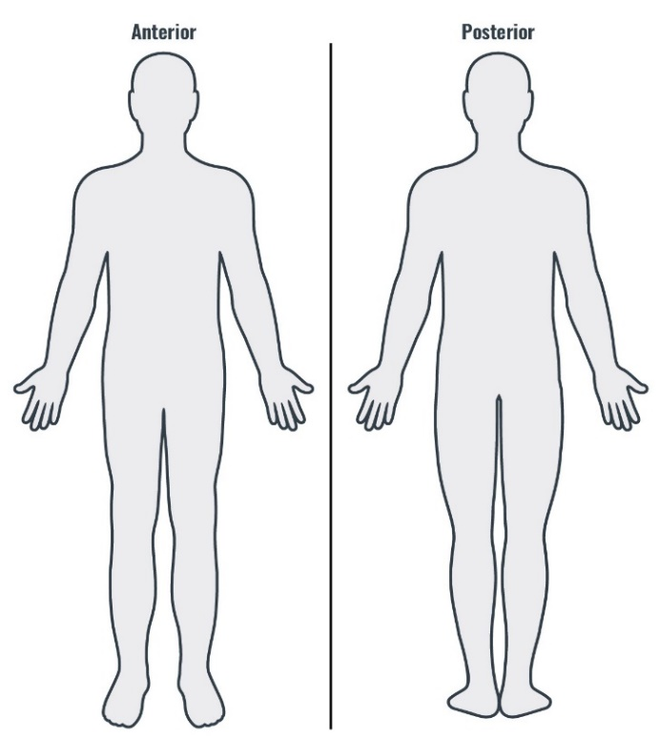

Sample Type:
☐ Blood
☐ Bone
☐ Buccal Swab
☐ Hair
☐ Muscle
☐ Skin
☐ Tooth
☐ Other Tissue:
☐ Other:
Processing Technique Used to Sample the UHR for DNA Testing:
☐ Cutting
☐ Scraping
☐ Swabbing
☐ N/A (e.g., entire evidence item is being consumed for testing):
☐ Other (e.g., tape collection, drilling):
Sample Condition:
☐ Good Condition (e.g., red whole blood, buccal swab with yellow staining, fresh)
☐ Moderate Condition (e.g., red with some decomposition, some debris, tan/brown with some charred portions)
☐ Poor Condition (e.g., black and charred, white decomposition, insect activity, weather degraded)
Additional Sample Condition Information:

Sample Fully Consumed?
☐ Yes
☐ No
Current Storage Location of Sample To Be Tested:
Current Storage Location of Remaining Sample (if applicable):
Instrument Information
Instrument ID (if applicable):
Date Instrument Performance Check Was Completed and the Instrument Was Approved for Use:

Instrument Operator:
Instrument Location:
Ownership of Instrument (agency name):
Chip/Cartridge Type:
Chip/Cartridge Lot Number:
Chip/Cartridge Expiration Date:

UHR Sample Testing Information
Date Submitted for Testing:
Tested By:
Instrument Operator’s Initials:
Date Tested:
Time Tested:
Post-Testing Suitability Result
☐ Full Profile Generated (sample ready to report)
☐ Partial Profile Generated (sample ready to report)
☐ No DNA Detected (sample ready to report)
☐ Re-Test (select the reason for re-testing below, note the details of the error or other issue experienced, and provide testing plan explanation in Post-Testing Result Verification)
☐ Instrument Error:
☐ Chip Error:
☐ Sample Was Overloaded:
☐ Too Little DNA Present:
☐ Migration Issues:
☐ Other:
Storage Location of Data:
Analyst’s/Technician’s Sign-Off Date:
Analyst’s/Technician’s Signature:

Post-Testing Result Verification
Technical Reviewer:
Date of Technical Review:
Time of Technical Review:
Technical Review Criteria:
Yes | No
☐ | ☐ | An instrument performance check was completed, and the instrument was approved for use before being used for sample testing.
☐ | ☐ | The peaks in the electropherogram are sharp and well defined.
☐ | ☐ | The peaks have a relative fluorescence intensity above the established analytical threshold.
☐ | ☐ | All homozygous allele calls have been checked and verified.
☐ | ☐ | Reported DNA results are accurate, complete, and justifiable based on the interpretation of the data.
☐ | ☐ | Reviewer agrees with the decision to re-test the sample or send the sample to the laboratory for traditional short tandem repeat typing and analysis.
Sample Ready to Report?
☐ Yes
☐ No
Explanation of the Testing Plan if the Sample Is Not Ready to Report:
☐ N/A
☐ The sample will be re-tested using the remaining sample; an accompanying Unidentified Human Remains Intake Form (under the same Sample ID) will be completed.
☐ A new sample will be taken from the evidence item to test; an accompanying Unidentified Human Remains Intake Form (under the same Evidence Item #) will be completed.

Technical Review Date:
Technical Reviewer’s Signature:

