Mock Scenario—Plane Crash (Commingled Remains)

Instructions
This mock exercise was developed to assist forensic science service providers with planning and preparing for immediate deployment of Rapid DNA instrumentation for a scenario involving a plane crash (commingled remains). It is encouraged that this mock exercise be completed through a collaborative, multidisciplinary approach by involving all individuals who may be involved in dispatching to a mass disaster event. It is also encouraged that you provide answers with as much detail as possible, even when an answer could simply be answered by “yes” or “no.”
To begin, read the following case information. The questions after the case information are structured to follow a logical response order from pre-deployment through post-deployment, followed by a general reflection section to be completed after working through the mock exercise. You are encouraged to answer these questions in sequential order and provide responses based on your agency’s available resources and developed protocols (if applicable).
Mock Plane Crash Case Description
On August 25, 2023, the [Agency] was notified at 1230 hours that a plane has crashed near the local fishing pier. The plane was traveling from the northeast toward the local international airport. Residents in the area reported an aircraft flying too low (~2,000 feet). As a result, while in flight, the plane struck four Canada geese, causing severe damage to the engine. Because of this damage, the pilot lost control, and the plane crashed. Refer to Table 1 for a summary of the weather conditions expected during deployment.
Table 1. Weather report for [City], [State], on August 25, 2023.
Range | Temperature (F°) | Apparent Temperature (F°) | Humidity (%) | Wind Gusts (mph) | Precipitation
High | 92 | 103 | 49 | 22 | None
Low | 73 | 79 | 69 | 13 | None

According to flight records, 150 passengers, 2 pilots, and 3 crew members (a total of 155 individuals) were on board during the flight. The remains are expected to be commingled and scattered in a 0.09-mile radius (Figure 1). Because of the location of the plane crash, ground casualties of human and non-human descent may be expected.

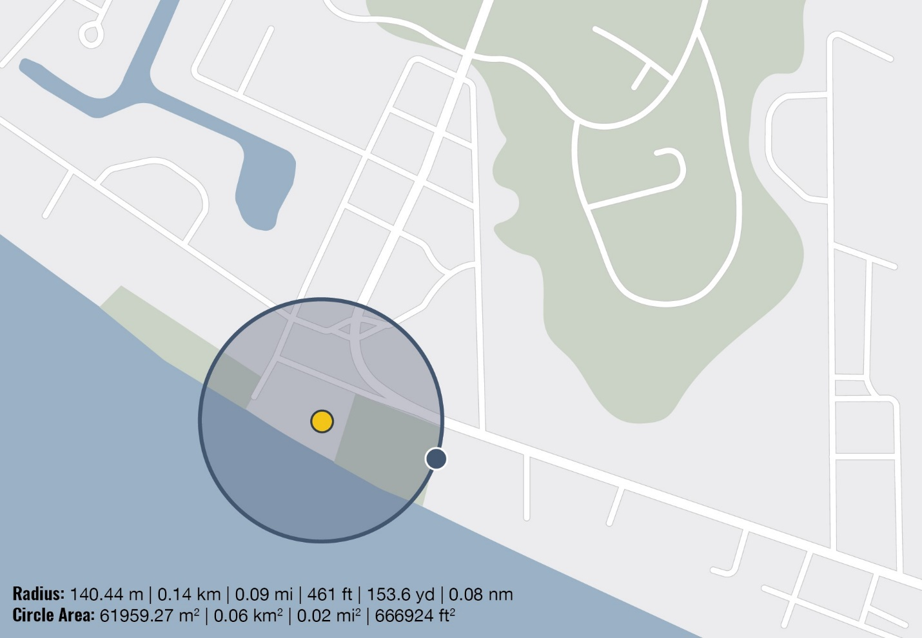
Figure 1. A map of the area surrounding the local fishing pier demonstrating the expected radius of the scattered remains.
Pre-Deployment: Initial Contact (Internal)
- How would your agency be informed that the plane has crashed at the local fishing pier and that your agency is being requested to deploy to the scene?

a. Who would be the first internal agency staff member to be notified of the plane crash?

b. How would this first internal agency staff member communicate this information to the rest of the deployment team?

c. Who would give confirmation to the agency requesting the deployment that the information has been received and that the agency is responding? How would this internal agency staff member provide this confirmation?

- Who is the first person from your agency who would deploy to the scene?

a. What information would this individual be tasked with for intaking?

b. Who would disseminate this information to the rest of the deployment team, and how would it be disseminated?

- List the roles and responsibilities that would be assigned to each internal agency staff member deploying to the scene and with whom they would communicate to establish a communication chain of command.
Internal Roles, Responsibilities, and Communication Chain of Command
(add additional rows as necessary)
Internal Job Title | Role | Responsibilities | Communicates With  (e.g., coordinators, team members)
Pre-Deployment: Initial Contact (External)
- Once your agency has been notified that the plane has crashed at the local fishing pier, whom would you contact outside of your agency for support and why?

a. Which internal agency staff member would contact and communicate with external agencies for support?

b. What contact method would this internal agency staff member use to communicate with external agencies (e.g., email, phone call)?

c. How would this internal agency staff member receive confirmation that an external agency will support the deployment efforts (e.g., memorandum of understanding)?

- List the roles and responsibilities of all participating external agencies that would be on the scene and the internal agency staff member(s) who would communicate with each external agency to establish a communication chain of command.
External Agencies’ Roles, Responsibilities, and Communication Chain of Command
(add additional rows as necessary)
External Agency | Role | Responsibilities | Internal Agency Staff Member Responsible for Communication with External Agency (e.g., coordinators, team members)
- Which external agency would have control or ownership of the scene?

Pre-Deployment: Supplies and Transportation
- List all critical supplies that your agency has readily available to deploy to the plane crash (e.g., reagents, instruments, tents, generators, freezers) and the location of each.
Supply List (add additional rows as necessary)
Item | Quantity | Location
- Describe how your agency would package these supplies for transport to the scene and how they would be transported.

- How would your agency obtain critical supplies that are needed to deploy to the scene but are not readily available?

a. List the critical supplies your agency does not have readily available that would be needed to deploy to the scene.

b. What agencies or organizations would you engage to obtain these supplies? Who is the primary point of contact at these agencies or organizations?

c. Would there be a repayment cost associated with supply procurement?

d. How and when would the supplies be delivered to your agency?

- What vehicle(s) does your agency have available to transport personnel and supplies to the scene?

a. If your agency does not own a vehicle, how would your agency procure transportation to transport personnel and supplies to the scene?

Deployment: On-Scene Workspace and Access Permissions
- Describe where (in reference to Figure 1) and how your agency would set up an operational workspace at the scene.

- Who would have access to this workspace, and how would the flow of traffic be secured (e.g., from media personnel or family members of missing relatives)? Who would be responsible for securing the on-scene workspace and flow of traffic?

- Describe how your agency would control the temperature and humidity of the operational workspace to ensure that instrumentation remains operable.

- Describe how your agency would provide support for the health and wellbeing of all staff members participating in the deployment.

  - Describe the basic humanitarian offerings that would be provided to all staff members participating in the deployment (e.g., scheduled breaks, meals, water, adequate sleep).

Deployment: On-Scene External and Internal Communication
- Describe how internal collaborators would communicate during deployment.

a. Would someone be tasked with serving as the point of contact for all internal communication? Who would assume this role, and why?

b. What method of communication would be used (e.g., personal cell phones, work cell phones, business messaging applications [Teams, Slack, Signal, etc.])?

c. What type(s) of information would be important to communicate among internal personnel?

- Describe how internal collaborators would communicate with external collaborators during deployment.

a. Would someone be tasked with serving as the point of contact for all internal to external communication? Who would assume this role, and why?

b. What method of communication would be used (e.g., personal cell phones, work cell phones, business messaging applications [Teams, Slack, Signal, etc.])?

c. What type(s) of information would be important for internal personnel to communicate to external personnel?

Deployment: Supplies
- How would your agency store temperature-controlled resources at the scene?

- How would supplies be organized and replenished at the scene? Who would be responsible for this?

Deployment: Sample Testing, Data Generating, and Data Storage
- Based on the scenario, would your agency opt to test unidentified human remains at the scene, at the laboratory, or both? Why?

- How would your agency procure family reference samples?

- Describe how the unidentified human remains and family reference samples would be triaged, tested, and maintained following a chain of custody.

- Describe what type of controls would be run on the instrument to ensure proper functionality.

- Who would make the decision to re-test or re-sample an item of evidence?

a. How would the decision to re-test or re-sample an item of evidence be made?

b. How would these decisions be communicated to the personnel testing the samples and the medical examiner/coroner?

- During Rapid DNA testing, you obtain a low-signal sample that was rejected by the system. Upon review of the data, there appears to be uncalled allelic peaks, but you notice the size standard has migration issues. What steps would you take to troubleshoot this malfunction?

a. You decide to re-test the sample and obtain the same data; however, this time, the size standard is intact. How would you proceed to troubleshoot this sample?

b. Would your tactic change if you were informed that some of the ground casualties from the nearby park had their pets with them? Whom would you contact regarding this anomaly?

- Is there a process in place to have secondary and tertiary review of the data generated?

a. Who has the final decision to move a DNA profile forward?

- Describe how your agency stores data from the Rapid DNA instrument (e.g., on the instrument, in a flash drive, on a database).

Post-Deployment
- Which agency takes ownership of the data generated during deployment?

a. How and when would ownership be decided?

b. How would the data be transferred to the agency that has ownership of them?

c. What are the data deletion and retention policies?

d. Would other agencies have access to the data? If so, which agencies and for what purpose?

- How is a final report generated?

a. What elements and data would be included in the final report?

b. Who would receive the report once finalized?

- Describe how your agency would host a post-deployment debrief. Include the types of questions that would be asked.

- Describe how your agency would provide post-deployment support for the health and wellbeing of all staff members who participated in the deployment.

Reflection
- After completing this mock scenario, did this exercise highlight any need for your agency to amend the current emergency response preparedness protocols and procedures?

- After completing this mock scenario, did this exercise identify any training gaps or needs for personnel who may deploy to future scenes?

- After completing this mock scenario, did this exercise help your agency gain insight for preparation for this kind of event?

