Deployment Personal Protective Equipment
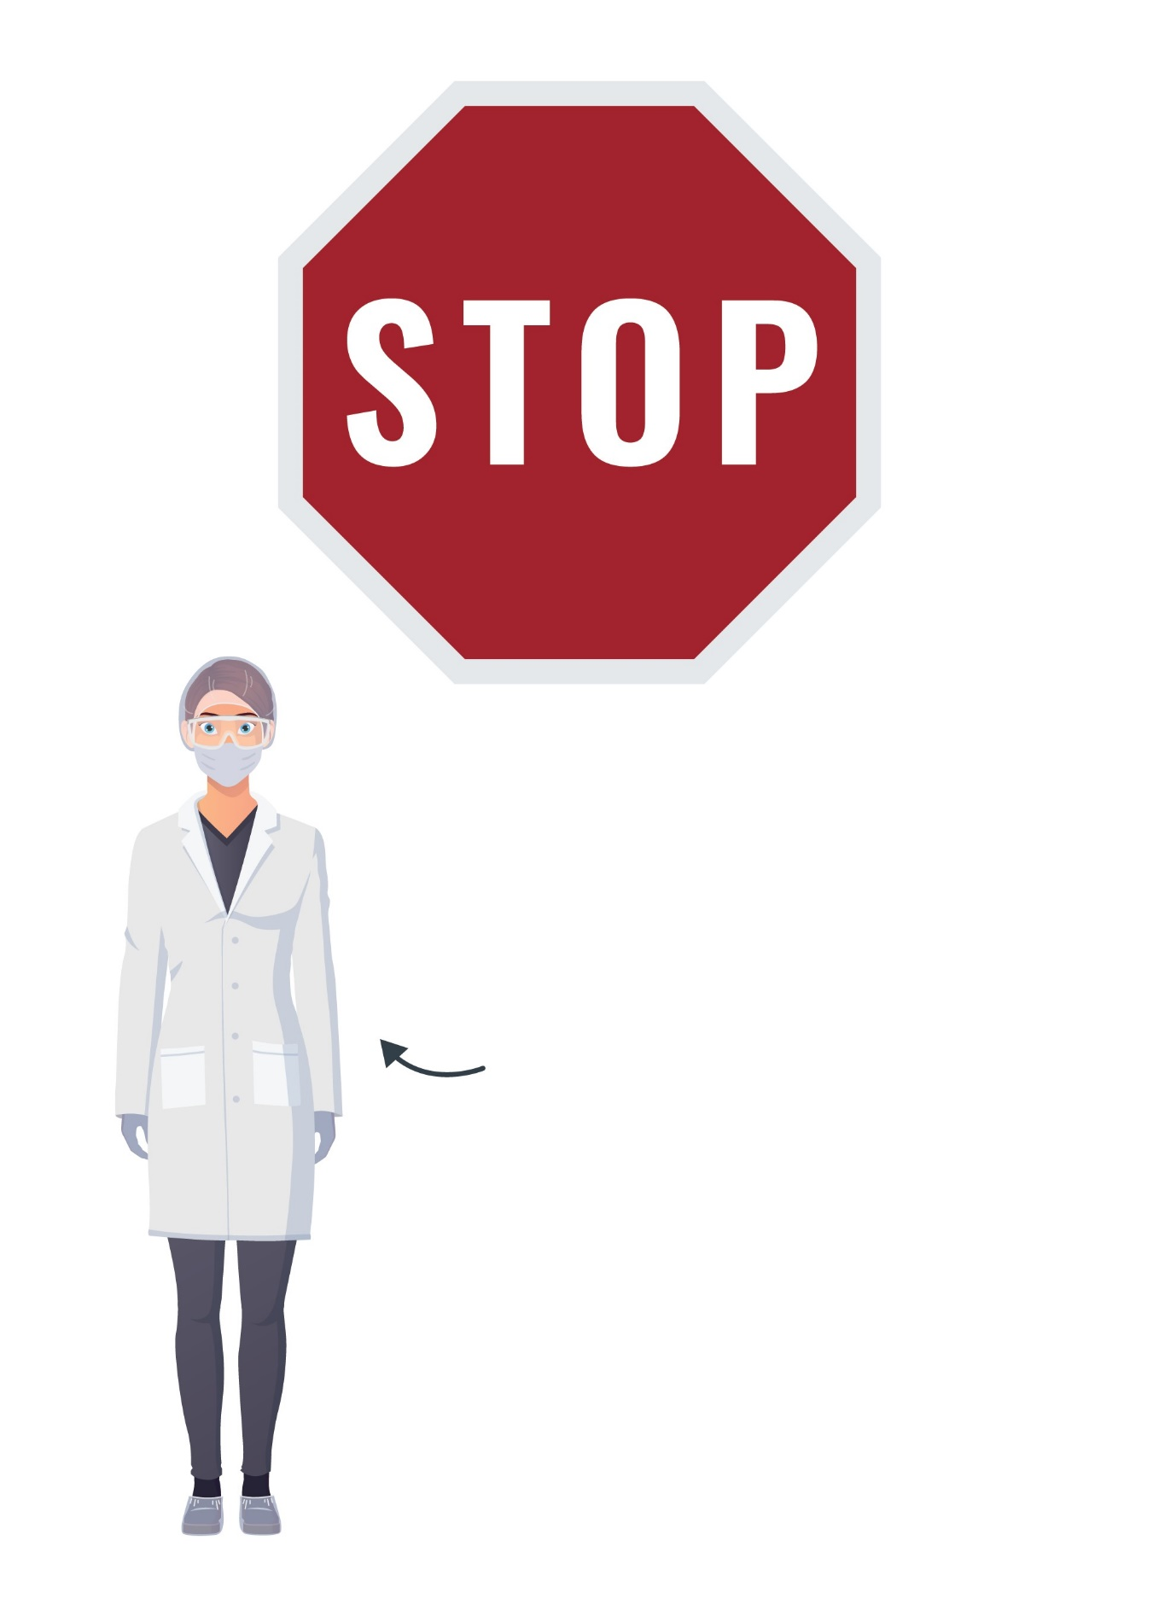
ARE YOU DRESSED LIKE THIS?
The following is required beyond this point:
- Laboratory coat
- Face mask
- Gloves
The following is optional beyond this point:
- Hair net
- Goggles
- Shoe covers

