Associated Personal Item Intake Form
Without an Exclusionary DNA Sample

Associated Personal Item (API) Evidence Information
Evidence Item #:
Submitted By:
Collected By:
Collector’s Initials:
Date Collected:
Time Collected:
Evidence Item Description:

Current Storage Location of Evidence Item:
Use the ruler template (or a similar measurement tool) on the next page to photo document the API for reference purposes. Also use the ruler template on the next page to photo document the sample collected (e.g., cutting, swabbing) from the API to approximate the measurement of the sample being tested.

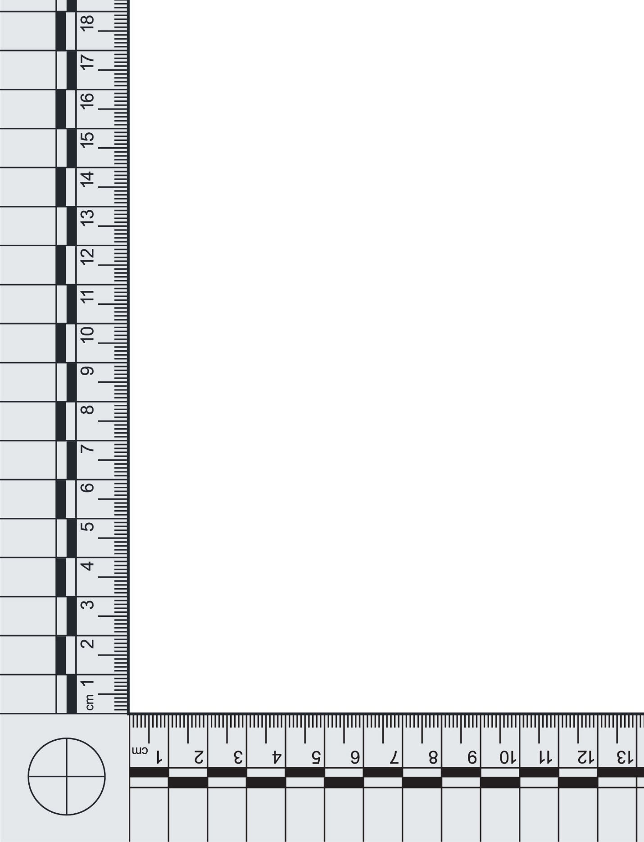
Evidence Item # or Sample ID:
API Sample Processing Information
Date Submitted for Processing:
Sample ID or Sample Barcode(s):
[Place barcode(s) here]
Processed By:
Analyst’s/Technician’s Initials:
Date Processed:
Time Processed:
Sample Processing Technique:
☐ Cutting
☐ Scraping
☐ Swabbing
☐ N/A (e.g., entire evidence item is being consumed for testing):
☐ Other (e.g., tape collection, wet vacuum):
Amount of Sample Processed for Testing:
Sample Fully Consumed?
☐ Yes
☐ No
Current Storage Location of Sample To Be Tested:
Current Storage Location of Remaining Sample (if applicable):
Instrument Information
Instrument ID (if applicable):
Date Instrument Performance Check Was Completed and the Instrument Was Approved for Use:

Instrument Operator:
Instrument Location:
Ownership of Instrument (agency name):
Chip/Cartridge Type:
Chip/Cartridge Lot Number:
Chip/Cartridge Expiration Date:
API Sample Testing Information
Date Submitted for Testing:
Tested By:
Instrument Operator’s Initials:
Date Tested:
Time Tested:
Post-Testing Suitability Result
☐ Full Profile Generated (sample ready to report)
☐ Partial Profile Generated (sample ready to report)
☐ Mixture Profile Generated and an Exclusionary DNA Sample (EDS) Is Not Available for Deduction (consult with the laboratory on recommendations for proceeding and provide testing plan explanation in Post-Testing Result Verification)
☐ No DNA Detected (sample ready to report)
☐ Re-Test (select the reason for re-testing below, and note the details of the error or other issue experienced, and provide testing plan explanation in Post-Testing Result Verification):
☐ Instrument Error:
☐ Chip Error:
☐ Sample Was Overloaded:
☐ Too Little DNA Was Present:
☐ Migration Issues:
☐ Other:
Storage Location of Data:
Analyst’s/Technician’s Sign-Off Date:
Analyst’s/Technician’s Signature:
Post-Testing Result Verification
Technical Reviewer:
Date of Technical Review:
Time of Technical Review:

Technical Review Criteria:
Yes | No
☐ | ☐ | An instrument performance check was completed, and the instrument was approved for use before being used for sample testing.
☐ | ☐ | The peaks in the electropherogram are sharp and well defined.
☐ | ☐ | The peaks have a relative fluorescence intensity above the established analytical threshold.
☐ | ☐ | All homozygous allele calls have been checked and verified.
☐ | ☐ | Reported DNA results are accurate, complete, and justifiable based on the interpretation of the data.
☐ | ☐ | Reviewer agrees with the decision to re-test the sample or send the sample to the laboratory for traditional short tandem repeat typing and analysis.
Sample Ready to Report?
☐ Yes
☐ No
Explanation of the Testing Plan if the Sample Is Not Ready to Report
☐ N/A
☐ The sample will be re-tested using the remaining sample; an accompanying Associated Personal Item Intake Form Without an Exclusionary DNA Sample (under the same Sample ID) will be completed.
☐ A new sample will be taken from the evidence item to test; an accompanying Associated Personal Item Intake Form Without an Exclusionary DNA Sample (under the same Evidence Item #) will be completed.

Technical Review Date:
Technical Reviewer’s Signature:

