Associated Personal Item Intake Form
With an Exclusionary DNA Sample

Associated Personal Item (API) Evidence Information
Evidence Item #:
Submitted By:
Collected By:
Collector’s Initials:
Date Collected:
Time Collected:
Evidence Item Description:

Current Storage Location of Evidence Item:
Use the ruler template (or a similar measurement tool) on the next page to photo document the API for reference purposes. Also use the ruler template on the next page to photo document the sample collected (e.g., cutting, swabbing) from the API to approximate the measurement of the sample being tested.

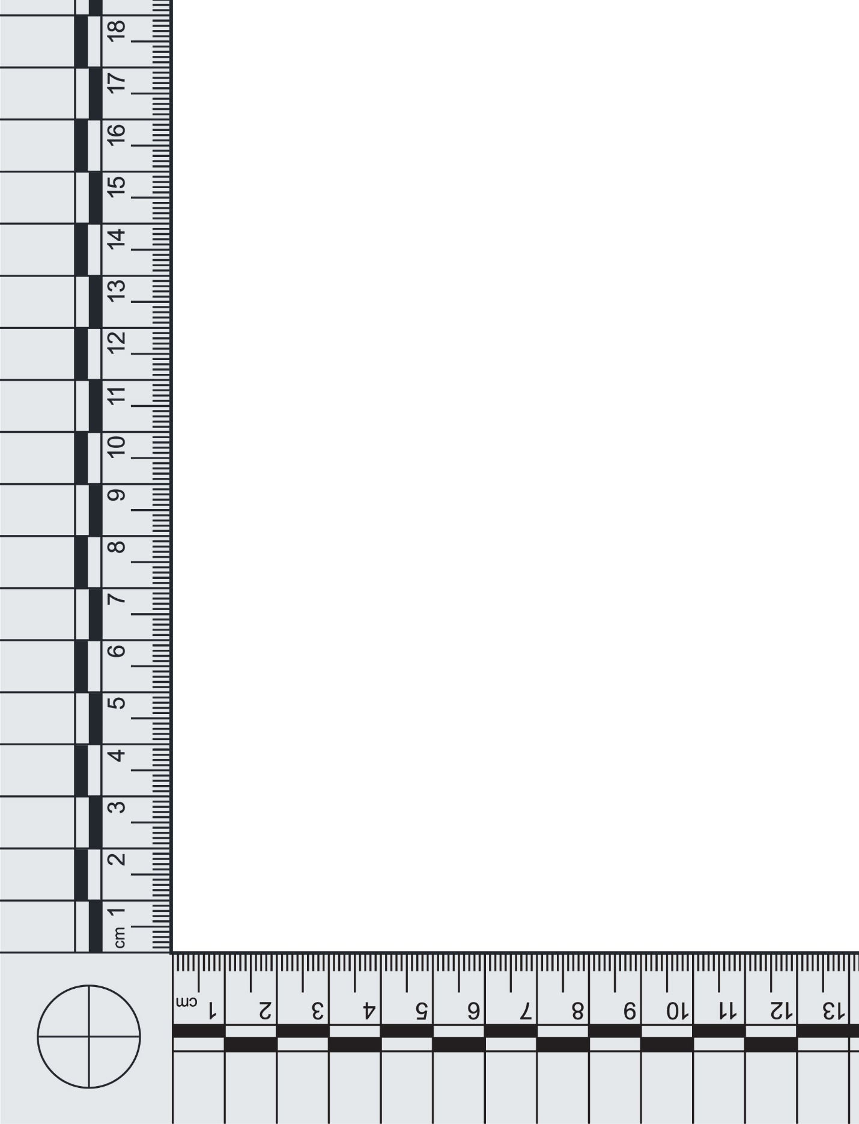
Evidence Item # or Sample ID:
API Sample Processing Information
Date Submitted for Processing:
Sample ID or Sample Barcode(s):
[Place barcode(s) here]
Processed By:
Analyst’s/Technician’s Initials:
Date Processed:
Time Processed:
Sample Processing Technique:
☐ Cutting
☐ Scraping
☐ Swabbing
☐ N/A (e.g., entire evidence item is consumed for testing):
☐ Other (e.g., tape collection, wet vacuum):
Amount of Sample Processed for Testing:
Sample Fully Consumed?
☐ Yes
☐ No
Current Storage Location of Sample To Be Tested:
Current Storage Location of Remaining Sample (if applicable):

API Sample Testing Information and Instrument Information
Date Submitted for Testing:
Tested By:
Instrument Operator’s Initials:
Date Tested:
Time Tested:
Instrument ID (if applicable):
Date Instrument Performance Check Was Completed and the Instrument Was Approved for Use:

Instrument Operator:
Instrument Location:
Ownership of Instrument (agency name):
Chip/Cartridge Type:
Chip/Cartridge Lot Number:
Chip/Cartridge Expiration Date:
API Sample Post-Testing Suitability Result
☐ Full Profile Generated (sample ready to report)
☐ Partial Profile Generated (sample ready to report)
☐ Mixture Profile Generated (proceed to Exclusionary DNA Sample (EDS) Processing Information)
☐ No DNA Detected (sample ready to report)
☐ Re-Test (select the reason for re-testing below, note the details of the error or other issue experienced, and provide testing plan explanation in Post-Testing Result Verification):
☐ Instrument Error:
☐ Chip Error:
☐ Sample Was Overloaded:
☐ Too Little DNA Was Present:
☐ Migration Issues:
☐ Other:
Storage Location of Data:
Analyst’s/Technician’s Sign-Off Date:
Analyst’s/Technician’s Signature:
Exclusionary DNA Sample (EDS) Processing Information
Date Submitted for Processing:
Sample ID or Sample Barcode(s):

Processed By:
Analyst’s/Technician’s Initials:
Date Processed:
Time Processed:
Processing Method (e.g., swab-the-swab, cutting):
Amount of Sample Processed for Testing:
Sample Fully Consumed?
☐ Yes
☐ No
Current Storage Location of Sample to be Tested:
Current Storage Location of Remaining Sample (if applicable):
EDS Testing Information and Instrument Information
Date Submitted for Testing:
Tested By:
Instrument Operator’s Initials:
Date Tested:
Time Tested:
Instrument ID (if applicable):
Date Instrument Performance Check Was Completed and the Instrument Was Approved for Use:

Instrument Operator:
Instrument Location:
Ownership of Instrument (agency name):
Chip/Cartridge Type:
Chip/Cartridge Lot Number:
Chip/Cartridge Expiration Date:
EDS Post-Testing Suitability Result
☐ Full Profile Generated (sample ready to report)
☐ Partial Profile Generated (sample ready to report)
☐ Mixture Profile Generated (provide testing plan explanation in Post-Testing Result Verification)
☐ No DNA Detected (sample ready to report)
☐ Re-Test (select the reason for re-testing below, note the details of the error or other issue experienced, and provide testing plan explanation in Post-Testing Result Verification):
☐ Instrument Error:
☐ Chip Error:
☐ Sample Was Overloaded:
☐ Too Little DNA Was Present:
☐ Migration Issues:
☐ Other:
Storage Location of Data:
Analyst’s/Technician’s Sign-Off Date:
Analyst’s/Technician’s Signature:

Post-Testing Result Verification
The post-testing verification review of the data should account for the API Sample and the EDS. If the following criteria are met for a sample, specify the sample (i.e., API, EDS) next to the applicable technical review criteria statement below.
Technical Reviewer:
Date of Technical Review:
Time of Technical Review:
Technical Review Criteria:
Yes | No
☐ | ☐ | An instrument performance check was completed, and the instrument was approved for use before being used for sample testing.
☐ | ☐ | The peaks in the electropherogram are sharp and well defined.
☐ | ☐ | The peaks have a relative fluorescence intensity above the established analytical threshold.
☐ | ☐ | All homozygous allele calls have been checked and verified.
☐ | ☐ | Calculations for mixture deconvolution are accurate (if applicable) and correlate with electropherogram.
☐ | ☐ | Reported DNA results are accurate, complete, and justifiable based on the interpretation of the data.
☐ | ☐ | Reviewer agrees with the decision to re-test the sample or send the sample to the laboratory for traditional short tandem repeat typing and analysis.
Explanation of the Above Criteria Not Met for a Given Sample (specify which sample; i.e., API, EDS):
☐ N/A

Sample Ready to Report (specify which sample; i.e., API, EDS, next to the applicable statement below)?
☐ Yes
☐ No

Explanation of the Testing Plan if the Sample Is Not Ready to Report (specify which sample; i.e., API, EDS next to the applicable statement or within the explanation to be provided below):
☐ N/A
☐ The sample will be re-tested using the remaining sample; an accompanying Associated Personal Item Intake Form With an Exclusionary DNA Sample (under the same Sample ID) will be completed.
☐ A new sample will be taken from the evidence item to test; an accompanying Associated Personal Item Intake Form With an Exclusionary DNA Sample (under the same Evidence Item #) will be completed.

Technical Review Date:
Technical Reviewer’s Signature:

