Draft
NIJ Standard 0115.01
Stab Resistance of Body Armor

National Institute of Justice
March 2020

Introduction

This draft document specifies minimum performance requirements and test methods for the stab resistance of body armor used by U.S. criminal justice personnel that is intended to protect against knife and spike stab threats. It is a proposed revision of NIJ Standard 0115.00, Stab Resistance of Personal Body Armor, published in 2000. The final version of this draft document is anticipated to be published in 2021 as NIJ Standard 0115.01, Stab Resistance of Body Armor. Its primary purpose will be for use by the NIJ Compliance Testing Program (CTP) for testing and evaluation of stab-resistant body armor for certification by NIJ. It will be used by both laboratories that test body armor and body armor manufacturers participating in the NIJ CTP. This standard will be included in the Personal Body Armor scope of accreditation used by the National Voluntary Laboratory Accreditation Program (NVLAP) to accredit laboratories that test body armor.

This document uses the following in accordance with international standards:

- “shall” indicates a requirement;

- “should” indicates a recommendation;

- “may” indicates a permission;

- “can” indicates a possibility or a capability.

Please send all written comments on this draft document to Mark Greene; Technology and Standards Division Director; Office of Research, Evaluation, and Technology; National Institute of Justice in electronic format by email at mark.greene2@usdoj.gov.

Please send all other written comments and suggestions to the Director, National Institute of Justice, Office of Justice Programs, U.S. Department of Justice, 810 7th Street NW, Washington, DC 20531.

Nothing in this document is intended to create any legal or procedural rights enforceable against the United States. Moreover, nothing in this document creates any obligation for any individual or organization to follow or adopt this voluntary standard nor does it create any obligation for suppliers, law enforcement agencies, or others to follow or adopt voluntary NIJ equipment standards.
Table of Contents
1. Scope 4
2. References 4
3. Terms and Definitions 5
4. Test Threats, Equipment, and Materials 8
5. Armor Protection Levels 9
6. Armor Performance Requirements 9
7. Armor Test Items: Requirements and Utilization 10
8. Procedure for Visual Examination of Test Items 11
9. Stab Test Requirements and Pre-test Procedures 15
10. Stab Test Procedure 21
11. Test Report 21
Annex A (Mandatory): Test Threat Drawings and Requirements 22
Annex B (Mandatory): Stab Test Apparatus, Requirements, and Setup 30
Annex C (Mandatory): Equipment and Procedure for Conditioning Soft Armor by Submersion 36
Annex D (Mandatory): Template for Test Item Size 37
Annex F (Mandatory): Diagrams showing impact locations for planar test items 44
Annex G (Mandatory): Soft Armor Designed for Female Wearers 45
Annex H (Mandatory): Conversion Tables for Penetration Depth 49

Scope
  - This standard specifies minimum performance requirements and test methods for stab-resistant body armor intended to protect against stab (i.e., edged blade and spike) threats for U.S. criminal justice personnel.
    - The test methods within this standard were developed and validated for broadly available armor designs. Some armor designs may require additional or modified testing than that specified in this standard.
  - This standard addresses only stab-resistant panels intended to protect the torso and does not address extremity protection.
  - Body armor covered by this standard is classified into two protection levels based on mission requirements and threats anticipated to be encountered within the distinct operational environments:
    - Commercial threat protection: Commercially made knives and spikes, typically encountered outside of controlled access facilities or within the jail in-take area.
    - Improvised threat protection: Improvised or inmate-made weapons, typically encountered inside controlled access facilities, such as jails, detention centers and prisons.
  - This standard does not address ballistic-resistant body armor.
  - This standard is applicable for certification testing or research and development testing.
  - This standard incorporates other standards from ASTM International and ISO/IEC.
  - The values stated in SI units are to be regarded as standard. The values given in parentheses are mathematical conversions to inch-pound units that are provided for information only and are not considered standard.
  - The tests required by this standard have inherent hazards. It is the responsibility of the user of this standard to establish appropriate safety and health practices and to comply with regulatory requirements.

References
The following references form a basis and provide support for the requirements and procedures described in this standard. For dated references, only the edition cited applies. For undated references, the latest edition of the referenced document applies, including any amendments.
  - An Assessment of Human Performance in Stabbing 1999. Shrivieham, UK: Royal Military College of Science. https://dspace.lib.cranfield.ac.uk/handle/1826/4930
  - ASTM D1056-14 Standard Specification for Flexible Cellular Materials-Sponge or Expanded Rubbers. West Conshohocken: PA: ASTM International.
  - ASTM D2240-14 Standard Test Method for Rubber Property—Durometer Hardness. West Conshohocken: PA: ASTM International.
  - ASTM E3005-18. Standard Terminology for Body Armor and Related Items. West Conshohocken: PA: ASTM International.
  - ASTM E3086-17. Standard Practice for Creating Appliques for Use in Testing of Nonplanar Soft Body Armor Designed for Females. West Conshohocken: PA: ASTM International.
  - ASTM D3575-14 Standard Test Methods for Flexible Cellular Materials Made From Olefin Polymers. West Conshohocken: PA: ASTM International.
  - ASTM D4819-13 Standard Specification for Flexible Cellular Materials Made From Polyolefin Plastics. West Conshohocken: PA: ASTM International.
  - ASTM D5264-98 (2011) Standard Practice for Abrasion Resistance of Printed Materials by the Sutherland Rub Tester. West Conshohocken: PA: ASTM International.
  - Croft, J. and D. Longhurst 2007. HOSDB Body Armour Standards for UK Police. Part 3: Knife and Spike Resistance.., St. Albans, UK: Home Office Scientific Development Branch.
  - ISO/IEC 17025. General requirements for the competence of testing and calibration laboratories. Geneva, Switzerland: ISO/IEC.
  - Law Enforcement Officers Killed and Assaulted, 2009. Washington, DC: U.S. Department of Justice, Federal Bureau of Investigation.
  - NIJ Standard-0115.00, Stab Resistance of Personal Body Armor. Washington, DC: U.S. Department of Justice, National Institute of Justice.

Terms and Definitions
  - The following terms from ASTM E3005, ASTM E3078 and ASTM E3086 are applicable:
    - angle of incidence, n - the angle between the test threat line of aim and the line normal to a reference plane based on the front surface of the backing assembly or witness panel. (Terminology E3005).
    - applique, n. - a three-dimensional item molded from backing material that is shaped and sized for testing or conditioning a nonplanar test item. (Terminology E3005).

Discussion - Some appliques are designed for the purpose of filling the entire space behind a nonplanar test item; other appliques are designed to assess features of a nonplanar test item.
    - armor carrier, n - See carrier.
    - armor panel, n - a component of soft body armor consisting of protective materials, typically enclosed in a panel cover. See ballistic panel, blunt impact panel, stab panel. See also panel cover.
    - backing material, n - the substance placed behind the test item during testing.

Discussion - The backing material typically provides support for the test item, and it may act as a witness material and may provide a measurable indication of the test item performance.
    - body armor, n - an item of personal protective equipment intended to protect the wearer from threats that may include ballistic threats, stabbing, fragmentation or blunt impact.

Discussion - Law enforcement and corrections officers typically refer to body armor as a vest. See vest.
    - carrier, n - a garment whose primary purpose is to retain the armor panel(s) or plate(s) and provide a means of supporting and securing the armor panel(s) or plate(s) to the wearer.
    - conditioning, n - a process that exposes an item, prior to testing, to a specified controlled environment or physical stresses, or both.
    - controlled ambient, n - conditions with temperature of 20 °C ± 5.5 °C (68 °F ± 10 °F) and 50% ± 20% relative humidity (RH). Within this standard, this definition applies to any direct or indirect reference to controlled ambient. (ASTM Practice E3078).
    - fair hit, n - a test threat impact (on a test item) that meets all specified requirements in a particular test method.
    - insert, n - a removable unit of protective material (soft armor or hard armor) intended to be placed into a special pocket on a carrier to enhance protection in a localized area.
    - nonplanar, adj - having features that would prevent the test item from making full contact with a flat surface; typically used to describe curved plates and armor designed for female wearers.
    - panel cover, n - a covering, typically nonremovable, that encloses the protective materials and protects them from environmental factors, such as moisture, ultraviolet light, debris and dust.
    - soft armor, n - an item of personal protective equipment constructed of pliable/flexible materials intended to protect the wearer from threats that may include ballistic threats, stabbing, fragmentation or blunt impact.
    - stop, n - See partial penetration.
    - strike face, n - the surface of an armor panel or plate intended to face the incoming threat.
    - test item, n - a single article intended for testing.

Discussion - Examples may include one panel, one plate or one shoot pack.
    - test series, n – the set of all impacts necessary to obtain the required number of fair hits on a single test item or the set of all impacts necessary over multiple test items to generate the required data. (Adapted from ASTM Terminology E3005).
    - test threat, n - the projectile, edged blade, spike or other object that is used in laboratory testing to impact the test item at a specific velocity or energy to assess performance of body armor.
    - unfair hit, n - a test threat impact that does not meet the specified requirements in a particular test method for impact location and spacing, velocity, angle of incidence, energy or other. (Adapted from ASTM E3005).
    - witness panel, n - a sheet of material placed in a specific location and orientation to determine complete or partial penetration of the test item or to determine other performance characteristics of the test item or projectile.

  - The following terms are specific to this standard:
    - commercial threat, n - a commercially manufactured knife or spike.
    - impact-to-edge distance, n - the distance from the center of the test threat impact to the nearest test item edge.
    - impact-to-impact distance, n - the distance from the center of the test threat impact to the center of any other test threat impact on the test item.
    - improvised threat, n - an inmate-manufactured knife or spike.

Discussion - Improvised threats can be referred to as shanks or shivs.
    - model, n - the manufacturer’s design, with unique specifications and characteristics, of a particular item.
    - overtest energy level (E2), n - the energy level specified in this standard that corresponds to 1.5 times the primary energy value and is intended to ensure that the armor material performs in a linear fashion and does not suffer catastrophic failure at, or near, the primary energy level.
    - primary energy level (E1), n - the energy level specified in this standard at which the armor is intended to afford protection against the applicable test threat.
    - supplier, n - the party that is responsible for ensuring that products meet and, if applicable, continue to meet, the requirements on which the certification is based.

Test Threats, Equipment and Materials
  - Test Threats
    - This standard requires two types of test threats as described below:
      - Commercial Test Threats
        - Three commercial test threats representing kitchen knives, pocket knives, ice picks, awls and other similar items are required:
- P1: Single-edged blade
- S1: Double-edged blade
- SP1: Spike
        - Testing with commercial test threats shall be done at the following energies:
- Primary energy (E1): 24 ± 0.50 J (17.7 ± 0.36 ft-lbf)
- Overtest energy (E2): 36 ± 0.60 J (26.6 ± 0.44 ft-lbf)
      - Improvised Test Threat
        - Three improvised test threats representing edged blades and spikes made by inmates from materials found inside correctional facilities are required:
- T1: Improvised single-edged blade
- T2: Improvised double-edged blade
- T3: Improvised spike
        - Testing with improvised test threats shall be done at the following energies:
- Primary energy (E1): 43 ± 0.60 J (31.7 ± 0.44 ft-lbf)
- Overtest energy (E2): 65 ± 0.80 J (47.9 ± 0.59 ft-lbf)
    - Detailed drawings and specifications for the test threats are provided in Annex A, Test Threat Drawings and Requirements.

  - Test Facility

The environmental conditions of the test facility shall be controlled ambient during testing.

  - Stab Test Apparatus
    - Testing shall be performed using a stab test apparatus that meets the requirements below and those of Annex B, Stab Test Apparatus, Requirements, and Setup.

  - Conditioning Equipment
    - Equipment for soft armor test item conditioning by submersion shall meet the requirements described in Annex C, Equipment and Procedure for Conditioning Soft Armor by Submersion.

Armor Protection Levels
  - The supplier shall declare the intended protection level for an armor model being submitted for testing to this standard.

  - Protection Level: Commercial Threat Protection
    - Armor intended to meet the commercial threat protection level shall be tested as specified in this standard using all of the following:
- P1 single-edged blade test threat
- S1 double-edged blade test threat
- SP1 spike test threat

  - Protection Level: Improvised Threat Protection
    - Armor intended to meet the improvised threat protection level shall be tested as specified in this standard using all of the following:
- T1 improvised single-edged blade test threat
- T2 improvised double-edged blade test threat
- T3 improvised spike test item

Armor Performance Requirements
  - Armor Resistance to Penetration by Commercial Threats
    - Each test item shall be tested as specified in the appropriate section of this standard and shall withstand the required number of fair hits and shall experience no penetration greater than the following:
      - 7 mm (0.27 in) at E1, for fair hits at angles of incidence of 0° and 45°
      - 20 mm (0.79 in) at E2, for fair hits at angles of incidence of 0°

  - Armor Resistance to Penetration by Improvised Threats
    - Each test item shall be tested as specified in the appropriate section of this standard and shall withstand the required number of fair hits and shall experience no penetration greater than the following:
      - 0 mm (0 in) at E1, for fair hits at angles of incidence of 0° and 45°
      - 20 mm (0.79 in) at E2, for fair hits at angles of incidence of 0°

Armor Test Items: Requirements and Utilization
  - Test Item Size Requirements
    - The test items shall be provided by the supplier in size NIJ-C-4, using the size template provided in Annex D, Template for Test Item Size.

  - Soft Armor Test Item Workmanship and Construction Requirements
    - Each test item shall be free from evidence of inferior workmanship, such as wrinkles, blisters, cracks or fabric tears, fraying, crazing, or chipped or sharp corners and edges.
    - The stitching for each test item shall be straight and secure.
    - There shall be no variations in construction details between individual test items or between any test item and the supplier’s documentation for a given model.
    - All test items shall be identical in appearance, materials and manner of construction, including stitch size and location.

  - Soft Armor Test Item Label Requirements
    - The label shall be permanently attached to the panel cover of the test item.
    - The label text shall be in a readable typeface and font size, and the content shall be as specified in Annex E.
    - A label affixed to one spare test item panel cover shall be tested. It shall remain legible and adhered to the test item following completion of the label durability test specified in Annex E.
      - The label durability test shall not be performed on a test item that will subsequently undergo stab testing, unless such testing is approved by the supplier.
    - Failure of a label to meet the above requirements is not considered a failure of the armor model. In the event of a label failing to meet these requirements, a case-by-case evaluation will be made by the NIJ CTP.

  - Soft Armor Test Item Utilization
    - Number of required test items
    - The number of test items required to complete a test series is dependent on whether the armor is to be tested in a gender-specific configuration. Tables 1, 2 and 3 provide specify the required number of test items and how they are to be used.

  - Soft armor test item carrier requirements
    - Test items shall be removed from carriers prior to stab testing.

Procedure for Visual Examination of Test Items
  - Verify the group of test items for correct quantity and size.
  - Examine the group of test items for variations in appearance, materials and manner of construction.
  - Examine each test item exterior to determine whether workmanship requirements are met.
  - Examine the label of a single spare test item to determine whether requirements are met.
  - Prior to conditioning by submersion, photograph at least one test item. For the photograph, the test item shall be lying on a flat surface and shall have a scale visible.
  - Following stab testing, examine the workmanship of each test item as described below to determine whether the requirements are met:
    - Horizontally slit only the test item panel cover with a razor blade near the bottom of the test item and remove the stab panel from its cover. Document the construction of the stab panel (e.g., layer count, material description, stitching).
  - Document the relevant details for each test item.

Table 1. Planar Test Items: Summary of Test Item Sizes, Quantity, Conditioning and Testing
Size and # of Test items | Conditioning of Test Items |  | Number of Test Items for Each Test
Sized per NIJ-C-4 template  14 test items:  6 test items with neck scoop  8 test items without neck scoop | Tested at controlled ambient | 7 | P1 Test | With neck scoop | 1
 |  |  |  | Without neck scoop | 1
 |  |  | S1 Test | With neck scoop | 1
 |  |  |  | Without neck scoop | 1
 |  |  | SP Test | With neck scoop | 1
 |  |  |  | Without neck scoop | 1
 |  |  | Spares | Without neck scoop | 1
 | Submersion per Annex C | 7 | P1 Test | With neck scoop | 1
 |  |  |  | Without neck scoop | 1
 |  |  | S1 Test | With neck scoop | 1
 |  |  |  | Without neck scoop | 1
 |  |  | SP Test | With neck scoop | 1
 |  |  |  | Without neck scoop | 1
 |  |  | Spares | Without neck scoop | 1

Table 2. Nonplanar Female Test Items: Summary of Test Item Sizes, Quantity, Conditioning and Testing, if the construction of the planar panel has not previously passed all testing requirements
Size and # of Test items | Conditioning of Test Items |  |  | Number of Test Items for Each Test
Sized per NIJ-C-4 template  30 test items:  8 test items are B-cup with neck scoop  8 test items are E-cup with neck scoop  14 test items without neck scoop | Tested at controlled ambient | 15 | P1 Test |  | B-cup, with neck scoop | 1
 |  |  |  |  | E-cup, with neck scoop | 1
 |  |  |  |  | Without neck scoop | 2
 |  |  | S1 Test |  | B-cup, with neck scoop | 1
 |  |  |  |  | E-cup, with neck scoop | 1
 |  |  |  |  | Without neck scoop | 2
 |  |  | SP Test |  | B-cup, with neck scoop | 1
 |  |  |  |  | E-cup, with neck scoop | 1
 |  |  |  |  | Without neck scoop | 2
 |  |  | Spares |  | B-cup, with neck scoop | 1
 |  |  |  |  | E-cup, with neck scoop | 1
 |  |  |  |  | Without neck scoop | 2
 | Submersion per Annex C | 15 | P1 Test |  | B-cup, with neck scoop | 1
 |  |  |  |  | E-cup, with neck scoop | 1
 |  |  |  |  | Without neck scoop | 2
 |  |  | S1 Test |  | B-cup, with neck scoop | 1
 |  |  |  |  | E-cup, with neck scoop | 1
 |  |  |  |  | Without neck scoop | 2
 |  |  | SP Test |  | B-cup, with neck scoop | 1
 |  |  |  |  | E-cup, with neck scoop | 1
 |  |  |  |  | Without neck scoop | 2
 |  |  | Spares |  | B-cup, with neck scoop | 1
 |  |  |  |  | E-cup, with neck scoop | 1
 |  |  |  |  | Without neck scoop | 2
Table 3. Nonplanar Female Test Items: Summary of Test Item Sizes, Quantity, Conditioning and Testing, if the construction of the planar panel has previously passed all testing requirements
Size and # of Test items | Conditioning of Test Items |  | Number of Test Items for Each Test
Sized per NIJ-C-4 template  16 test items:  8 test items are B-cup with neck scoop  8 test items are E-cup with neck scoop | Tested at controlled ambient | 8 | P1 Test | B-cup, with neck scoop | 1
 |  |  |  | E-cup, with neck scoop | 1
 |  |  | S1 Test | B-cup, with neck scoop | 1
 |  |  |  | E-cup, with neck scoop | 1
 |  |  | SP Test | B-cup, with neck scoop | 1
 |  |  |  | E-cup, with neck scoop | 1
 |  |  | Spares | B-cup, with neck scoop | 1
 |  |  |  | E-cup, with neck scoop | 1
 | Submersion per Annex C | 8 | P1 Test | B-cup, with neck scoop | 1
 |  |  |  | E-cup, with neck scoop | 1
 |  |  | S1 Test | B-cup, with neck scoop | 1
 |  |  |  | E-cup, with neck scoop | 1
 |  |  | SP Test | B-cup, with neck scoop | 1
 |  |  |  | E-cup, with neck scoop | 1
 |  |  | Spares | B-cup, with neck scoop | 1
 |  |  |  | E-cup, with neck scoop | 1

Stab Test Requirements and Pre-test Procedures
  - General Test Requirements
    - Any individual test item result not meeting the performance requirements shall constitute a failure. This applies to all test protocols unless the performance requirement specifically states an average result is derived for the pass/fail criteria.

  - Determination of Fair Hit
    - A fair hit meets all of the following conditions:
- Has a strike energy that is within the specifications given in table 4 for the intended level of protection.
- Strikes no closer than 51 mm (2.0 in) to the edge of the armor.
- Strikes no closer than 51 mm (2.0 in) to the edge of the backing material.
- Strikes no closer than 51 mm (2.0 in) to any prior strike.
- Strikes the test item within ± 5° from the intended angle of incidence.

If a penetration of greater than 7 mm (0.28 in) occurs from a strike with energy less than E1, but the strike would otherwise be considered a fair hit, then the strike shall be considered fair.

If a penetration of greater than 20 mm (0.79 in) occurs from a strike with energy less than E2, but the strike would otherwise be considered a fair hit, then the strike shall be considered fair.
    - A strike that is delivered under more stringent conditions that results in an acceptable (i.e., passing) penetration shall be considered fair. The more stringent conditions are specifically limited to:
- Strikes that are too close to the edge of the test item.
- Strikes that are too close to a prior strike.
- Strikes in which the strike energy is greater than the tolerances specified for the chosen performance level.
- Any combination of a, b and c above.

  - The kinetic energy (KE) at impact shall be calculated from:

KE = ½mv² Equation1

Where: KE is kinetic energy, m is the mass of the drop mass and v is the velocity at approximately 6.4 mm (0.25 in) above the target surface.
    - The result shall be documented in the test report. A determination of fair hit shall be made based on the strike location and impact kinetic energy.

  - If the strike is determined to be an unfair hit, then subsequent attempts shall be made until a fair hit is achieved.

  - Measurement of Penetration
    - If the strike meets the criteria for a fair hit, or if a passing penetration result (i.e., meeting relevant requirements of Section 6) was obtained for a more stringent hit, the penetration depth shall be measured and recorded on the test report.
    - Carefully separate the test item from the backing material and examine it, the witness paper and the backing material to determine if the test threat has penetrated the rear face of the test item. If any penetration has occurred, the depth shall be measured using the appropriate method described below.
      - When the rear face of the test item is not compressible, the penetration depth may be measured directly by placing a suitable measuring device alongside the protruding portion of the test threat. The length of the test threat protruding from the rear of the test item shall be measured and recorded.
      - When the rear face of the test item is compressible, one of the two procedures below shall be taken to determine the penetration depth:
        - For blade test threats, carefully measure the length of the cut in the test item panel cover or the witness panel if one was used. The tables in Annex H shall then be used to determine the depth of penetration.
        - For spike test threats, compress any lofted or foam materials on the rear face of the test item. Then, the penetration depth may be measured directly by placing a suitable measuring device alongside the protruding portion of the test threat.

Note: This method applies when the rear face of the test item is compressible because the compressible material collapses on impact and then returns to its original thickness. This can lead to inaccuracies when measuring the penetration depth.
      - If the drop mass bounces on impact causing the test threat to impact multiple times, then only the first impact shall be used. If the test threat bounced out of the initial hole, then the test threat shall be manually reinserted into that initial hole until it fits snugly but is not forced beyond this point.
      - For blade test threats, a measurement of the cut length on the test item wear face shall be taken before reinsertion of the blade; this measurement is then repeated after the reinsertion to ensure that the test threat was not inserted further than the original depth.

  - Preparation of Test Items
    - The intended stab locations shall be clearly marked on each test item. The intended stab location shall satisfy the fair hit requirements for impact location and spacing.
      - A template shall be used to mark the intended stab impact locations.
    - The 0° rotational angle shall be marked from neck to waist vertically, in relation to the orientation of the blade strike.
    - All test items shall be stored at controlled ambient for a minimum of 12 hours prior to conditioning by submersion.
    - Calibration trials of the drop tower apparatus shall be conducted to confirm strike energies.
    - Before conducting a stab test series, preliminary drop test trials shall be conducted to determine the drop heights necessary to produce velocities that correspond to the specified impact energies determined at a 6.4 mm (0.25 in) standoff from the surface of the test item.

  - Preparation of Backing Material and Mounting of Test Items
    - A backing material pack that complies with the requirements of Annex B shall be used.
    - If a female body armor front panel is being tested, then appliques meeting the requirements of Annex G shall be used. The appliques shall be placed in their designated locations, aligning the apex of each applique directly behind each apex of the test item.
    - If required, a sheet of Polyart™ paper shall then be placed on top of the backing material to act as a witness panel and allow penetration depth measurements to be made.
    - The pre-marked test item shall be placed on top of the witness panel, and both the witness panel and the test item shifted such that the intended strike location is located over unused sections of the paper and the backing material. The test item panel shall be smoothed, flattened and secured to the backing material and support table using nominally 50-cm (2-in) wide, non-elastic straps. The straps shall be held together using hook and loop attachments or other suitable fasteners.
      - Figure 1 details the location of the straps. The placement of the straps shall be a minimum of 127 mm (5 in) apart, measured from the inner boundary of the strap, and a maximum of 178 mm (7 in) apart such that they do not interfere with the impact point on the test item. The straps shall securely hold the test item in place without any visible compression of the backing materials.
      - When required, the test item shall be rotated to achieve the appropriate rotational angle.
      - When required, the test item shall be tilted to achieve the appropriate angle of incidence.
Figure 1. Acceptable Strapping Method
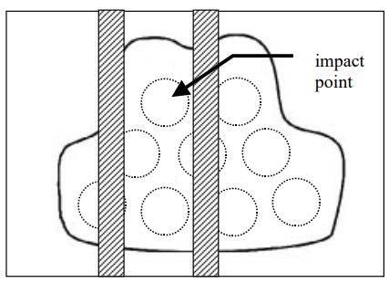
  - Test Details
    - Table 4 details the test series for planar test items, including the sequence, panel front or back, test threat, angles, energy number of impacts and panel rotational angle.
      - See Annex F for diagrams showing impact locations for planar test items. Impact location A shall always be the geometric center of the panel; impact locations B, C, D and E shall be located as shown in the figures; and other impacts shall be distributed in the unlabeled locations.
      - For testing with the SP test threat, at least one perpendicular impact per test item shall be within 38 mm (1.5 in) from the edge.
      - The 0° angle shall be indicated by the test lab on the test item from neck to waist vertically.

    - Table 5 details the test series for nonplanar female test items, front panels only. If testing of back panels is required, the details of Table 4 shall apply.
      - See Annex G for details on appliques and diagrams showing the locations for the impacts for female nonplanar front panels.
      - For testing with the SP test threat, at least one perpendicular impact per test item shall be within 38 mm (1.5 in) from the edge.
      - The 0° angle shall be indicated by the test lab on the test item from neck to waist vertically.

Table 4. Test Series for Planar Test Items
Panel # | Panel | Test Threat | Angle of Incidence | Energy | # Impacts | Impact  Locations | Panel Rotational Angle*
1 | Front | P1 | 0 ± 5° | Primary E1 | 2 | A, B | 0° ± 15°
 |  | P1 |  |  | 2 | C, D | 45° ± 15°
 |  | P1 |  |  | 2 | E, F | 90° ± 15°
 |  | P1 |  |  | 2 | G, H | Any angle
 |  | P1 | 45° ± 5° | Primary E1 | 2 | I, J | 2 angles > 30° different
2 | Back | P1 | 0 ± 5° | Primary E1 | 2 | A, B | 0° ± 15°
 |  | P1 |  |  | 2 | C, D | 45° ± 15°
 |  | P1 |  |  | 2 | E, F | 90° ± 15°
 |  | P1 |  |  | 2 | G, H | Any angle
 |  | P1 | 0 ± 5° | Overtest E2 | 1 | I | 0° ± 15°
 |  | P1 |  |  | 1 | J | 45° ± 15°
 |  | P1 |  |  | 1 | K | 90° ± 15°
 |  | P1 |  |  | 1 | L | Any angle
3 | Front | P2 | 0 ± 5° | Primary E1 | 2 | A, B | 0° ± 15°
 |  | P2 |  |  | 2 | C, D | 45° ± 15°
 |  | P2 |  |  | 2 | E, F | 90° ± 15°
 |  | P2 |  |  | 2 | G, H | Any angle
 |  | P2 | 45° ± 5° | Primary E1 | 2 | I, J | 2 angles > 30° different
4 | Back | P2 | 0 ± 5° | Primary E1 | 2 | A, B | 0° ± 15°
 |  | P2 |  |  | 2 | C, D | 45° ± 15°
 |  | P2 |  |  | 2 | E, F | 90° ± 15°
 |  | P2 |  |  | 2 | G, H | Any angle
 |  | P2 | 0 ± 5° | Overtest E2 | 1 | I | 0° ± 15°
 |  | P2 |  |  | 1 | J | 45° ± 15°
 |  | P2 |  |  | 1 | K | 90° ± 15°
 |  | P2 |  |  | 1 | L | Any angle
5 | Front | SP | 0 ± 5° | Primary  E1 | 8 | A, B, C, D, E, F, G, H | N/A
 |  | SP | 45° ± 5° | Primary  E1 | 2 | I, J | 2 angles > 30° different
6 | Back | SP | 0 ± 5° | Primary  E1 | 8 | A, B, C, D, E, F, G, H | N/A
 |  | SP | 0 ± 5° | Overtest  E2 | 4 | I, J, K, L | N/A

Table 5. Test Series for Nonplanar Female Test Items: Front Panels Only
Panel # | Applique (Cup Size) | Test Threat | Energy | Angle of Incidence | Location on Panel
1 | A2 (B-cup) | P1 | Primary E1 | 0 ± 5 | A
 |  | P1 | Overtest E2 | 0 ± 5 | B
 |  | S1 | Primary E1 | 0 ± 5 | C
 |  | S1 | Overtest E2 | 0 ± 5 | D
 |  | P1 | Primary E1 | 45 ± 5 | E
 |  | S1 | Primary E1 | 45 ± 5 | F
2 | A2 (B-cup) | P1 | Primary E1 | 0 ± 5 | A
 |  | P1 | Overtest E2 | 0 ± 5 | B
 |  | S1 | Primary E1 | 0 ± 5 | C
 |  | S1 | Overtest E2 | 0 ± 5 | D
 |  | P1 | Primary E1 | 45 ± 5 | E
 |  | S1 | Primary E1 | 45 ± 5 | F
3 | A5 (E-cup) | P1 | Primary E1 | 0 ± 5 | A
 |  | P1 | Overtest E2 | 0 ± 5 | B
 |  | S1 | Primary E1 | 0 ± 5 | C
 |  | S1 | Overtest E2 | 0 ± 5 | D
 |  | P1 | Primary E1 | 45 ± 5 | E
 |  | S1 | Primary E1 | 45 ± 5 | F
4 | A5 (E-cup) | P1 | Primary E1 | 0 ± 5 | A
 |  | P1 | Overtest E2 | 0 ± 5 | B
 |  | S1 | Primary E1 | 0 ± 5 | C
 |  | S1 | Overtest E2 | 0 ± 5 | D
 |  | P1 | Primary E1 | 45 ± 5 | E
 |  | S1 | Primary E1 | 45 ± 5 | F
5 | A2 (B-cup) | Spike | Primary E1 | 0 ± 5 | G
 |  | Spike | Overtest E2 | 0 ± 5 | H
 |  | Spike | Primary E1 | 0 ± 5 | G2
 |  | Spike | Overtest E2 | 0 ± 5 | H2
 |  | Spike | Primary E1 | 45 ± 5 | I
 |  | Spike | Primary E1 | 45 ± 5 | I2
6 | A5 (E-cup) | Spike | Primary E1 | 0 ± 5 | G
 |  | Spike | Overtest E2 | 0 ± 5 | H
 |  | Spike | Primary E1 | 0 ± 5 | G2
 |  | Spike | Overtest E2 | 0 ± 5 | H2
 |  | Spike | Primary E1 | 45 ± 5 | I
 |  | Spike | Primary E1 | 45 ± 5 | I2

- Stab Test Procedure
  - Stab testing requires a stab test apparatus meeting the requirements of Annex B.
  - Insert the drop mass, including test threat, into the bottom end of the guided drop assembly in its proper orientation. Attach the drop mass to the hoist.
    - For tests requiring 45° angle of incidence, the cutting edge of the blade shall face the test item.
  - Adjust the hoist so that the drop mass is exposed from the drop tube by 210 ± 13 mm (8.25 ± 0.50 in) as measured vertically from the bottom edge of the drop tube to the leading edge of the polymer portion of the sabot.
  - Place the test item on the backing material and position this assembly beneath the drop mass.
  - Adjust the height of the articulating table such that the tip of the test threat is within 25 mm (1 in) of the surface of the test item.
  - Horizontally position the test item below the drop tube such that the test threat will strike at the intended impact location.
  - Raise the drop mass to the proper height determined in Section 10.3 so that it will strike with the specified energy.
  - Initialize the velocity measurement instrumentation in preparation for making a measurement.
  - Release the drop mass.
  - For each impact, record penetration depth, kinetic energy, impact location, angle of incidence, rotation angle and other required data.
  - Repeat the above steps until all required impacts on all test items are complete.

Test Report
  - The test laboratory shall develop a test report that meets the requirements of ISO/IEC 17025 and the referenced ASTM standards.
  - All data and required calculated values shall be included in the test report.

Annex A (Mandatory): Test Threat Drawings and Requirements

Drawings for Test Threats
The drawings below detail the specifications required for the commercial threat test items: P1, S1 and SP1.

Figure A.1. P1 Single-edged Blade
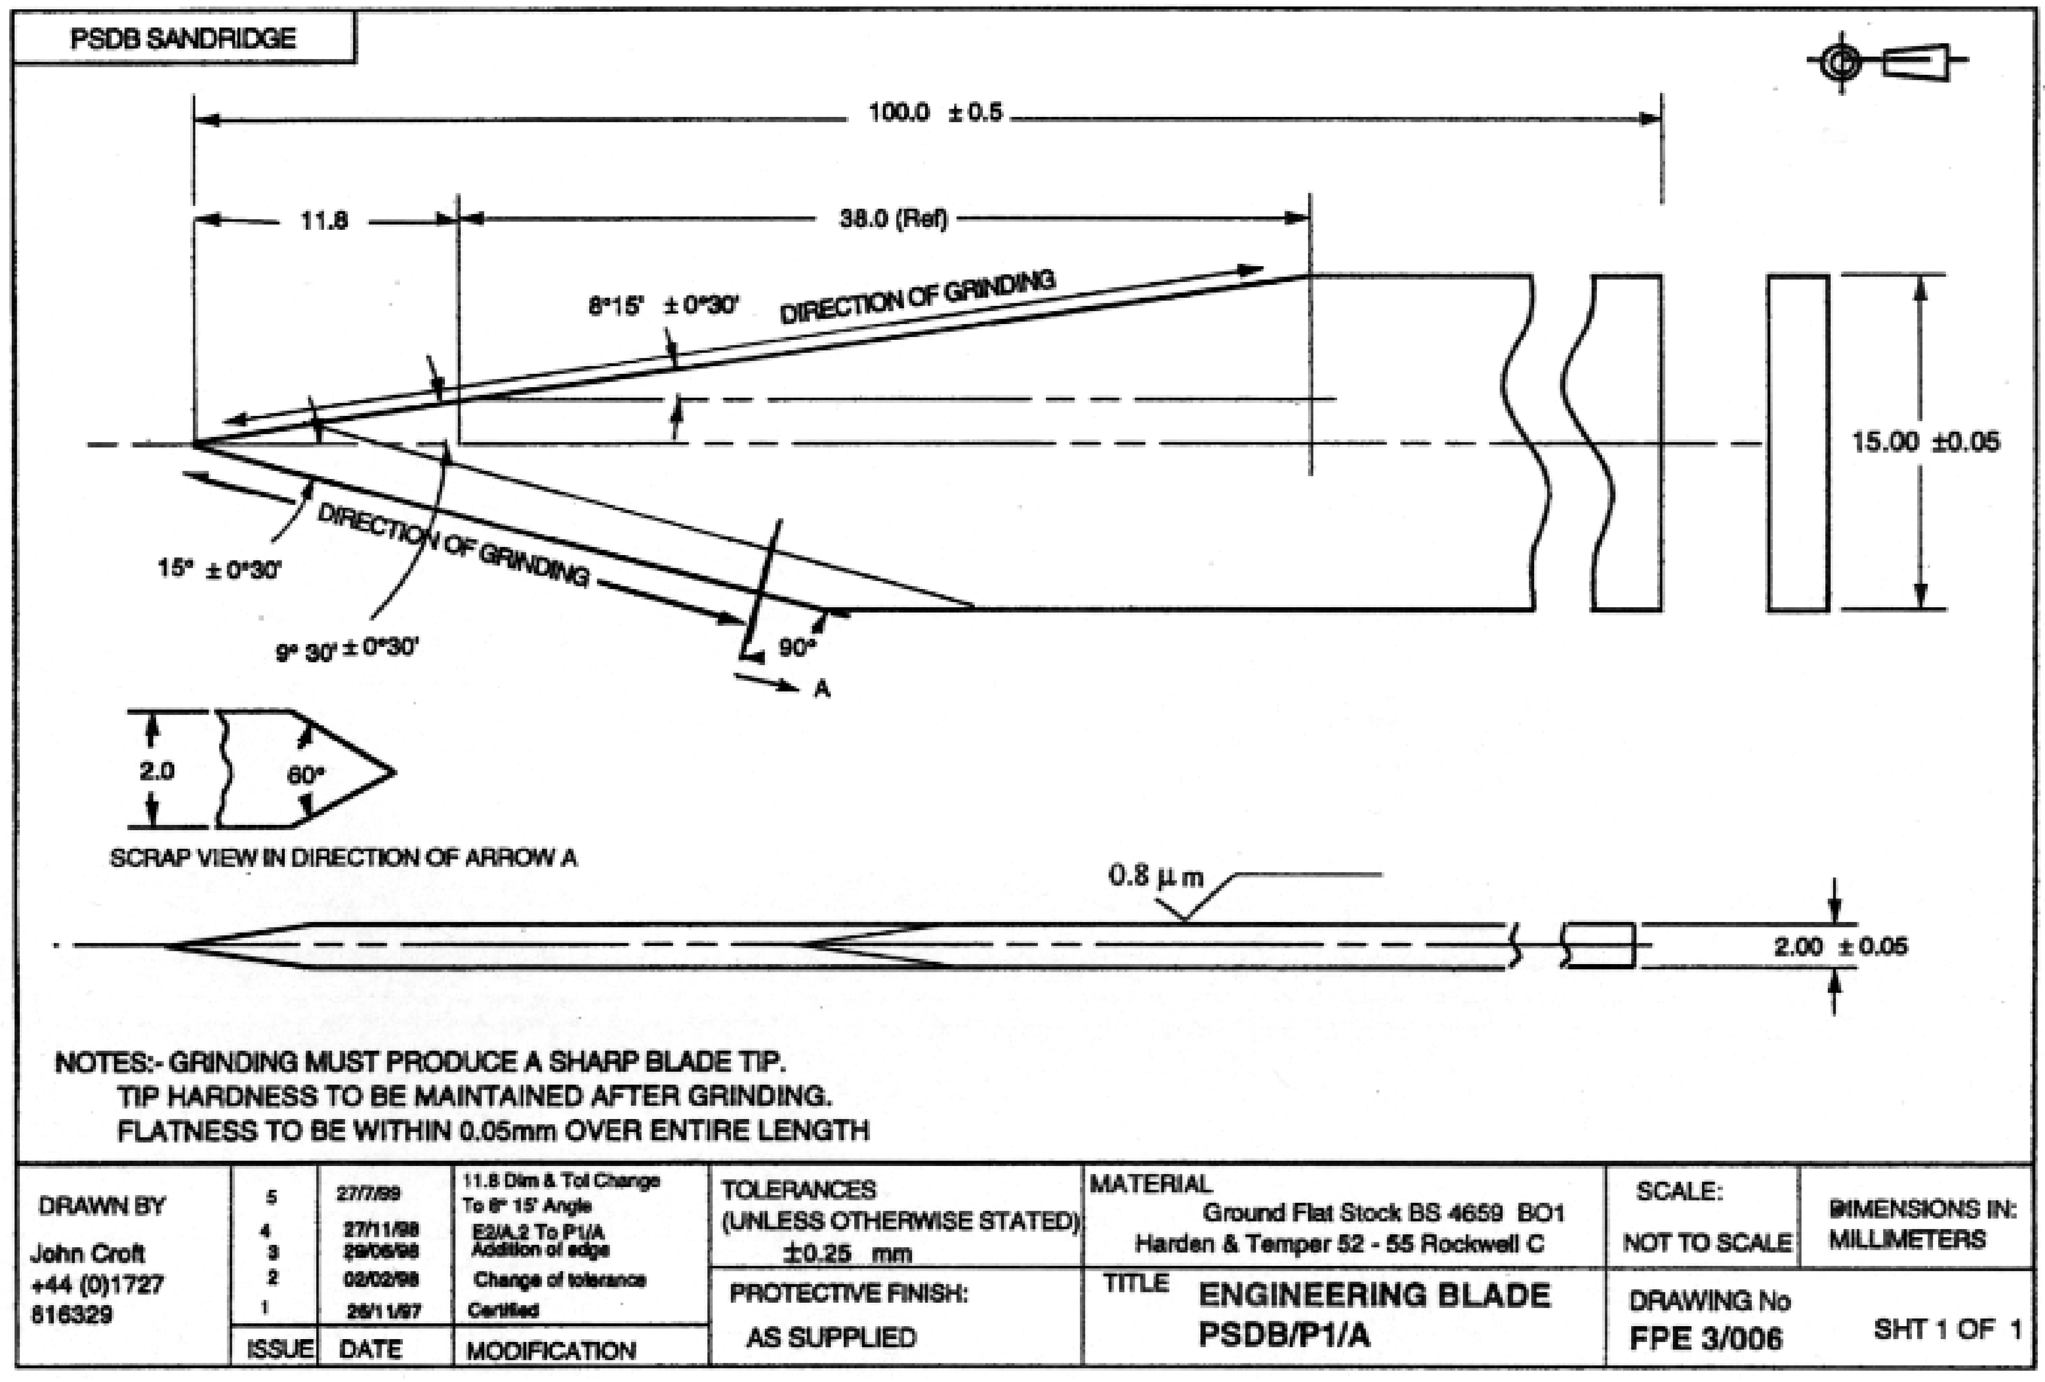

Figure A.2. S1 Double-edged Blade
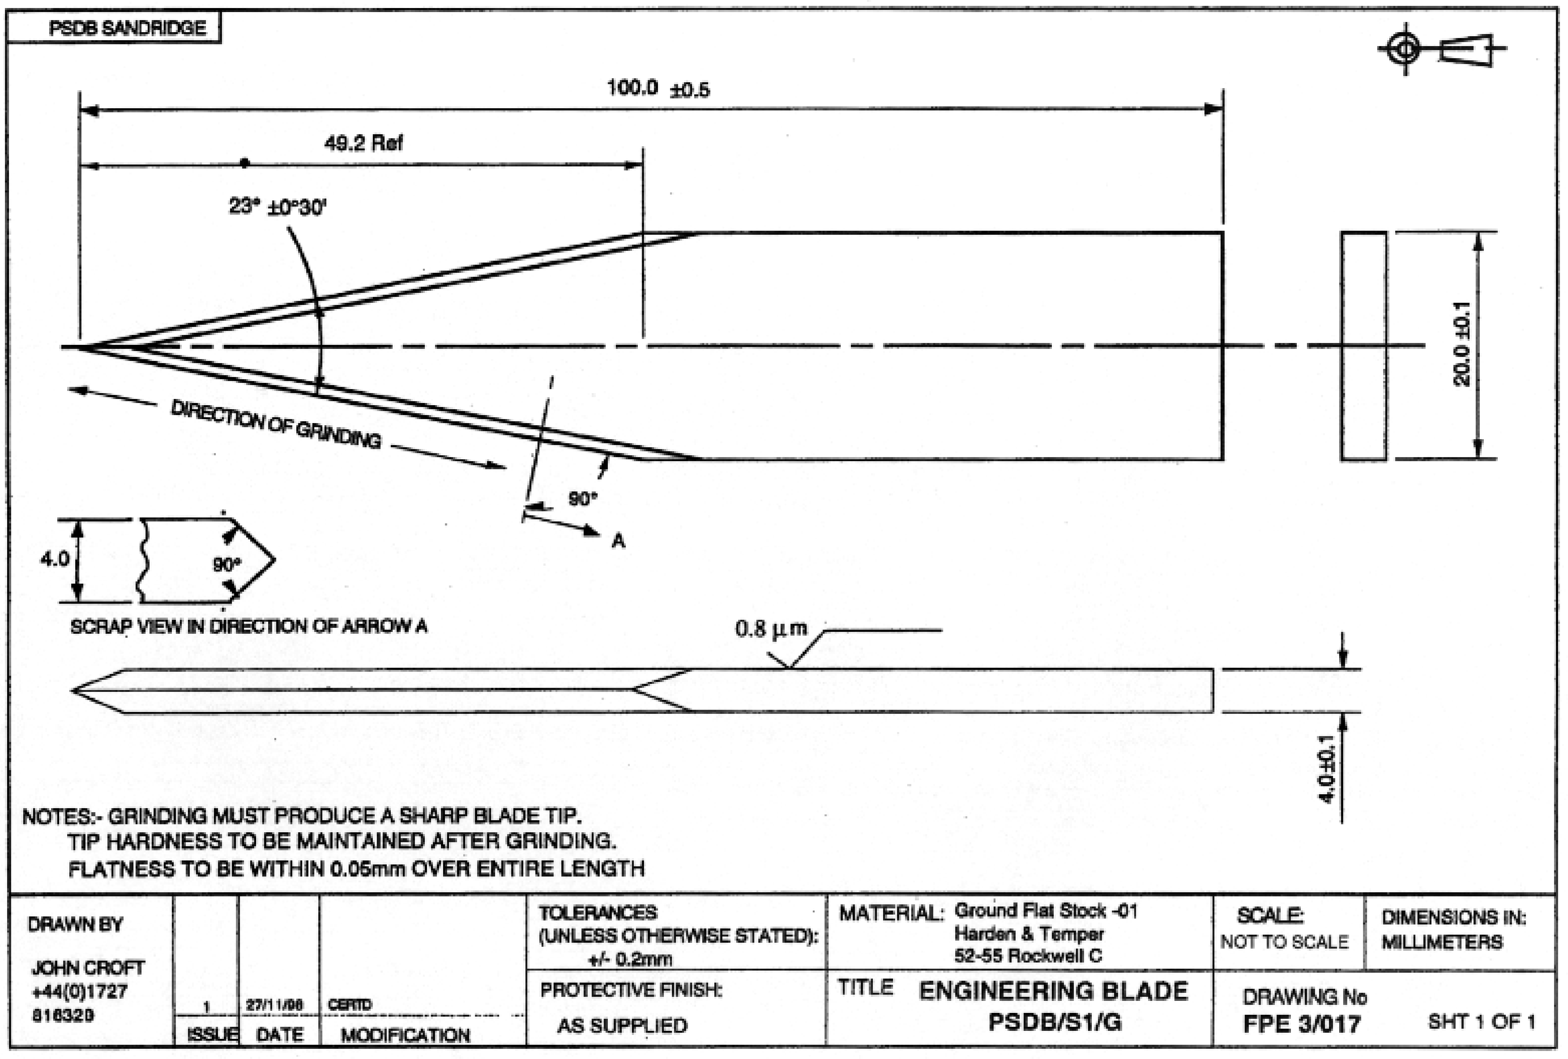

Figure A.3. SP1 Spike
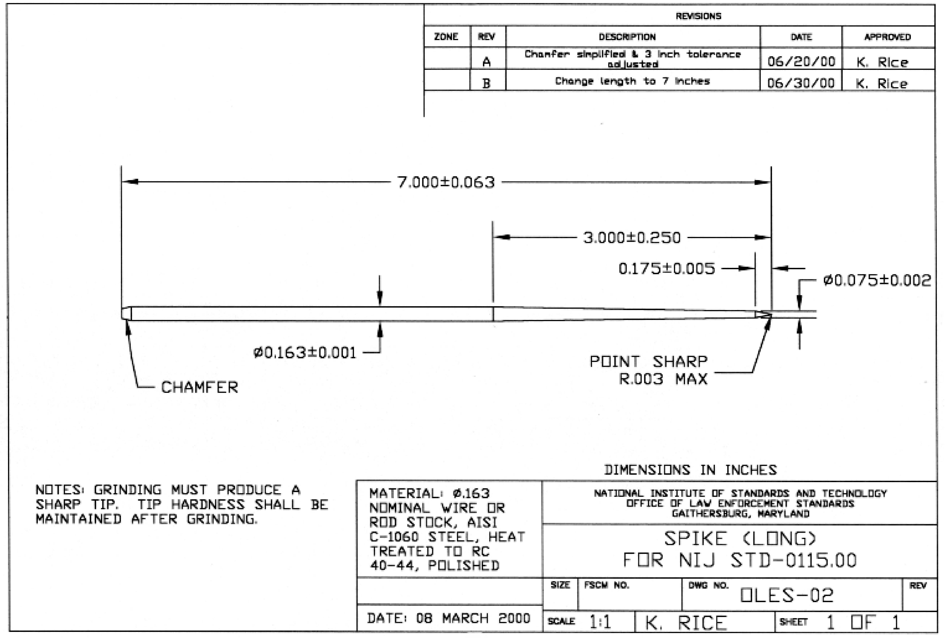

The drawings below detail the specifications required for the improvised threat test items: T1, T2 and T3.

Figure A.4. T1 Improvised Single-edged Blade
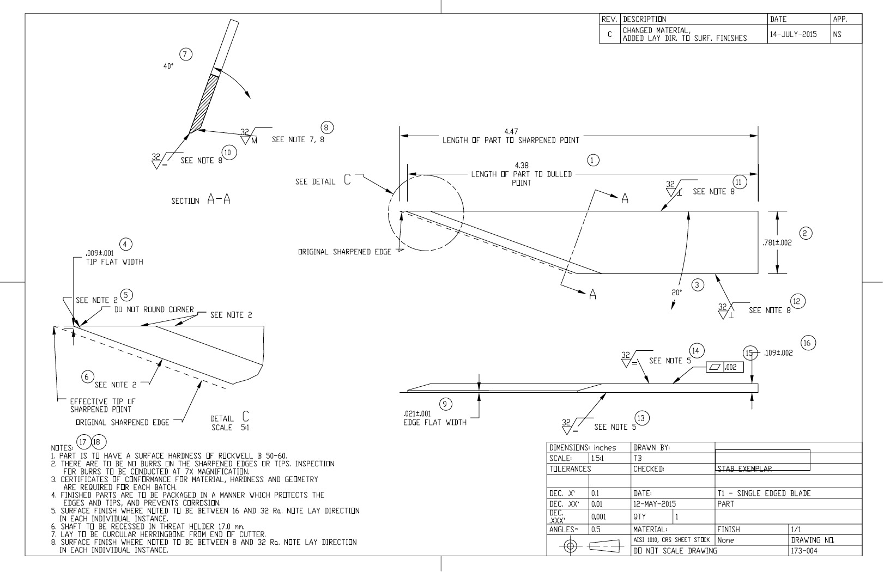

Figure A.5. T2 Improvised Double-edged Blade
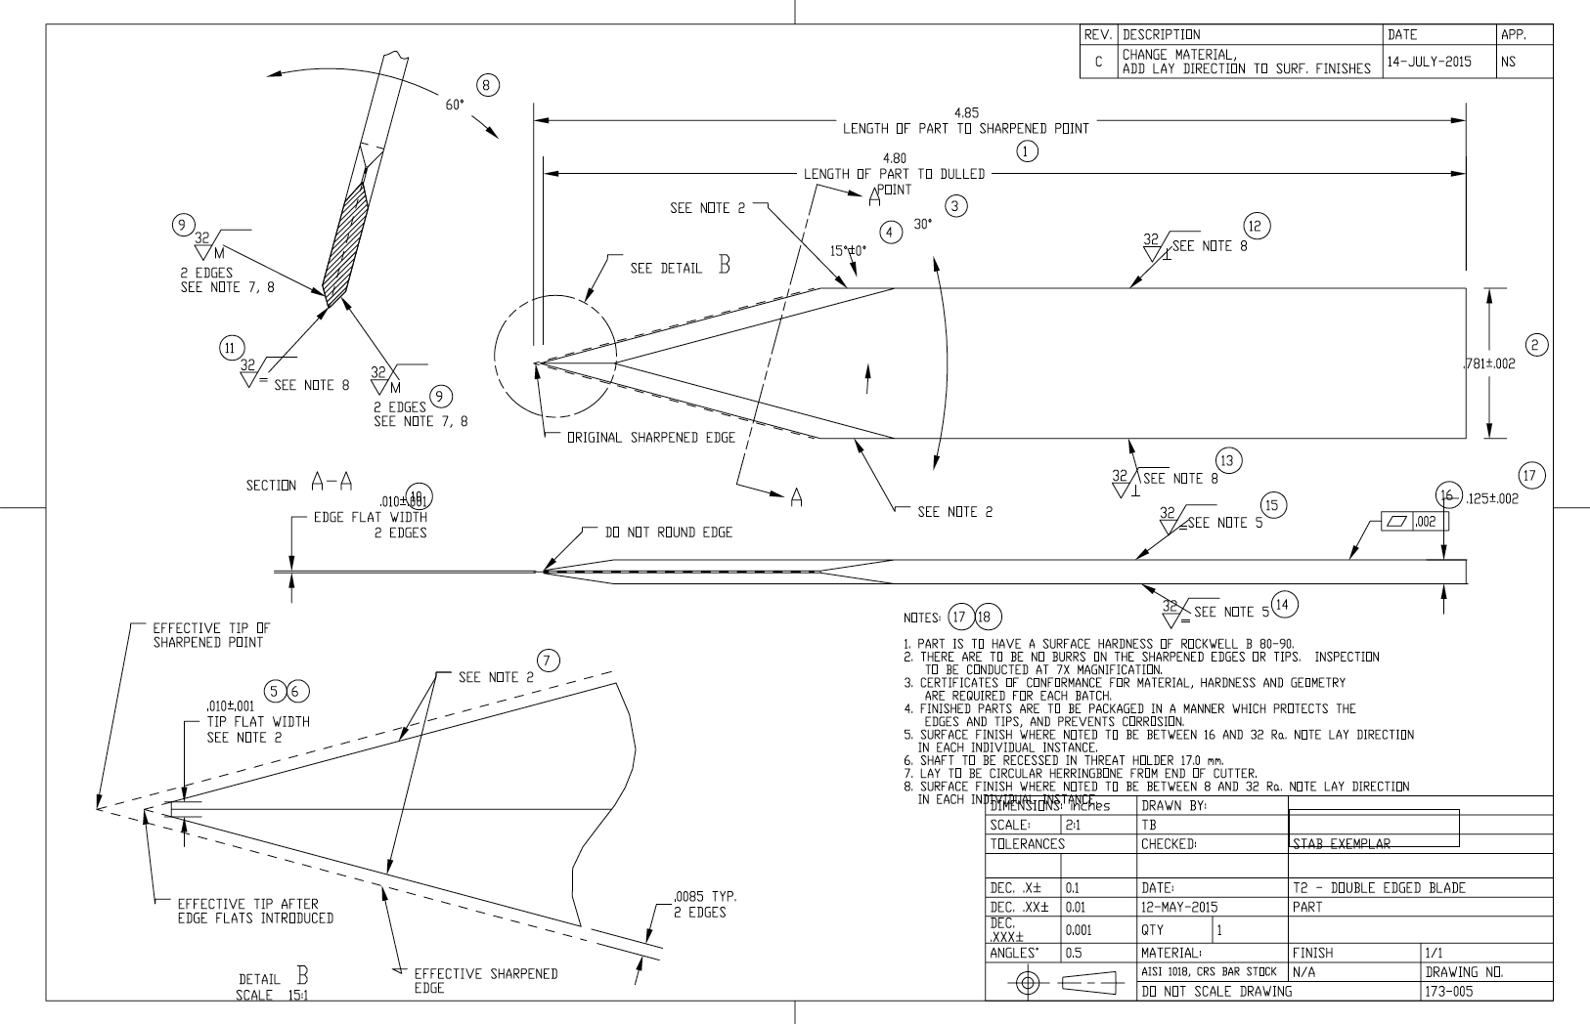

Figure A.6. T3 Improvised Spike
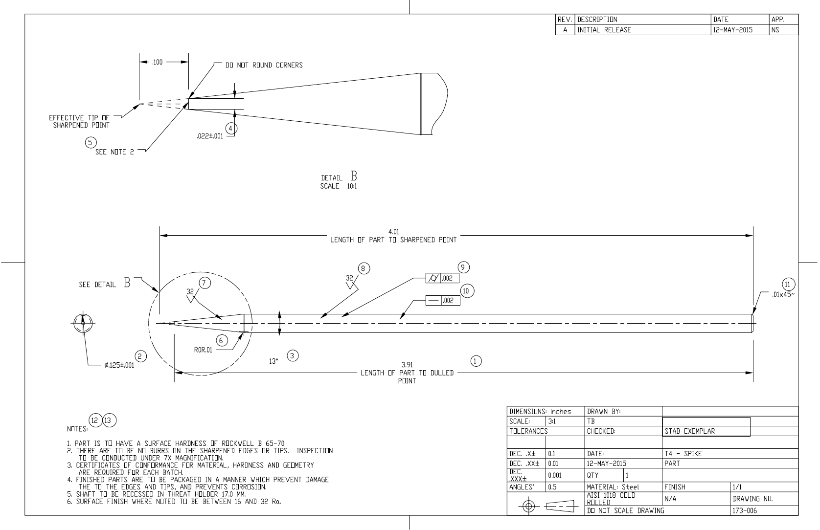

Test Threat Requirements
- Each test threat shall be inspected to ensure that it meets the requirements of the respective engineering drawings and that the overall finish is clean and free from rough edges.
- Each commercial test threat shall be subjected to a tip sharpness test and shall be considered acceptable for stab testing if it produces a “hardness” value of between -50 and -150 on the Rockwell C scale in the following modified Rockwell hardness tip sharpness test:
  - The standard indenter shall be replaced with an adapter that will hold the test threat.
  - The machine shall be preset to give minor and major loads of 3 kg (6.61 lb) and 5 kg (11.0 lb) respectively, to produce a total load of 8 kg (17.61 lb).
  - The sample block to be indented shall be a small flat block of 99.997 % nearly pure aluminum at least 5 mm (0.197 in) thick.
  - The test threat shall first be wiped with a clean dry cotton cloth to remove any traces of lubricant and then installed in the holder adapter.
  - The test threat tip sharpness shall then be measured by applying the load to the blade or spike tip into the aluminum block and recording the reading from the Rockwell C scale.

Note: These are not actual Rockwell hardness values because of the modifications to the machine and test procedure. As an alternative means of assessing the tip sharpness, the range of Rockwell C values are expressed in terms of indentation depth produced by the major load application, and correspond to indentation depths in the aluminum test block of 0.30 mm (0.012 in) and 0.50 mm (0.020 in), for “hardness” values of -50 and -150 respectively. See Table A.1 listing relating the hardness values to indentation depth (D).
- Each improvised test threat shall meet the dimension and material specifications in the table below.

Table A.1. Conversion of HRC Values to Indentation Values
HRC | D (mm) | HRC | D (mm) | HRC | D (mm) | HRC | D (mm) | HRC | D (mm)
-160 | 0.52 | -130 | 0.46 | -100 | 0.40 | -70 | 0.34 | -40 | 0.28
-150 | 0.50 | -120 | 0.44 | -90 | 0.38 | -60 | 0.32 | -30 | 0.26
-140 | 0.48 | -110 | 0.42 | -80 | 0.36 | -50 | 0.30 | -20 | 0.24

Table A.2. T1 Threat Specifications
Description | Unit | Lower tolerance | Nominal | Upper tolerance
Length | Inch | 4.37 | 4.38 | 4.39
Width | Inch | 0.779 | 0.781 | 0.783
Tip plan angle | Deg | 19.5 | 20.0 | 20.5
Tip flat width | Inch | 0.007 | 0.009 | 0.011
Tip flat condition | - | - | No burrs | -
Tip crest condition | - | - | No burrs | -
Grind angle | Deg | 39.5 | 40.0 | 40.5
Grind surface finish | Ra | 16 | - | 32
Edge flat width | Inch | 0.02 | 0.021 | 0.022
Edge flat surface finish | Ra | 16 | - | 32
Body long edge surface finish | Ra | 16 | - | 32
Body short edge surface finish | Ra | 16 | - | 32
Body underside surface finish | Ra | 16 | - | 32
Body upper-side surface finish | Ra | 16 | - | 32
Body flatness | Inch | 0 | - | 0.002
Body thickness | Inch | 0.107 | 0.109 | 0.111
Hardness | RB | 50 | - | 55

Table A.3. T2 Threat Specifications
Description | Unit | Lower tolerance | Nominal | Upper tolerance
Length | Inch | 4.79 | 4.80 | 4.81
Width | Inch | 0.779 | 0.781 | 0.783
Tip plan angle | Deg | 29.5 | 30.0 | 30.5
Tip plan angle symmetry | Deg | 14.5 | 15.0 | 15.5
Tip flat width | Inch | 0.009 | 0.01 | 0.011
Tip flat condition | - | - | No burrs | -
Tip crest condition | - | - | No burrs | -
Bevel included angle | Deg | 59.5 | 60.0 | 60.5
Grind surface finish | Ra | 16 | - | 32
Edge flat width | Inch | 0.009 | 0.010 | 0.011
Edge flat surface finish | Ra | 16 | - | 32
Body long edge surface finish | Ra | 16 | - | 32
Body short edge surface finish | Ra | 16 | - | 32
Body underside surface finish | Ra | 16 | - | 32
Body upperside surface finish | Ra | 16 | - | 32
Body flatness | Inch | 0 | - | 0.002
Body thickness | Inch | 0.123 | 0.125 | 0.127
Hardness | RB | 75 | - | 80

Table A.4. T3 Threat Specifications
Description | Unit | Lower tolerance | Nominal | Upper tolerance
Length | Inch | 3.90 | 3.91 | 3.92
Shaft body diameter | Inch | 0.124 | 0.125 | .0126
Tip cone angle | Deg | 12.0 | 12.5 | 13
Tip flat width | Inch | 0.021 | 0.022 | 0.023
Tip flat condition | - | - | No burrs | -
Tip cone surface finish | Ra | 16 | - | 32
Shaft body surface finish | Ra | 16 | - | 32
Shaft body concentricity | Inch | 0 | - | 0.002
Shaft body flatness | Inch | 0 | - | 0.002
Shaft body end chamfer |  |  | Present
Hardness | Rb | 65 | - | 70

Annex B (Mandatory): Stab Test Apparatus, Requirements and Setup
- The stab test apparatus consists of a guided drop assembly, velocity measurement instrumentation, an articulating table, a drop mass, test threat, composite backing material and test item strapping. See Figure B.1 for an overview of the stab test apparatus with the drop mass and test threat fully deployed.

Note: The composite backing material and test threats are consumable materials that require replacement.
- The guided drop assembly facilitates the delivery of the test threat to the surface of the test item with specific orientation and velocity. The test threat is attached to a drop mass to ensure the test threat impacts the test item at the required energy. The guided drop assembly consists of a rigid tube or equivalent, affixed vertically to the laboratory wall or ceiling, and a mechanism for raising and releasing the drop mass from a specified height. On release, the drop mass falls freely, delivering the test threat to the strike face of the test item, and the guided drop tube prevents rotation about the vertical axis of the drop mass. The test item is held in place, by strapping, on composite backing material mounted atop an articulating table that allows the test item to be angled with respect to the test threat. The velocity measuring instrument measures the velocity at which the test threat falls.
Figure B.1. Diagram of Stab Test Apparatus
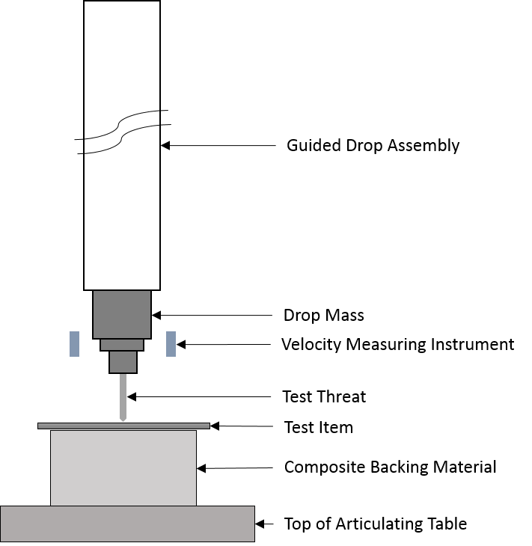

- Guided Drop Assembly
  - The guided drop assembly consists of a rigid tube or equivalent, affixed vertically to the laboratory wall or ceiling, and a hoist for raising and releasing the drop mass from a specified height.
  - In order to meet the energy requirements for this test, the drop distance ranges up to approximately 4.25 m (14 ft).
  - Velocity Measurement Equipment
    - A suitable method of accurately measuring the velocity of the drop mass within the velocity measurement zone shall be employed.
    - The measuring equipment shall measure the velocity to an accuracy of ± 0.05 m/s (± 0.16 ft/s) or better.
    - The velocity gates shall be positioned to measure the velocity of the drop mass when the leading edge of the polymer portion of the sabot is 210 ± 13 mm (8.25 ± 0.50 in) below the bottom edge of the drop tube.

- Composite Backing Material:
  - A pack of composite backing material shall be used. The composite backing material pack shall measure 60 cm ± 1 cm (24 in ±1/3 in) in length and 60 cm ± 1 cm (24 in ± 1/3 in) in width. Adjustments in length and width may be made to accommodate smaller test items; however, the minimum permitted size of the backing material pack is 38 cm (15 in) by 30 cm (12 in).
  - The components of the backing material pack shall consist of layers of materials (from the strike face down) as shown in Figure B.2, and the materials shall be as specified below and in Tables B.1, B.2 and B.3:
  - Neoprene:
    - Density measurements shall be conducted according to ASTM D3575 on cylindrical samples of 50 mm (1.97 in) diameter prepared using the same hole saw for cutting dampers.
    - Thickness shall be measured using calipers (or other suitable measurement instrument) accurate to ± 0.5 mm (0.02 in) or better.
    - Compression deflection measurements shall be conducted on four layers of neoprene according to ASTM D3575 and in the cylindrical geometry for the dampers.
    - Shore hardness measurements shall be conducted on the polyethylene without the skin to confirm the surface hardness is consistent between tests.
    - The durometer shall be a type OO durometer.
  - Plastazote:
    - A single layer of closed-cell low-density plastazote crosslinked polyethylene foam,
    - Density measurements shall be conducted, according to ASTM D4819 on cylindrical samples of 50 mm (1.97 in) diameter prepared using the same hole saw for cutting dampers.
    - Thickness shall be measured using calipers or a micrometer accurate to ± 0.5mm or better. The polyethylene shall be ordered with the thick skin removed to achieve the specified thickness.
    - Compression deflection measurements shall be conducted on a single layer of polyethylene according to ASTM D3575 and in the cylindrical geometry for the dampers.
    - Shore hardness measurements shall be conducted on the polyethylene without the skin to confirm the surface hardness is consistent between tests.
    - The durometer shall be a type OO durometer.
  - Natural rubber sheet:
    - Shore hardness measurements shall be conducted on the surface of the natural rubber.
    - The durometer shall be a type A durometer.

Table B.1. Neoprene (EPDM/SBR) Specification
Figure B.2. Composite Backing Material Layers
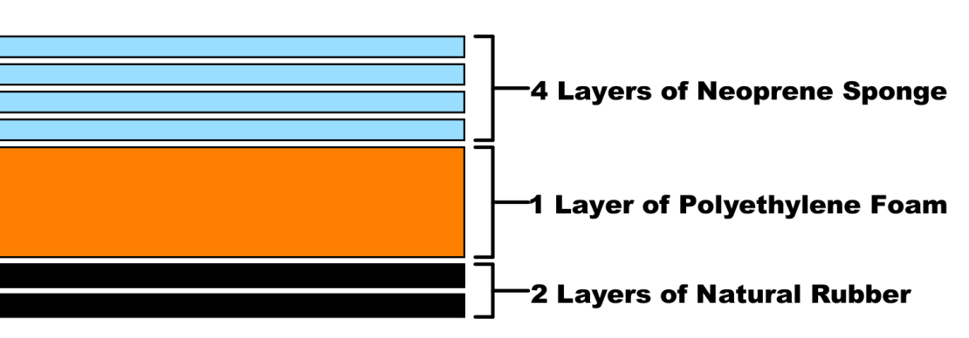

 | Test Method | Requirement
Color | N/A | Black
Type | N/A | Closed
Standard Specification | ASTM D1056 | 2A3
Density (kg/m3) | ASTM D3575# | 150 ± 15
Thickness (mm) | N/A | 6 ± 0.5
Compression Deflection (kPa), % strain | ASTM D1056 | 10%: 47 ± 15
 |  | 25%: 73 ± 13
 |  | 50%: 162 ± 10
Shore Hardness [OO Scale] | ASTM D2240 | 60 ± 5

# No ASTM density standard is identified for sponge or expanded rubber; it is recommended to use the method prescribed for polyolefin foam. Samples should be cylindrical with the same diameter as the polyethylene damping discs.

Table B.2. Polyethylene Specification
 | Test Method | Requirement
Color | N/A | Black
Type | N/A | Closed
Standard Specification | ASTM D4819 | D4819 Type I - B4
Density (kg/m3) | ASTM D3575 | 32 ± 2
Thickness (mm) | N/A | 28 ± 2 (no skin)
Compression Deflection (kPa) | ASTM D3575 | 10%: 40 ± 10
 |  | 25%: 55 ± 10
 |  | 50%: 125 ± 10
Shore Hardness [OO Scale] | ASTM D2240 | 60 ± 3

Table B.3. Rubber Specification
 | Test Method | Requirement
Color | N/A | Black
Type | N/A | Natural
Shore Hardness [A Scale] | ASTM D2240 | 50 ± 5
Thickness (mm) | N/A | 6 ± 0.5

  - Composite Backing Material Acceptance Criteria
    - The individual materials shall meet the requirements stated in Tables B.1, B.2, and B.3, prior to use in testing.
    - Where test items have a pre-formed curve that is not considered a bust form, it may not be possible for the rear face of the test item to lie in close contact with the surface of the backing material. If this occurs, then the following should be attempted in the order described:
    - If the armor design permits, the test item shall be flattened so that the curved portions of the armor make good contact with the backing material.
    - If it is still not possible to achieve good contact between the test item and the backing material, then smaller pieces of the neoprene backing material shall be cut and then stacked together to make good contact with the tight curvature of the test item.
    - Composite Backing Material Acceptance Test 1
    - The backing materials shall be conditioned at controlled ambient.
    - The pack shall be assembled in the correct order as described above and placed on a rigid surface.
    - The pack shall be strapped to the rigid surface, under tension similar to testing, to reduce any air gaps between the material layers or between the pack and the rigid surface.
    - A 1.042 kg (2.297 lb) spherical steel ball shall then be dropped from a vertical height of 1,500 mm ± 15 mm (59 in ± 0.59 in) above the surface of the pack.
    - The height of the rebound shall be measured.
    - The point of impact of the steel sphere on the backing material shall be marked.
    - Composite Backing Material Acceptance Criteria 1
    - The height of rebound achieved from each of two drops shall be 475 mm ± 76 mm (18.7 in ± 3.0 in). The marked points of impact of the steel sphere on the backing material shall not be positioned immediately below the impact point for any of the stab tests. The center of the impacts shall be spaced at least 51 mm (2 in) apart from each other and 51 mm (2 in) from the edge.
    - The backing material shall be replaced when it is no longer possible to conduct a strike greater than 51 mm (2 in) from the edge and from previous strikes.
  - Female Armor Backing Material
    - The appliques for testing female armor shall be formed using Roma Plastilina No.1 as described in ASTM E3086, Standard Practice for Creating Appliques for Use in Testing of Nonplanar Soft Body Armor Designed for Females.

  - Drop Mass
    - The drop mass consists of the following components:
      - A test threat, as defined in Annex A.
      - A sabot designed and built according to the drawings available from the NIJ Compliance Testing Program.
      - Two damping disks
    - Each damping disk shall be made from the same closed cell polyethylene foam used in the composite backing material.
      - Each disk shall be 28 mm ± 1 mm (1.1 in ± 0.04 in) thick and 50 mm (1.97 in) diameter and should be cut using a steel hole saw 50 mm (1.97 in) diameter, without the center guiding bit. The hole saw shall have a smooth bore and a knife edge for cutting, and distilled water should be used as a cooling lubricant.
      - The disks shall be allowed to dry for a minimum of 24 hours prior to use in stab testing.
    - The drop mass shall securely hold the test knife blade or spike with at least 81 mm (3.2 in) of the blade or spike length exposed. The shape of the lower surface of the drop mass shall permit at least 30 mm (1.2 in) of penetration to occur while striking the test item at a 45° angle of incidence.

    - Assembly of Drop Mass
      - Two damping disks shall be installed in the nylon body of the upper portion of the sabot.
        - For damping disks that are used for commercial threat armor testing and drop tests at less than 65 J (47.9 ft·lbf), they shall be replaced after being subjected to no more than 1 seating drop and 10 drop tests.
        - For damping disks that are used for improvised threat testing at 65 J (47.9 ft·lbf) or greater, they shall be subjected to no more than one seating drop and five drop tests.
    - Five minutes shall elapse between drops to allow the damping disks to recover. The lower portion of the sabot should not exhibit slack (e.g., no resistance felt when moving lower mass up into upper mass) prior to loading threat. If the dampers do not recover within the five-minute period, the disks shall be replaced.
    - Once the damping disks have reached their drop limit (5 or 10 drops respectively), they shall be discarded.
      - After installation of the damping disks, the lower drop mass shall be inserted into the upper mass, and the damping disks shall be compressed 6mm +/- 2mm.
      - Prior to first test drop and after every change of damping disk; an initial damper seating drop must be made onto an armor panel with conditioned backing material and test threat present. The drop must be at the same energy as the intended test energy. A threat blade must be used, although an old blade is permissible. This drop is to be performed prior to compliance drop tests being conducted and every time the dampers are changed during the test process. The test should be in an unused section of the test armor and marked accordingly to identify it as a damper seating test. A separate/spare armor may be used.
    - A recovery period of at least 5 minutes is required between each drop.
  - Installation of Test Threat Into Drop Mass
    - A new test threat shall be used for each test strike.
    - The specified test threat shall be affixed to the drop mass and the assembly shall be weighed to the nearest gram. The mass measurement method shall have an accuracy of ± 1 g (± 0.002 lb) or less.

  - Witness Panel
    - The witness panel shall be panel Polyart™ paper having a basis weight of 140 g/m² and a thickness of 0.178 mm (7 mil). Penetration measurements shall be taken from the cut in the witness paper.

Annex C (Mandatory): Equipment and Procedure for Conditioning Soft Armor by Submersion

Equipment
The armor submersion equipment shall consist of a water bath sufficiently sized to allow at least one test item of the largest template size to hang vertically, without any folds or bends, with the top edge of the test item at least 102 mm (4 in) below the surface of the water, and with at least 51 mm (2 in) clearance around the test item.
The water in the bath shall be clean and shall be either potable tap or demineralized water. The water shall be replaced any time there are visible impurities in the water. The water temperature shall be 21 °C + 3 °C/-6 °C (70 °F + 5 °F/-10 °F).

Procedure
Each test item shall be hung vertically in the water bath for 30 min (+ 5 min/- 0 min) with the top edge of the test item positioned 100 mm ± 25 mm (4 in ± 1 in) below the water surface and maintaining at least 51 mm (2 in) clearance around the test item. For test items that are buoyant, weights shall be attached to the bottom edge with clothes pins or similar clips to allow the test item to hang vertically. After removing the test item from the water, it shall be hung vertically to drip dry for 10 min (+ 5 min/- 0 min) before mounting on
the backing material for stab testing.

Annex D (Mandatory): Template for Test Item Size

Note on sizing template: The red outline below represents the maximum dimensions for either the front or the back panel. The blue outline below represents the minimum dimensions for either the front or the back panel. The dashed, blue line represents the maximum scoop allowed for the neck scoop for the front panel only. It is a common misconception that the red outline represents the back panel and the blue outline represents the front panel.
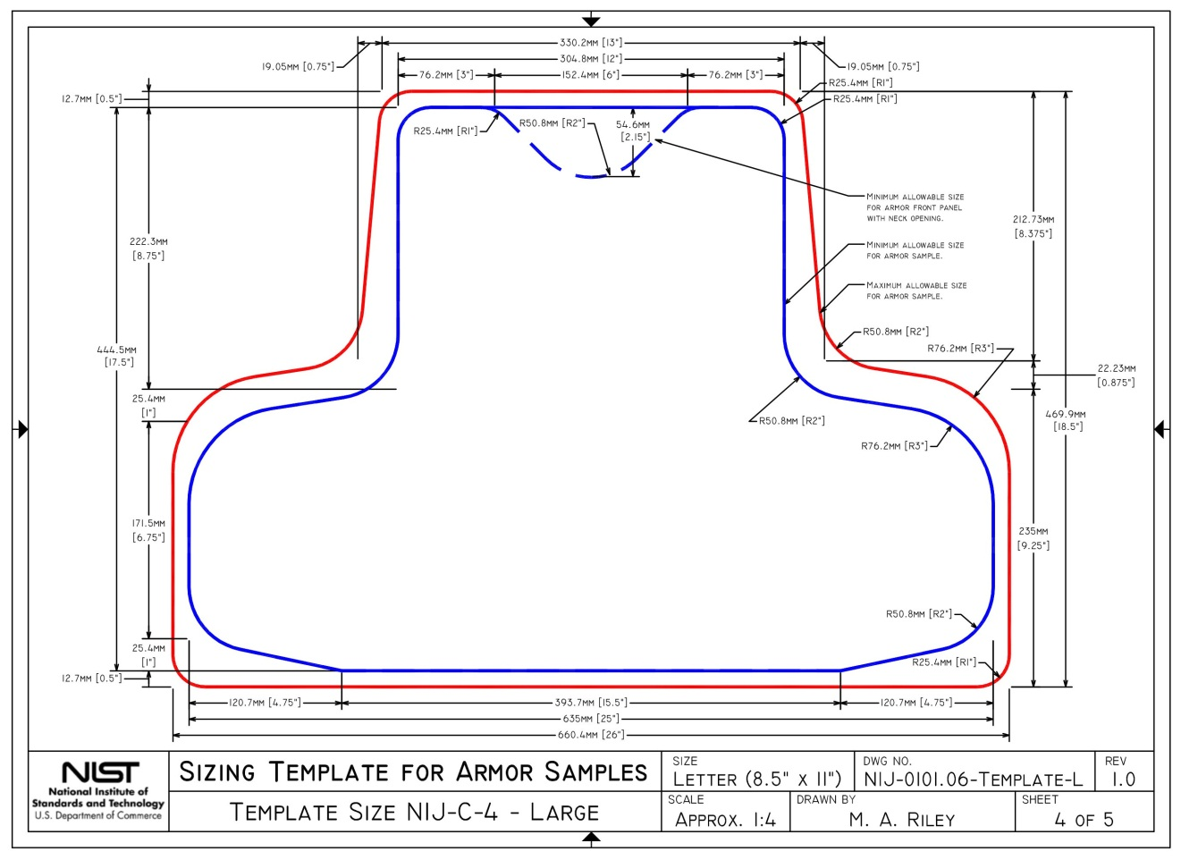

Annex E (Mandatory): Test Item Label Requirements and Testing

Test Item Label Content Requirements
The label shall be permanently attached to the face of the panel. The label shall contain the following information (an example is provided in Figure E.1):
Figure E1. Example Test Item Label
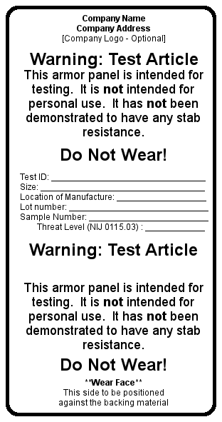
- Name, registered trademark or other identification of the supplier.
- The rated level of protection and reference to this edition of the standard (e.g., NIJ Commercial protection level in accordance with NIJ Standard-0115.01).
- A test ID number or model designation that uniquely identifies the armor design for testing purposes.
- The test item template size.
- A number or serial number that uniquely identifies each test item.
- Location of manufacture.
- The date of manufacture.
- Identification of the proper orientation of the stab panel (i.e., strike face or wear face).
- A warning in larger type than the rest of the type on the label that clearly emphasizes the warning, stating that the stab panel is a test item that has not yet been demonstrated to provide stab resistance and that the armor panel is not intended to be worn. Printing color changes are acceptable but cannot be substituted for the type size requirement herein.

Test Item Label Permanency and Durability

References

ASTM E2771, Terminology for Homeland Security Applications. West Conshohocken, PA: ASTM International.

ASTM D5264, Practice for Abrasion Resistance of Printed Materials by the Sutherland Rub Test. West Conshohocken, PA: ASTM International.

Terms and Definitions

For terminology not defined in this annex, the definitions found in ASTM D5264 and ASTM E2771 apply.

Label, n – A material applied to a product and containing information about the product.

Label assembly, n – The label itself and any clear plastic laminate that will be used to protect the label.

Label system, n – The label assembly and the substrate to which it is applied.

Substrate, n – The material identical to the external surface of the production body armor to which the label will be affixed. In soft armor, this will typically be the ballistic panel cover material. In some hard armors, the substrate will be the plate material itself. In other hard armors, the substrate will be the plate wrap material or the “sprayed-on liner” covering material.

Test item, n – A single article intended for testing (ASTM E2771). For this annex, the test item shall be the labeling system being evaluated. This system includes the label itself, the substrate the label adheres to and any clear plastic laminate intended to protect the label. See Figure E.2 for a graphic of the labeling system.

Test Items

The test item is the labeling system being evaluated. This labeling system shall match (in materials and manner of construction) the labeling system intended for use on the finished product.

To facilitate testing, the label assembly on the test items shall be affixed such that the long edge of the label assembly is near the edge of the substrate, as shown in Figure E.2. If a clear laminate is present in the label assembly, it shall not extend more than 0.5 in (13 mm) beyond the edge of the label at this edge. The label itself shall be less than 0.75 in (19 mm) away from and parallel to the same edge of the substrate.

Special considerations for hard armor systems

All substrate systems shall be nominally flat.

If the label substrate material is not a stand-alone material (e.g., spray liner or fabric wrap), then the manufacturer shall submit test items with representative substrates applied to a nominally planar surface (e.g., plastic, steel or wood). The surface finish of this material shall be representative of the surface finish that will be present in the finished product.

A total of 10 test items shall be submitted for testing.

Visual Examination of Test Items

Visually examine each test item for imperfections. Imperfections include areas along the edge of the label or clear plastic laminate that are not in contact with the substrate or areas of the clear plastic laminate that are not in contact with the label.

Document any observed imperfections.
Figure E.2. Graphic of Labeling System
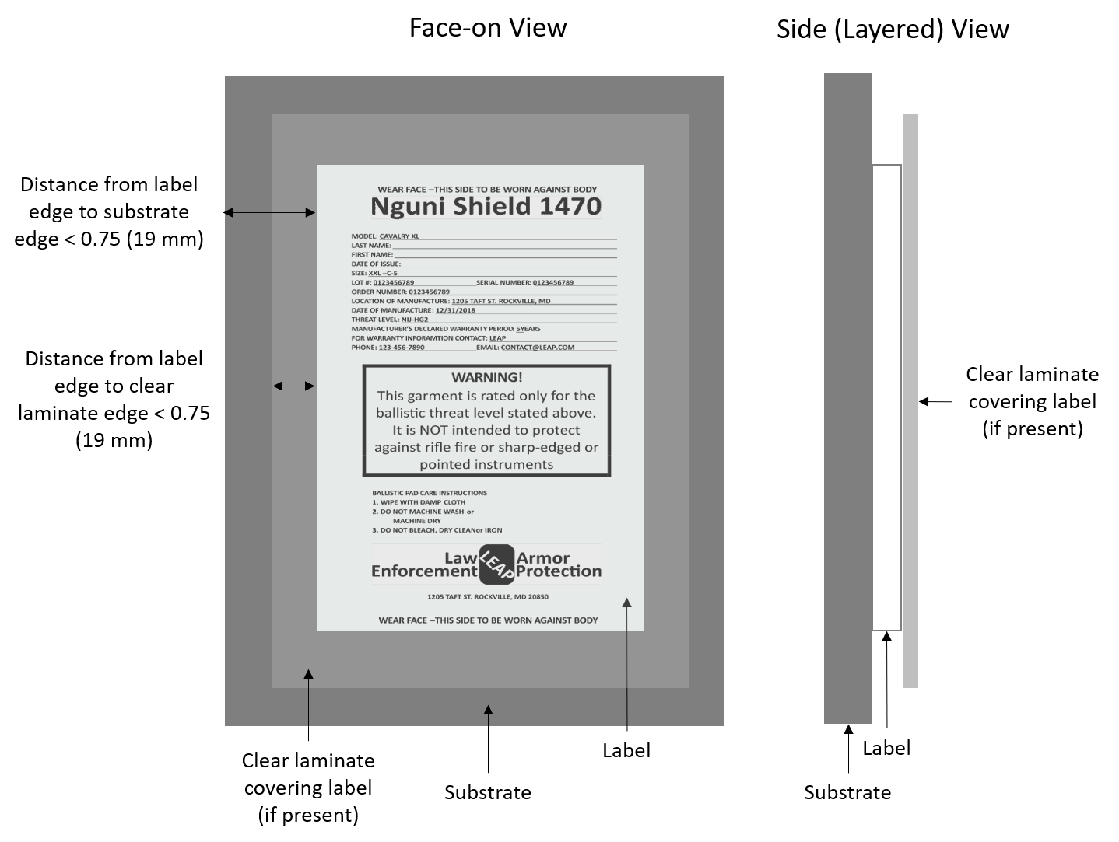

Resistance to Peeling Test

Quantity of Test Items

Two new test items are required.

Equipment and Materials

Packaging tape: Nominally 2-in wide, clear polypropylene tape with acrylic adhesive, adhesion to steel rating of 32 to 35 oz/in (36 to 39 g/mm).

Procedure

Place the test item on a smooth, flat surface.

Adhere packaging tape lengthwise to the top surface of the label assembly. The adhered section must extend from at least the center of the label itself to approximately 0.25 to 0.5 in (6 to 13 mm) beyond a side edge of the label assembly. Form a “pull tab” by extending the length of the tape beyond this adhered section, doubling the tape back on itself.

After waiting 60 seconds, hold the substrate down and use the pull tab while pulling the packing tape to remove the packing tape from the test item.

Document if any portion of the label assembly was removed from the substrate.

The label has failed this test if any of the label assembly is removed from the substrate.

Ink Permanency Test

Quantity of Test Items

Four new test items are required.

Equipment and Materials

A Sutherland Ink Rub Tester (SIRT) shall be used, with a test weight having mass of 4 lb ± 0.18 oz (1.81 kg ± 5 g), as specified in ASTM D5264. The speed during testing shall be 42 cycles per minute.

The abradant shall be white nylon fabric, 200 Denier, uncoated.

Three challenge fluids are used.
- Water: nominally tap water
- Isopropyl alcohol: nominally 70% by volume commonly available
- Water, oil, soap combination with the following formulation:
  - 1 fl oz (30 ml) dish soap
  - 1 fl oz (30 ml) mineral oil
  - 18 fl oz water (532 ml)

Shake vigorously for a minimum of 30 seconds to mix well before every application.

This test shall be conducted on a new, dry test item and then repeated on new test items with each challenge fluid.

Procedure

Place a test item onto the SIRT such that:
- The long edge of the label assembly is parallel to the face of the ink rub testing apparatus.
- The narrow edge of the test is closest to the face of the SIRT if the test item is asymmetrical to meet the requirements of Section 3.3.1.1.
- The centerline of the label assembly is aligned with the nominal center of the sweep of the test weight.
- The test item is secured in place and unable to move when the test is initiated.

Place the abradant nylon into the holders on the base of the test weight supplied with the SIRT. Ensure that there are no folds or creases present in the nylon fabric and that it is pulled tight enough to prevent folds and creases from forming during testing.

Apply the challenge fluid to the abradant (when a challenge fluid is being used).

Place the test weight and abradant assembly onto the SIRT.

Run the SIRT for 2,000 cycles.

When a challenge fluid is being used, reapply it every 500 ± 100 cycles.

Inspect the labels at the end of the test to check for damage to the label.

Note: the evaluation is being performed on the label itself and not on any component intended to protect the label such as a clear plastic laminate coating.

If any individual character is rendered completely illegible by the test, then the label system has failed the test.

The label has failed this test if one or more characters become damaged through the course of the testing described above. The label has not failed if the characters on the label remain intact despite significant damage occurring to the label assembly.

Edge of Label Challenge and Ink Permanency Test

Quantity of Test Items

Four new test items are required.

Equipment and Materials

The equipment and materials shall be the same as specified in Section 5.

This test shall be conducted on a new dry test item and then repeated on new test items with each challenge fluid.

Procedure

Place a test item onto the SIRT such that:
- The long edge of the label assembly is parallel to the face of the ink rub testing apparatus.
- The narrow edge of the test item is closest to the face of the SIRT if the test item is asymmetrical to meet the requirements of Section 3.3.1.1.
- The edge of the label itself is aligned with the nominal center of the sweep of the test weight. Note: this creates a scenario in which the edge of the label is being challenged, but the edge of any clear plastic laminating material is only being challenged if it is within the sweep of the test weight.
- The test item is secured in place and unable to move when the test is initiated.

Place the abradant nylon into the holders on the base of the test weight supplied with the SIRT. Ensure that the nylon abradant is well positioned to prevent folds and creases from forming during testing.

Place the test weight and abradant assembly onto the SIRT.

Apply the challenge fluid (when one is being used in this test).

Run the SIRT for 2000 cycles.

When a challenge fluid is being used, reapply it every 500 ± 100 cycles.

Inspect the labels at the end of the test to check for damage to the label.

The label has failed this test if one or more characters become damaged. The label has not failed if the characters on the label remain intact despite significant damage occurring to the label assembly.

Test Report

The results from the label test and any relevant observations shall be included in the body armor test report.

Annex F (Mandatory): Diagrams showing impact locations for planar test items

Figures F.1 and F.2 show the impact locations for each test item.
Figure F.2. Planar Back Panel Impact Locations
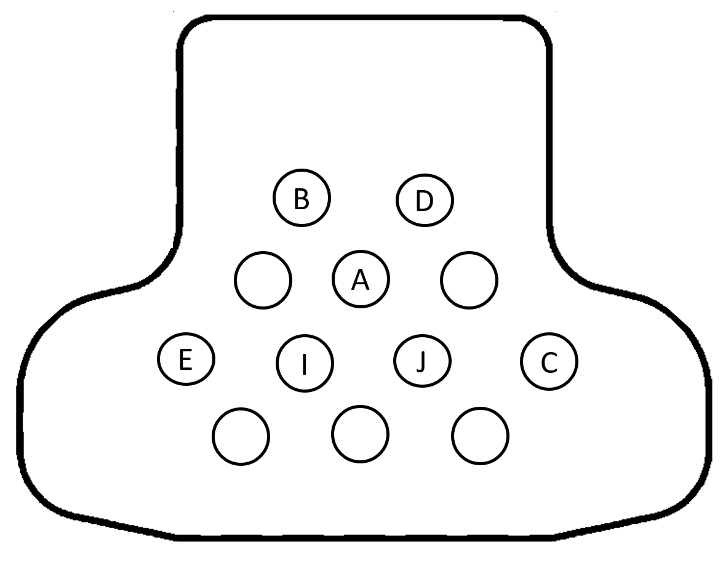
Figure F.1. Planar Front Panel Impact Locations
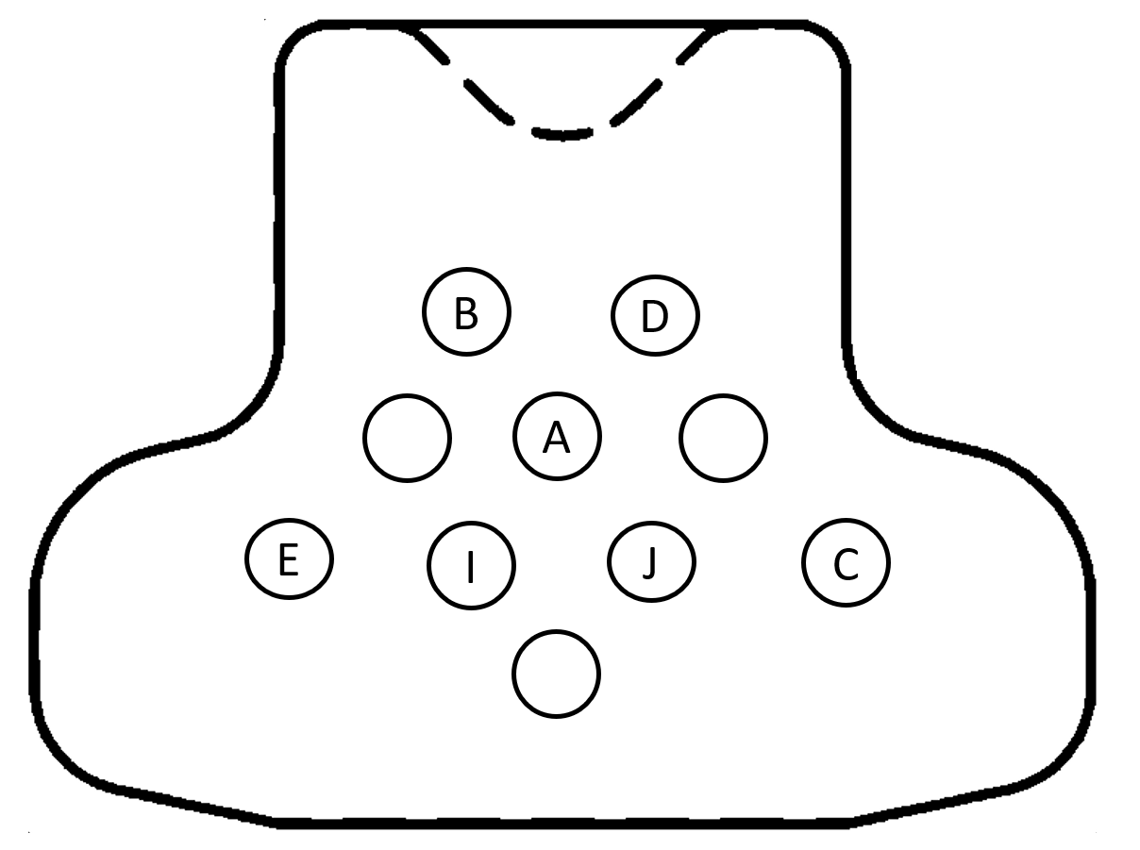

Annex G (Mandatory): Soft Armor Designed for Female Wearers

Nonplanar armor designed for female wearers is tested using the same apparatus as used for planar test items; however, appliques are used to support the armor during testing. For information on creating appliques for use in testing nonplanar armor designed for females, please refer to ASTM E3086-17, Standard Practice for Creating Appliques for Use in Testing of Nonplanar Soft Body Armor Designed for Females.
Appliques shall be created in accordance with ASTM E3086-17 section 5 through section 8.1 inclusive. In lieu of sections 8.2 & 8.3, place the appliques on the foam backing material, aligned horizontally with the apex of each bust positioned to reflect the distance created between bust apexes on the wear face of the armor being tested. On completion of the testing, the top layer of neoprene must be removed and discarded.
Figures G.1 – G.6 show the impact locations for each test item.
Figure G.1. Impact Locations for Panel 1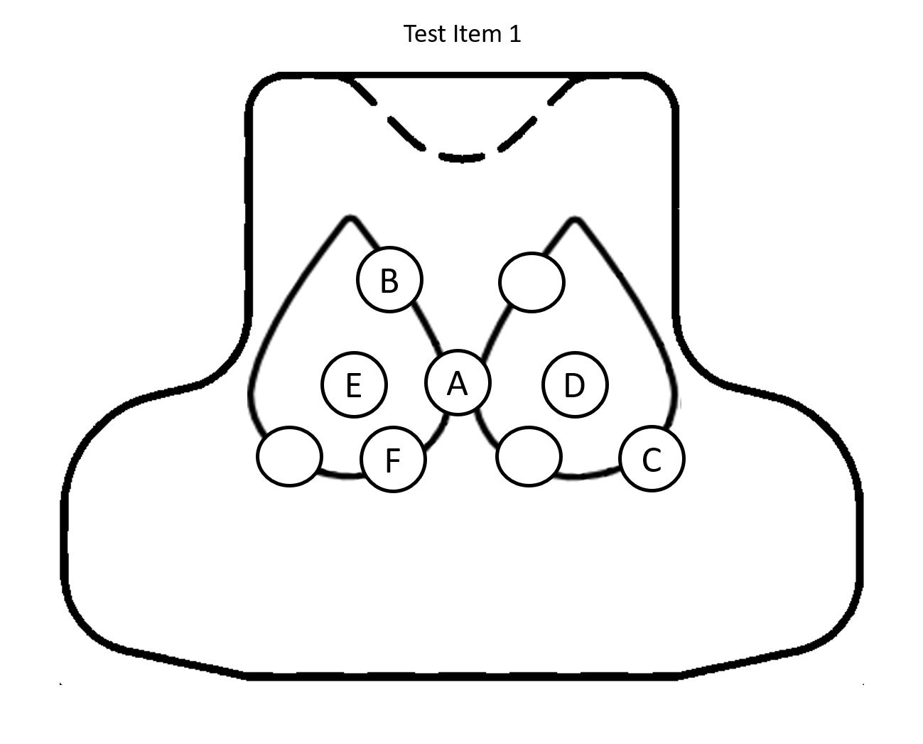

Figure G.2. Impact Locations for Panel 2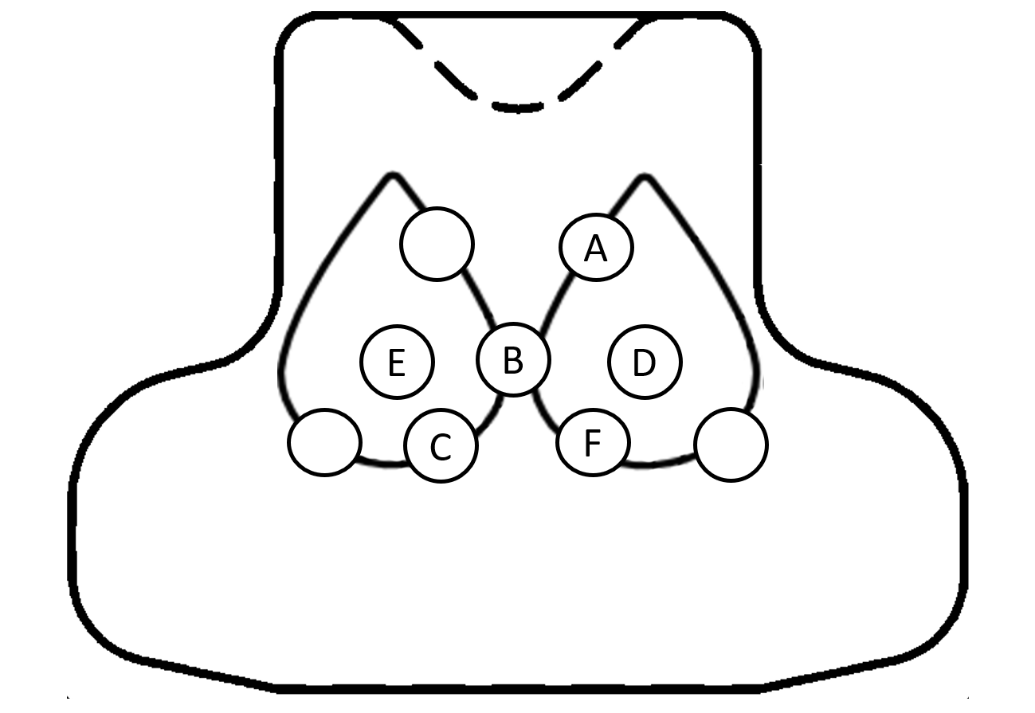
Figure G.3. Impact Locations for Panel 3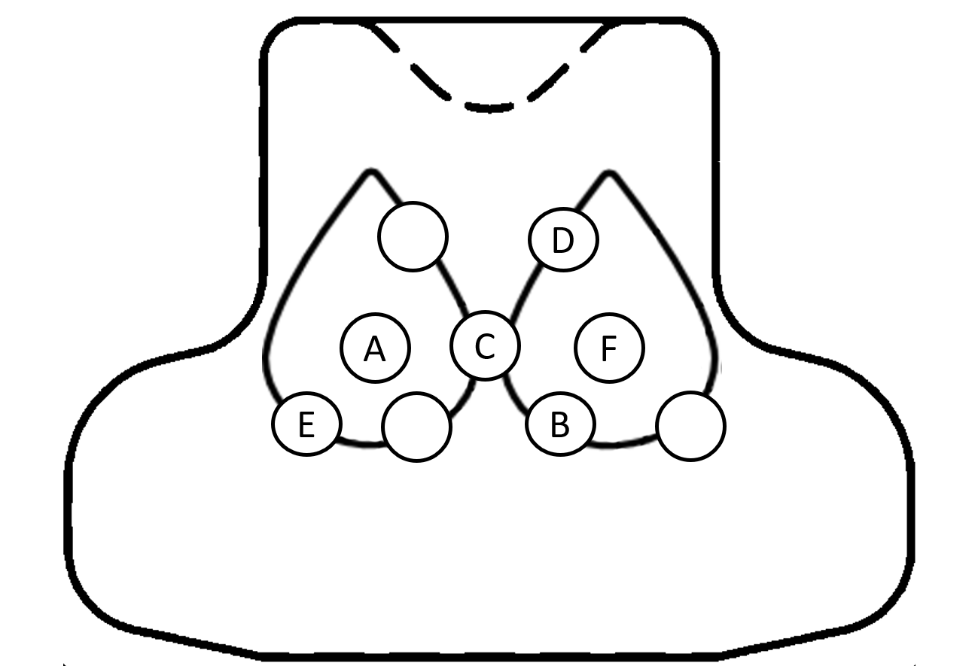
Figure G.4. Impact Locations for Panel 4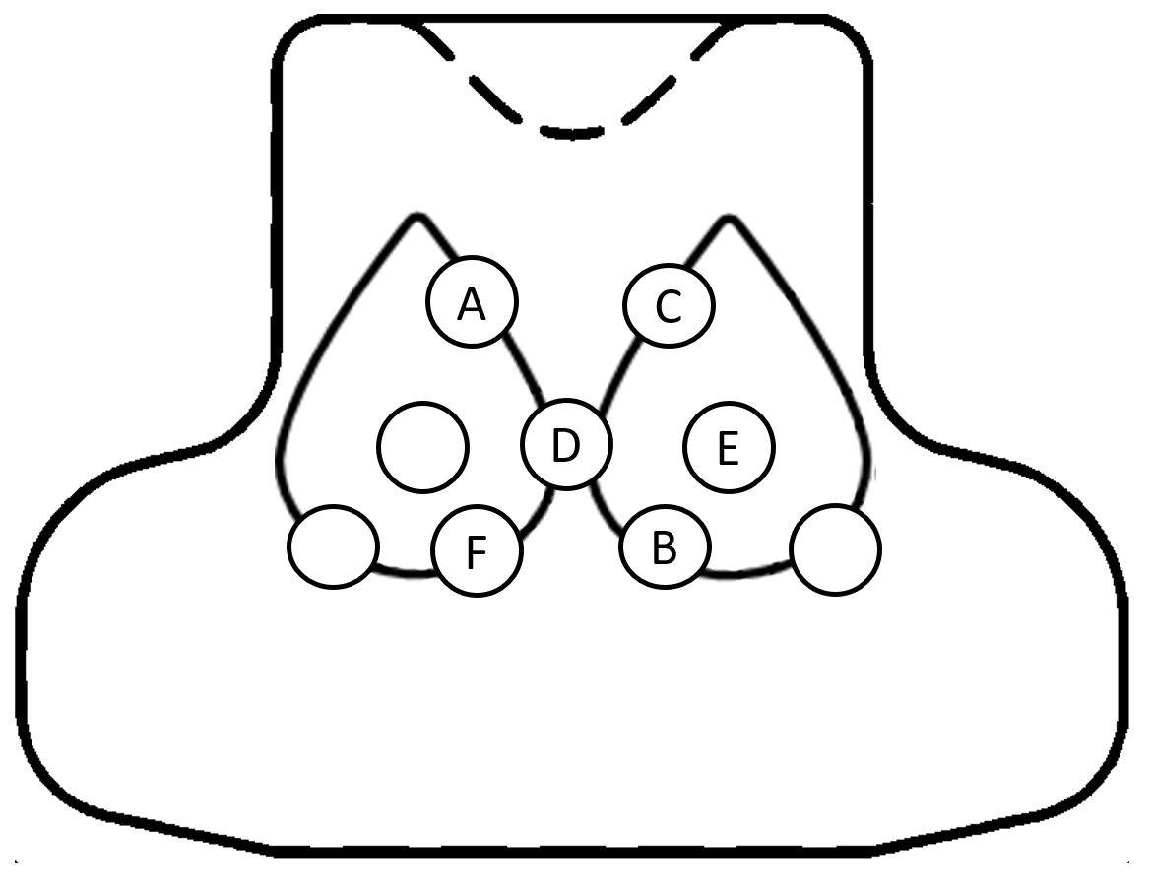
Figure G.5. Impact Locations for Panel 5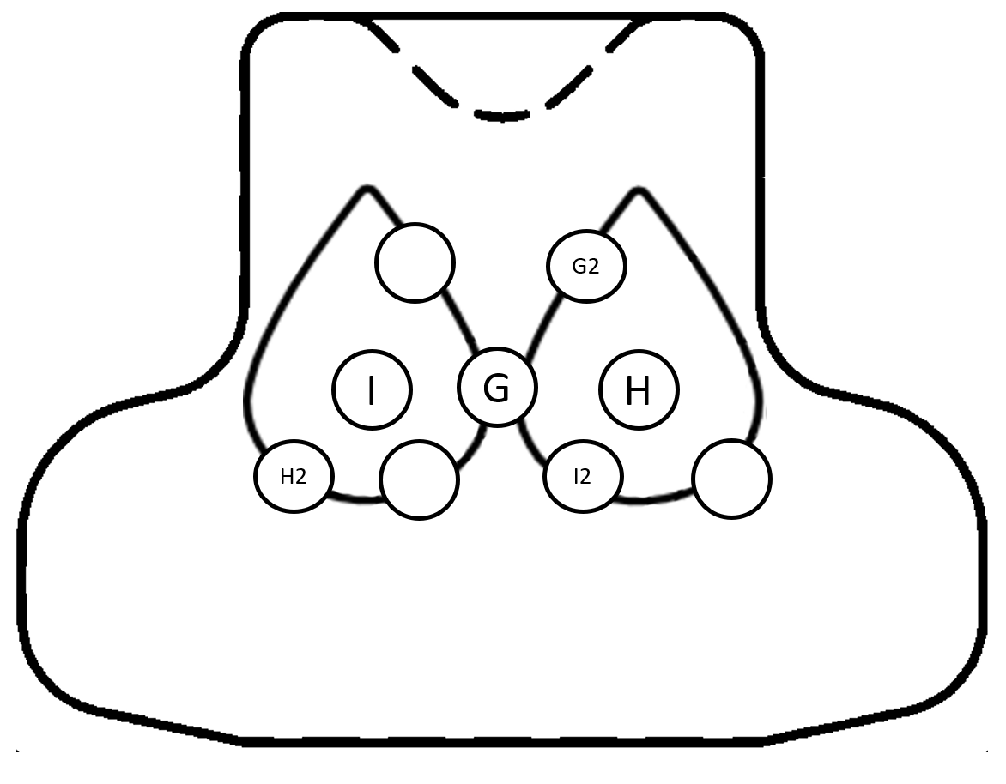

Figure G.6. Impact Locations for Panel 6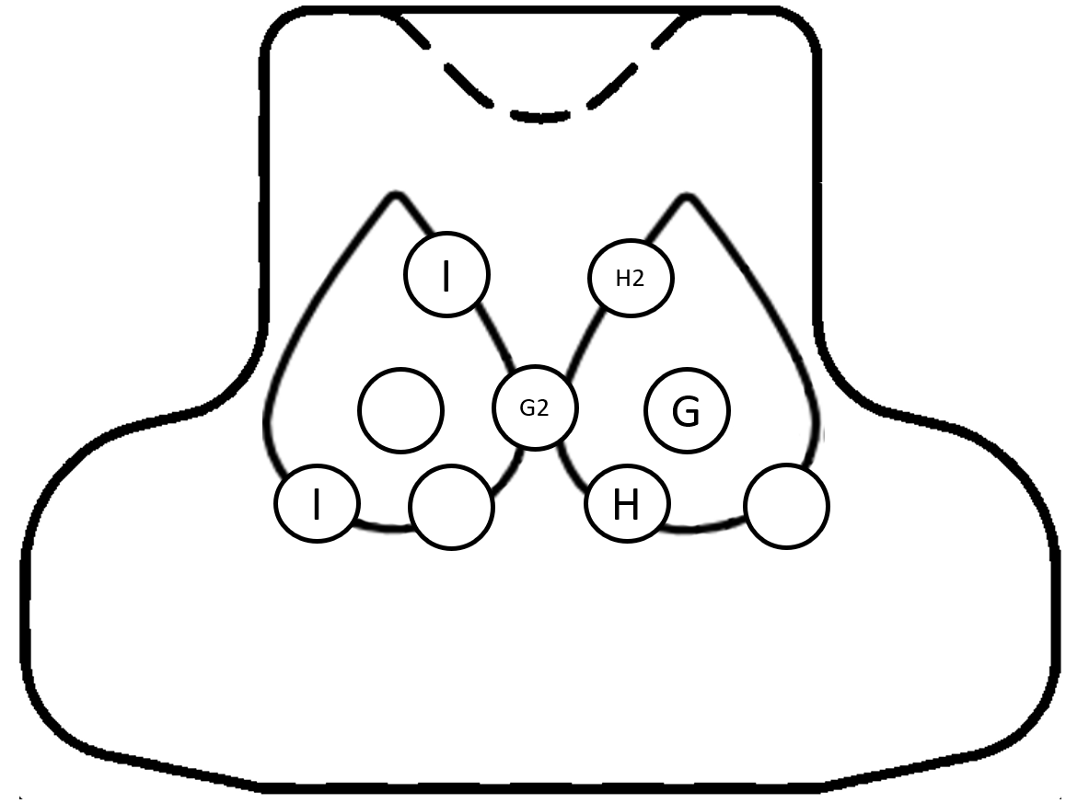

Annex H (Mandatory): Conversion Tables for Penetration Depth
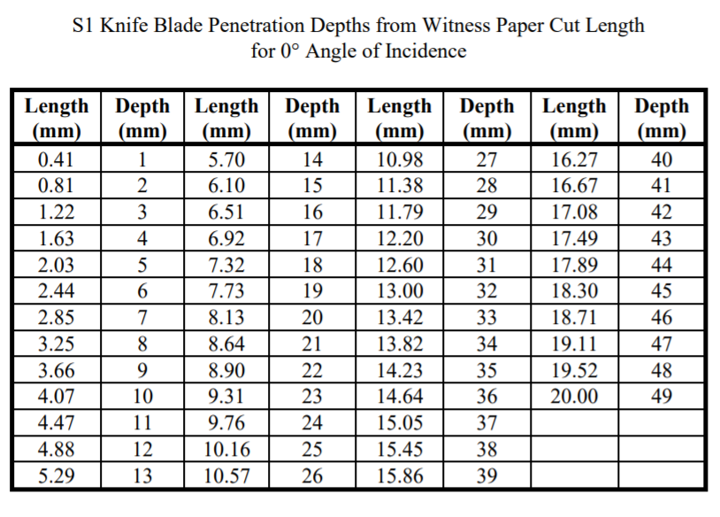
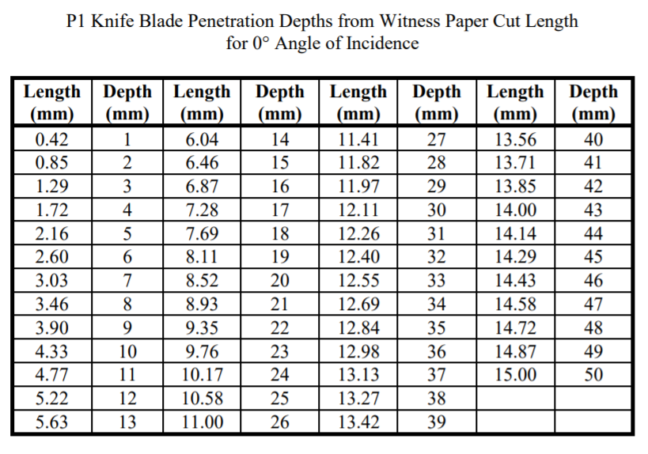

NIJ Standard 0115.00, Stab Resistance of Personal Body Armor, National Institute of Justice, U.S. Department of Justice, Washington, DC, September 2000, https://www.ncjrs.gov/pdffiles1/nij/183652.pdf.
Reprinted, with permission, from E3005-15 Standard Terminology for Body Armor, copyright ASTM International, 100 Barr Harbor Dr., West Conshohocken, PA 19428. A copy of the complete standard may be obtained from ASTM, www.astm.org."
The impact energy level for the commercial test threat was derived from An Assessment of Human Performance in Stabbing 1999. Royal Military College of Science. 24 J corresponds to the 85th percentile of the population that was studied. The 36 J overtest energy corresponds to 1.5 times this value and is intended to ensure that the armor material performs in a linear fashion and does not suffer catastrophic failure at, or near, the primary energy level.
The impact energy level for the improvised test threat was derived from An Assessment of Human Performance in Stabbing 1999. Royal Military College of Science. 43 J corresponds to the 96th percentile of the population that was studied. The 65 J overtest corresponds to 1.5 times this value.

