**Draft**

**NIJ Standard 0101.07**

***Ballistic Resistance of Body Armor***

**National Institute of Justice**

**January 2018**

**Introduction**

This draft document specifies minimum performance requirements and test methods for the ballistic resistance of body armor used by U.S. law enforcement that is intended to protect the torso against handgun and rifle ammunition. It is a proposed revision of NIJ Standard 0101.06, *Ballistic Resistance of Body Armor*, published in 2008.[1] The final version of this document is anticipated to be published in late 2018 as NIJ Standard 0101.07. Its primary purpose will be for use by the NIJ Compliance Testing Program (CTP) for testing and evaluation of ballistic-resistant body armor for certification by NIJ. It will be used by both ballistics laboratories that test body armor and body armor manufacturers participating in the NIJ CTP. This standard will be included in the Personal Body Armor scope of accreditation used by the National Voluntary Laboratory Accreditation Program (NVLAP) to accredit ballistics laboratories.

There are some departures in format from NIJ Standard 0101.06. First, standards describing various test methods and practices are incorporated by reference into this document, including those for soft armor designed for female wearers. NIJ, the U.S. Army, the National Institute of Standards and Technology (NIST), and others have been cooperating to harmonize laboratory test procedures and practices in ASTM Subcommittee E54.04 on Personal Protective Equipment within Committee E54 on Homeland Security Applications.[2] Unlike the current and previous versions of the NIJ standard which have been comprehensive, standalone documents, revision 0101.07 will incorporate by reference a suite of standardized test methods and practices developed in ASTM E54.04. Incorporation of relevant ASTM standards by reference into NIJ standards and U.S. Army requirements and testing documents, for example, affords the opportunity to harmonize laboratory test procedures and practices for both law enforcement and military ballistic-resistant armor and other ballistic-resistant equipment while providing those end user communities ultimate control over product specifications, such as the specific threats against which their equipment must protect.

Second, the ballistic test threats have been removed to their own standalone specifications document that defines ballistic threats identified by U.S. law enforcement as representative of prevalent threats in the United States. Currently in draft form, this document specifies the threat levels and associated ammunition intended for use with voluntary NIJ Standards that specify a minimum performance requirement for equipment intended to protect U.S. law enforcement against handgun and rifle ammunition. A standalone threats specification may also enable testing of a variety of ballistic-resistant equipment, not just ballistic-resistant body armor, against contemporary U.S. law enforcement threats.

Third, threat level nomenclature has been revised to be more descriptive of threats and to reduce confusion among law enforcement end users of body armor. Level II and level IIIA have been replaced with “HG1” and “HG2,” respectively, to represent handgun (HG) threats. Level III and level IV have been revised to three levels representing rifle (RF) threats—“RF1,” “RF2,” and “RF3”—with RF1 and RF3 replacing level III and level IV, respectively. RF2 is a new intermediate threat level introduced in this draft version of NIJ Standard 0101.07.

This document uses the following in accordance with international standards:

* “shall” indicates a requirement;
* “should” indicates a recommendation;
* “may” indicates a permission;
* “can” indicates a possibility or a capability.

Please send all written comments on this draft document to Mark Greene, Policy and Standards Division Director, Office of Science and Technology, National Institute of Justice in electronic format by email at [mark.greene2@usdoj.gov](mailto:mark.greene2@usdoj.gov).

Please send all other written comments and suggestions to the Director, National Institute of Justice, Office of Justice Programs, U.S. Department of Justice, 810 7th Street NW, Washington, DC 20531.

Nothing in this document is intended to create any legal or procedural rights enforceable against the United States. Moreover, nothing in this document creates any obligation for any individual or organization to follow or adopt this voluntary standard nor does it create any obligation for manufacturers, suppliers, law enforcement agencies, or others to follow or adopt voluntary NIJ equipment standards.

**Table of Contents**

1. Scope 5

2. References 5

3. Terms and Definitions 6

4. Test Threats, Equipment, and Materials 10

5. Armor Protection Levels 11

6. Armor Ballistic Performance Requirements 11

7. Soft Armor Test Items: Requirements and Utilization 12

8. Soft Armor: Procedure for Visual Examination of Labeling, Workmanship, and Construction 15

9. Soft Armor: Ballistic Test Requirements and Procedures 15

10. Hard Armor Test Items: Requirements and Utilization 19

11. Hard Armor: Procedure for Visual Examination of Labeling, Workmanship, and Construction 23

12. Hard Armor: Ballistic Test Requirements and Procedures 23

13. Test Report 26

Annex A (Mandatory): Procedure for Soft Armor Conditioning by Tumbling 27

Annex B (Mandatory): Equipment and Procedure for Conditioning by Submersion 32

Annex C (Mandatory): Hard Armor Conditioning Procedure 33

Annex D. (Mandatory) BFD Measurements 34

Annex E (Mandatory): Analysis of Ballistic Limit Data 36

Annex F (Mandatory): Test Item Size Templates 37

Annex G. (Mandatory) Test Item Label Inspection and Durability Test 43

Annex H. (Mandatory) Soft Armor Designed for Female Wearers 45

Annex I. Ballistic Limit Test Method 50

1. **Scope**
   1. This standard specifies minimum performance requirements and test methods for the ballistic resistance of body armor used by U.S. law enforcement intended to protect the torso against handgun and rifle ammunition.
      1. The test methods within this standard were developed and validated for broadly available armor designs. Some armor designs may require additional or different testing than that specified in this standard.
   2. Body armor covered by this standard is classified into five protection levels: NIJ HG1, NIJ HG2, NIJ RF1, NIJ RF2, and NIJ RF3.
   3. This standard also addresses hard armors that are intended to provide the stated level of ballistic protection only when paired with a specific model of soft armor. This type of armor is referred to as *in conjunction with* (ICW) armor, and addressed within protection levels NIJ RF1, NIJ RF2, and NIJ RF3.
   4. This standard is applicable for certification testing or research and development testing.
   5. This standard incorporates other standards from ANSI/SAAMI, ASTM International, and ISO/IEC.
   6. Values stated in either the International System of Units (metric) or U.S. Customary units (inch-pound) are to be regarded separately as standard. The values stated in each system may not be exact equivalents. Both units are referenced to facilitate acquisition of materials internationally and minimize fabrication costs. Tests conducted using either system maintain repeatability and reproducibility of the test method and results are comparable.
   7. **The tests required by this standard have inherent hazards. It is the responsibility of the user of this standard to establish appropriate safety and health practices and determine the applicability of regulatory limitations.**
2. **References**

The following references form a basis and provide support for the requirements and procedures described in this standard. For dated references, only the edition cited applies. For undated references, the latest edition of the referenced document applies, including any amendments.

* ANSI/SAAMI. *Glossary of Industry Terms.* Newtown, CT: Sporting Arms and Ammunition Manufacturers’ Institute (SAAMI).
* ASTM E3004-15e1. *Standard Specification for Preparation and Verification of Clay Blocks Used in Ballistic-resistance Testing of Torso Body Armor.* West Conshohocken: PA: ASTM International.
* ASTM E3005-15. *Standard Terminology for Body Armor and Related Items.* West Conshohocken: PA: ASTM International.
* ASTM E3062-15e1. *Standard Specification for Ballistic Test Range Configuration for Small Arms and Fragmentation Testing of Ballistic-resistant Items.* West Conshohocken: PA: ASTM International.
* ASTM E3068-17. *Standard Test Method for Contact Measurement of Backface Deformation in Clay Backing During Body Armor Testing*. West Conshohocken: PA: ASTM International.
* ASTM E3078-17. *Standard Practice for Conditioning of Hard Armor Test Items.* West Conshohocken: PA: ASTM International.
* ASTM E3086-17. *Standard Practice for Creating Appliques for Use in Testing of Nonplanar Soft Body Armor Designed for Females.* West Conshohocken: PA: ASTM International.
* ASTM E3107-17a. *Standard Test Method for Resistance to Penetration and Backface Deformation for Ballistic-resistant Torso Body Armor and Shoot Packs.* West Conshohocken: PA: ASTM International.
* ASTM WK52176. *Standard Test Method for Collection of Vx Ballistic Limit Data for Ballistic-resistant Torso Body Armor and Shoot Packs.* West Conshohocken: PA: ASTM International.
* ISO/IEC 17025. *General requirements for the competence of testing and calibration laboratories*. West Conshohocken: PA: ASTM International.
* NIJ Standard-1001.00. *Criminal Justice Restraints Standard*. Washington, DC: National Institute of Justice, U.S. Department of Justice.
* *Threat Levels and Associated Ammunition to Test Equipment Intended to Protect U.S. Law Enforcement Against Handguns and Rifles*. Washington, DC: National Institute of Justice, U.S. Department of Justice.

1. **Terms and Definitions**
   1. The following terms from ASTM E3005 are applicable[3]:

3.1.1. *accessory*, n - a body armor component that is detachable or removable from the body armor and is intended to provide extended area of coverage protection against threats that may include ballistic threats, stabbing, fragmentation, blunt impact, or a combination of threats.

Discussion - Accessories are typically attachments to tactical body armor providing protection to areas not covered by the vest, such as the shoulders, upper arms, neck, sides, pelvis, and groin. See *tactical body armor;* see *vest.*

3.1.2. *ammunition*, n - one or more loaded cartridges consisting of case, primer, propellant, and one or more projectiles.

3.1.3. *angle of incidence*, n - the angle between the test threat line of aim and the line normal to a reference plane based on the front surface of the backing assembly. (Adapted from NIJ 0101.06). See also *obliquity.*

Discussion - Some standards have used the terms *angle of incidence* and *obliquity* as synonyms, but in this standard, they are defined differently.

3.1.4. *armor carrier*, n - See *carrier.*

3.1.5. *armor panel*, n - a component of soft body armor consisting of protective materials, typically enclosed in a panel cover. *See* ballistic panel, blunt impact panel, stab panel. See also *panel cover.*

3.1.6. *backface deformation*, n - the indentation in the backing material caused by a projectile impact on the test item during testing. Synonymous with *backface signature.*

3.1.7. *backing assembly*, n - a backing fixture filled with backing material. For example, a clay block is a type of a backing assembly.

3.1.8. *ballistic panel*, n - a type of armor panel intended to provide ballistic resistance.

3.1.9. *ballistic resistance*, n - a characteristic of protective equipment or materials describing their ability to provide protection from projectiles.

3.1.10. *body armor*, n - an item of personal protective equipment intended to protect the wearer from threats that may include ballistic threats, stabbing, fragmentation, or blunt impact.

Discussion - Law enforcement and corrections officers typically refer to body armor as a vest. See *vest.*

3.1.11. *bullet*, n - a projectile fired from a firearm or testing apparatus.

Discussion - The SAAMI definition considers bullets to be projectiles fired from rifled barrels, which differentiates bullets from shot, slugs, fragment simulators, and other projectiles.

3.1.12. *carrier*, n - a garment whose primary purpose is to retain the armor panel(s) or plate(s) and provide a means of supporting and securing the armor panel(s) or plate(s) to the wearer.

3.1.13. *conditioning*, n - a process that exposes an item, prior to testing, to a specified controlled environment or physical stresses, or both.

3.1.14. *fair hit*, n - a test threat impact (on a test item) that meets all specified requirements in a particular test method.

3.1.15. *hard armor*, n - an item of personal protective equipment that is constructed of rigid materials and is intended to protect the wearer from threats that may include ballistic threats, stabbing, fragmentation, or blunt impact, or combinations thereof; synonymous with *hard armor plate* and *plate.*

3.1.16. *in conjunction with armor*, n - soft or hard armor that is designed to provide a specific level of ballistic protection only when layered with a specified model(s) of body armor.

3.1.17. *insert*, n - a removable unit of protective material (soft armor or hard armor) intended to be placed into a special pocket on a carrier to enhance protection in a localized area.

3.1.18. *nonplanar*, adj - having features that would prevent the test item from making full contact with a flat surface; typically used to describe curved plates and armor designed for female wearers.

3.1.19. *obliquity*, n - the angle between the test threat line of aim and the line normal to a reference plane based on features of the test item at the point of aim. (Adapted from MIL-STD- 3027.) See also *angle of incidence.*

Discussion - Some standards have used the terms angle of incidence and obliquity as synonyms, but in this standard, they are defined differently.

3.1.20. *over velocity*, n - velocity that is greater than the upper limit of a specified range.

3.1.21. *panel cover*, n - a covering, typically nonremovable, that encloses the protective materials and protects them from environmental factors, such as moisture, ultraviolet light, debris, and dust.

3.1.22. *partial penetration*, n - any result of a test threat impact that is not a complete penetration; synonymous with *stop.*

3.1.23. *shot-to-edge distance*, n - the distance from the center of the projectile impact to the nearest test item edge.

3.1.24. *shot-to-shot distance*, n - the distance from the center of the projectile impact to the center of any other projectile impact on the test item.

3.1.25. *soft armor*, n - an item of personal protective equipment constructed of pliable/flexible materials intended to protect the wearer from threats that may include ballistic threats, stabbing, fragmentation, or blunt impact.

3.1.26. *stop*, n - See *partial penetration.*

3.1.27. *strike face*, n - the surface of an armor panel or plate intended to face the incoming threat.

3.1.28. *test item*, n - a single article intended for testing.

Discussion - Examples may include one panel, one plate, or one shoot pack.

3.1.29. *test threat*, n - the projectile, edged blade, spike, or other object that is used in laboratory testing to impact the test item at a specific velocity or energy to assess performance of body armor.

3.1.30. *trauma pack*, n - a soft insert intended to reduce backface deformation due to a ballistic impact.

3.1.31. *trauma plate*, n - a hard insert intended to reduce backface deformation due to a ballistic impact.

3.1.32. *under velocity*, n - velocity that is less than the lower limit of a specified range.

3.1.33. *unfair hit*, n - a test threat impact that does not meet the specified requirements in a particular test method for impact location and spacing, velocity, obliquity, or yaw.

3.1.34. *Vx*, n - the velocity at which x % of the impacts by a specified test threat are expected to completely penetrate nominally identical test items when tested according to a specified test method.

3.1.35. *V0*, n - the maximum velocity at which 0 % of the impacts by a specified test threat are expected to completely penetrate nominally identical test items when tested according to a specified test method.

3.1.36. *V05*, n - the velocity at which 5 % of the impacts by a specified test threat are expected to completely penetrate nominally identical test items when tested according to a specified test method.

3.1.37. *V50*, n - the velocity at which 50 % of the impacts by a specified test threat are expected to completely penetrate nominally identical test items when tested according to a specified test method.

3.1.38. *wear face*, n - the surface of an armor panel or plate that is intended to be placed against or proximal to the wearer’s body.

3.1.39. *yaw*, n - the angular deviation between the projectile’s axis of symmetry and its line of travel.

* 1. *applique,* n – a three-dimensional item molded from backing material that is shaped and sized for testing or conditioning a nonplanar test item. (ASTM Practice 3086)
  2. *armor model,* n – Synonymous with *model.*
  3. *clay block,* n – a type of backing assembly in which the backing material is Roma Plastilina #1® modeling clay. (ASTM Specification E3004)
  4. *complete penetration,* n *–* the result of a test threat impact if one or more of the following conditions are met:

1. any portion of a test threat or a fragment of a test threat passes through the wear face of the test item.
2. the test threat is visible from the wear face of the test item.
3. a hole is created through the test item by the test threat.
4. for soft armor, any portion of a test threat or a fragment of a test threat is embedded in or passes into the backing material.
5. for hard armor, any portion of a test threat, a fragment of a test threat, or a fragment of the test item is embedded in or passes into the backing material.
   1. *controlled ambient,* n – conditions with temperature of 20 °C ± 5.5 °C (68 °F ± 10 °F) and 50% ± 20% relative humidity (RH). Within this standard, this definition applies to any direct or indirect reference to controlled ambient. (ASTM Practice E3078)
   2. *model,* n *-* the manufacturer’s design, with unique specifications and characteristics, of a particular item. (NIJ Standard-1001.00)
   3. *supplier,* n *–* the party that is responsible for ensuring that products meet and, if applicable, continue to meet, the requirements on which the certification is based (NIJ Standard-1001.00).
   4. *Test series,* n – the set of all shots necessary to obtain the required number of fair hits on a single test item or the set of all shots necessary over multiple test items to generate the required data. (ASTM Test Method WK52176)
6. **Test Threats, Equipment, and Materials**
   1. Test threats and test barrels
      1. The test threats and test barrels shall be as specified in *Threat Levels and Associated Ammunition to Test Equipment Intended to Protect U.S. Law Enforcement Against Handguns and Rifles*.
   2. Test range
      1. The test range shall meet the requirements of ASTM Specification E3062 (including the temperature and humidity requirements).
      2. No firearms shall be used for testing.
   3. Conditioning equipment
      1. Equipment for soft armor test item conditioning by tumbling shall be as described in Annex A, *Procedure for Soft Armor Conditioning by Tumbling*.
      2. Equipment for test item conditioning by submersion shall be as described in Annex B, *Equipment and Procedure for Conditioning by Submersion*.
      3. Equipment for hard armor test item conditioning shall be as described in Annex C, *Hard Armor Conditioning Procedure*.
   4. Backing assembly
      1. The backing assembly shall meet the requirements of ASTM Specification E3004.
7. **Armor Protection Levels**
   1. The supplier shall declare the intended protection level for an armor model being submitted for testing to this standard.
   2. Soft armorprotection levels
      1. The protection levels for soft armor are NIJ HG1 and NIJ HG2.
   3. Hard armor protection levels
      1. The protection levels for hard armor are NIJ RF1, NIJ RF2, and NIJ RF3.
8. **Armor Ballistic Performance Requirements**
   1. The ballistic performance requirements are applicable to soft armor and hard armor, including ICW armor.
   2. Perforation-backface deformation (P-BFD) performance requirements
      1. Each test item shall be tested as specified in the appropriate section of this standard and shall withstand the required number of fair hits and shall experience no complete penetrations. Any complete penetration by a fair hit constitutes a failure.
      2. BFD measurements shall be taken as specified in the appropriate section of this standard for test items conditioned by submersion or conditioned by the hard armor conditioning procedure.
         1. No BFD measurement due to a fair hit shall be greater than 50.0 mm.
         2. The test shall be considered a pass if either of the requirements below is met:
9. Every BFD measurement due to a fair hit shall be ≤ 44.0 mm

or

1. When any BFD measurement exceeds 44.0 mm, then ${BFD}_{ave}+k_{1}s ≤44.0 mm$.

BFDave is the average of all recorded fair hit BFD measurements rounded to the nearest 0.1 mm for test items of that particular model, size, conditioning status, and test threat; *s* is the sample standard deviation. See Annex D for explanations and calculations for BFDave.

* + 1. BFD measurements shall be taken as specified in the appropriate section of this standard for test items conditioned by tumbling. All BFD measurements shall be recorded, but there is no pass/fail BFD measurement requirement for test items conditioned by tumbling.
  1. Ballistic limit performance requirements
     1. Each test item shall be tested as specified in the appropriate section of this standard and shall withstand the required number of fair hits and shall experience no complete penetrations below a velocity that is the reference velocity plus 30 ft/s (9.1 m/s).
     2. The ballistic limit data shall be analyzed as described in Annex E and the estimated probability of complete penetration at the reference velocity shall be less than 5%.

1. **Soft Armor Test Items: Requirements and Utilization**
   1. Soft armor test item quantity and size requirements
      1. A total of 56 test items are required.
      2. The test items shall be provided by the supplier in two sizes, a larger size and a smaller size, using the size templates provided in Annex F, *Test Item Size Templates*.

Note: The supplier selects the templates to be used based on the range of sizes over which the armor model will be produced, noting that the National Institute of Justice (NIJ) Compliance Testing Program (CTP) places limitations on production sizes if templates NIJ-C-1 and NIJ-C-5 are not used.

* + - 1. All test items shall be sized to meet the appropriate size templates. Each template provides an allowable tolerance on the size through upper and lower boundaries. Each template also depicts a neck scoop.
      2. A total of 50% of each size of test items shall have a neck scoop.
      3. All test items of a specific template size shall be identically sized.
  1. Soft armor test item workmanship and construction requirements
     1. Each test item shall be free from evidence of inferior workmanship, such as wrinkles, blisters, cracks or fabric tears, fraying, crazing, or chipped or sharp corners and edges. Stitching shall be straight and secure.
     2. There shall be no variations in construction details between individual test items or between any test item and the supplier’s documentation.
     3. All test items shall be identical in appearance, materials, and manner of construction, including stitch size and location, as appropriate for the sizes submitted.
  2. Soft armor test item label requirements
     1. The label shall be permanently attached to the panel cover of the test item.
     2. The label text shall be in a readable typeface and font size, and the content shall be as specified in Annex G.
     3. A label affixed to one spare test item label shall be tested. It shall remain legible and adhered to the test item following completion of the label durability test specified in Annex G.
        1. The label durability test shall not be performed on a test item that will subsequently undergo ballistic testing, unless such testing is approved by the supplier.
     4. The labels for every test item conditioned by tumbling shall be evaluated following tumbling, and each label shall remain legible and adhered to the test item.
     5. Failure of a label to meet the above requirements is not considered a failure of the armor model. In the event of a label failing to meet these requirements, a case-by-case evaluation will be made by the NIJ CTP.
  3. Soft armor test item utilization
     1. A summary of how the test items of each template size shall be distributed for conditioning and testing is shown in Table 1.

**Table 1. Summary of Test Item Sizes, Quantity, Conditioning, and Testing**

|  |  |  |  |  |  |
| --- | --- | --- | --- | --- | --- |
| **Template size** | **# of Test items** | **Conditioning** | | **Number of Test Items for Each Test** | |
| Larger | 40 | Submersion per Annex B | 8 | P-BFD | 8 |
| Tumbling per Annex A | 10 | P-BFD | 4 |
| Ballistic Limit | 4 |
| Spares | 2 |
| Conditioning at controlled ambient for at least 24 hours | 22 | Ballistic Limit | 20 |
| Spares | 2 |
| Smaller | 16 | Submersion per Annex B | 8 | P-BFD | 8 |
| Tumbling per Annex A | 6 | P-BFD | 4 |
| Spares | 2 |
| Conditioning at controlled ambient for at least 24 hours | 2 | Spares | 2 |

* + 1. Figure 1 provides further details regarding the distribution and utilization of test items.

**Figure 1. NIJ HG1 and NIJ HG2: Distribution and utilization of soft armor test items**

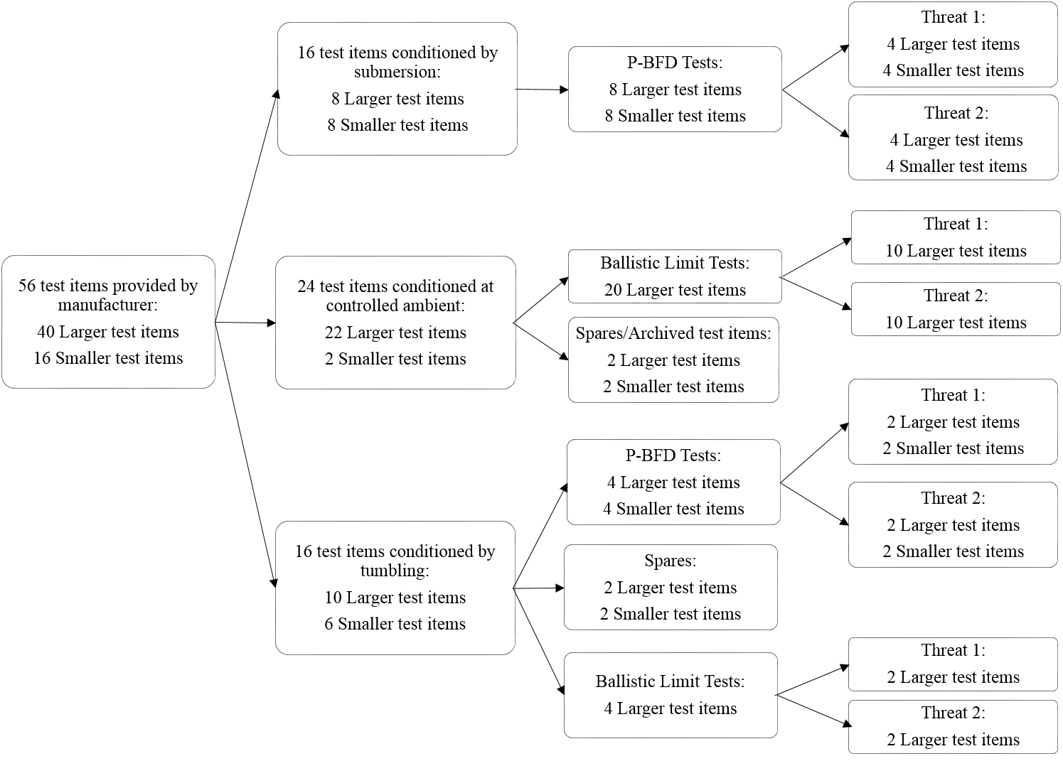

* 1. Soft armor test item carrier requirements
     1. Test items shall be submitted with either:
     2. Cotton or poly-cotton carriers having an areal density of not more than 250 g/m2. The test item carriers shall not have strapping, strapping attachment points, pockets for inserts, or any accessory mounting points.
     3. Carriers constructed of materials other than cotton or poly-cotton, having an areal density of more than 250 g/m2, or having strapping, strapping attachment points, pockets for inserts, or any accessory mounting points. If this option is chosen, this carrier becomes part of the unique design and construction of the armor model and cannot be changed in production.
        1. Carriers for test items that will undergo conditioning by tumbling shall not have strapping, strapping attachment points, or any accessory mounting points. For test items to be tested using their own strapping for mounting and support, separate carriers may be provided for conditioning by tumbling and for ballistic testing.
     4. For test items submitted as in conjunction with NIJ RF1, NIJ RF2, or NIJ RF3 hard armor, the carriers shall have the necessary pockets for the hard armor.

1. **Soft Armor: Procedure for Visual Examination of Labeling, Workmanship, and Construction**
   1. Verify the group of test items for correct quantity and sizes.
   2. Examine the group of test items for variations in appearance, materials, and manner of construction.
   3. Examine each test item exterior to determine whether workmanship requirements are met.
   4. Examine the label of a single spare test item to determine whether requirements are met.
   5. Prior to conditioning by submersion or tumbling, photograph at least one test item of each size.
   6. Following conditioning by tumbling, evaluate the label of each test item as specified in Annex G to determine if the label remains legible and adhered to the test item.
   7. Following ballistic testing, examine the workmanship of each test item as described below to determine whether the requirements are met:
      1. Horizontally slit only the test item panel cover with a razor blade near the bottom of the test item and remove the ballistic panel from its cover. Document the construction of the ballistic panel (e.g., layer count, material description, stitching).
   8. Document the relevant details for each test item.
2. **Soft Armor: Ballistic Test Requirements and Procedures**
   1. Soft armor shots required
      1. For P-BFD testing of test items conditioned by submersion, a minimum of 24 fair hits per test threat for each size test item are required for testing NIJ HG1 or NIJ HG2.
         1. Six fair hits are required per test item.
      2. For Ballistic Limit testing of test items conditioned at controlled ambient, 120 fair hits per test threat are required for testing NIJ HG1 or NIJ HG2.
         1. A minimum of 12 fair hits are required per test item (excluding spares that may be used).
      3. For P-BFD testing of test items conditioned by tumbling followed by controlled ambient conditioning, a minimum of 12 fair hits per test threat for each size test item are required for testing NIJ HG1 or NIJ HG2.
         1. Six fair hits are required per test item (excluding spares that may be used).
      4. For Ballistic Limit testing of test items conditioned by tumbling followed by controlled ambient conditioning, 24 fair hits per test threat are required for testing NIJ HG1 or NIJ HG2.
         1. A minimum of 12 Fair hits are required per test item.
   2. Soft armor P-BFD test requirements
      1. The fair hit requirements shall be as specified in ASTM E3107-17a, with the following exceptions:
         1. The minimum shot-to-edge distance may be decreased at the request of the supplier.
         2. When two test threats are specified, the minimum shot-to-edge distance for the greater mass test threat shall not be greater than 3.0 in (76 mm).

Note: For the lesser mass test threat, the minimum shot-to-edge distance shall not be greater than 2.0 in (51 mm).

* + - 1. When the measured velocity is not within ±30 ft/s (± 9.1 m/s) of the reference velocity, but all other requirements are met, the shot shall be considered a fair hit if either:

1. the velocity is less than the minimum allowed and the shot results in a complete penetration, a BFD measurement > 44.0 mm, or both

or

1. the velocity is greater than the maximum allowed and results in a partial penetration and BFD measurement ≤ 44.0 mm.
   * 1. When a shot is determined to be an unfair hit, additional attempts shall be made to obtain a fair hit on the same test item.
        1. The number of shots taken on a single test item shall not exceed eight. If this requirement cannot be met, the test series shall be repeated on a spare test item of the same size. This occurrence shall be documented.
     2. The duration of the ballistic testing of each test item shall be no more than 30 minutes from the time the first shot is fired until the last shot is fired. If the time limit is exceeded, any preceding shots on that test item shall be included in the data set, and the test series shall be repeated on a spare test item. This occurrence shall be documented.
     3. Ballistic testing of each test item conditioned by submersion shall begin promptly following the conditioning as described in Annex B (including the 10-minute drying time). All ballistic testing shall be completed within 40 minutes of removal from the water bath as described in Annex B. If the time limit is exceeded, any preceding shots on that test item shall be included in the data set, and the test series shall be repeated on a spare test item. This occurrence shall be documented.
     4. BFD measurements shall be taken on shots 1, 2, and 3 for each test item and shall be performed as specified in ASTM E3068. For nonplanar test items, additional guidance in Annex H shall be applied when making BFD measurements.
     5. The angle of incidence for each shot shall be as specified in ASTM E3107-17a.
   1. Soft armor P-BFD test procedure for planar test items (other than those designed for female wearers)
      1. For test items to be conditioned at controlled ambient or by submersion, mark shot locations on the test items per ASTM Standard E3107-17a, Section 11.
         1. For test items having construction and material thickness variations, the locations of shots 4, 5, and 6 shall be adjusted to exploit the weakest portion of the test item.
      2. Condition the test items as specified in Section 7.4 of this standard.
         1. For items conditioned by tumbling, all test items shall be conditioned at one time in a single tumbler. Following conditioning, mark shot locations on each test item per ASTM Standard E3107-17a, Section 11.
            1. For test items having construction and material thickness variations, the locations of shots 4, 5, and 6 shall be adjusted to exploit the weakest portion of the test item.
      3. Prepare and verify the clay block as specified in ASTM standard E3004.
      4. Mount the test item on the clay block as specified in ASTM Standard E3107-17a, Section 8.
      5. Shoot the test item per ASTM Standard E3107-17a, Section 11.
      6. Remove the test item and strike the surface of the clay block. For shots 1, 2, and 3, measure the BFD as specified in ASTM E3068.
      7. Record the result (i.e., complete penetration or partial penetration) and other required data.
      8. Repeat steps 9.3.4 through 9.3.7 until all shots have been taken.
      9. Repeat steps 9.3.3 through 9.3.8 until the test series is complete.
   2. Soft armor P-BFD test procedure for nonplanar test items designed for female wearers
      1. For test items to be conditioned at controlled ambient or by submersion, mark shot locations on the test items per Annex H*, Soft Armor Designed for Female Wearers*.
      2. Condition the test items as specified in Section 7.4 of this standard.
         1. For test items conditioned by tumbling, all test items shall be conditioned at one time in a single tumbler. Following conditioning, mark shot locations on the test items per Annex H*, Soft Armor Designed for Female Wearers*.
      3. Prepare and verify the clay block as specified in ASTM standard E3004.
      4. Mount the test item on the clay block as specified in ASTM Standard E3107-17a, Section 8, following the additional guidance regarding the use of appliques for mounting test items as provided in Annex H*, Soft Armor Designed for Female Wearers*.
      5. Shoot the test item per Annex H.
      6. Record the result (i.e., complete penetration or partial penetration) and other required data.
      7. Repeat steps 9.4.4 through 9.4.6 until all shots have been taken.
      8. Perform the clay block verification per ASTM Standard E3004, Section 6.6.
      9. Repeat steps 9.4.4 through 9.4.8 until the test series is complete.
   3. Soft armor ballistic limit test requirements
      1. The intended velocity of the first shot shall be the reference velocity for the test threat.
      2. After the first shot, the velocity shall be incremented per the steps shown in

Table 2 below. All steps shall be incremented based on the previous intended velocity (i.e., not the measured velocity).

**Table 2**

|  |  |
| --- | --- |
| **Velocity** | **Incremental Velocity Value** |
| Velocity step until first reversal | -100 ft/sec (-31 m/s) if first shot was a complete penetration |
| +100 ft/sec (+31 m/s) if first shot was a partial penetration |
| Velocity step until second reversal | ±75 ft/sec (± 23 m/s) depending on result of previous shot |
| Velocity step after second reversal | ±50 ft/sec (± 15 m/s) depending on result of previous shot |

* 1. The test requirements of Annex I apply.
  2. The removable plywood backing on the clay block shall be removed for ballistic limit testing.
  3. The fair hit requirements shall be as specified in Annex I, with the following exceptions:
     1. The minimum shot-to-edge distance may be decreased at the request of the supplier.
     2. The minimum shot-to-edge distance shall not be greater than 2 in (51 mm).
     3. When two test threats are specified, the minimum shot-to-edge distance for the greater mass test threat shall not be greater than 3.0 in (76 mm).
  4. The number of shots taken on a single test item shall not exceed 15. If this requirement cannot be met, the test series shall be continued on a spare test item. This occurrence shall be documented.
  5. All shots for ballistic limit testing shall be reported. The shot information shall be reported in the order of shots fired and shall include, at a minimum, shot number, measured velocity, and shot outcome.
  6. Soft armor ballistic limit procedure
     1. Mark shot locations on the test items following the shot spacing requirements. If test item size permits, the shot locations should avoid areas where there is an overlap of ballistic material. Note: Impacts on areas of overlap will still be considered fair hits and shall be documented.
     2. Condition the test items as specified in Section 7.4 of this standard.
     3. Prepare and verify the clay block as specified in ASTM standard E3004 and remove the plywood backing.
     4. Mount the test item on the clay block as specified in Annex I.
     5. Perform the steps of Annex I Ballistic Limit Procedure, replacing the clay block as needed.
     6. Record each shot outcome (i.e., complete penetration or partial penetration), the corresponding measured velocity for each shot, and other required data.

1. **Hard Armor Test Items: Requirements and Utilization**
   1. Hard armor test item quantity and size requirements
      1. A total of 39 or 51 test items per test threat are required for testing to NIJ RF1 (i.e., 12 or 16 test items for each test threat with two spare test items and one archive test item). **Note:** There are three test threats for NIJ RF1.
      2. A total of 51 or 67 test items per test threat are required for testing to NIJ RF2 (i.e., 12 or 16 test items for each test threat with two spare test items and one archive test item). **Note:** There are four test threats for NIJ RF2, including the three threats for NIJ RF1 and an additional threat.
      3. 14 to 38 test items are required for testing to RF3, and the number required depends on whether the test items are specified by the supplier for one shot, two shots, or three shots. **Note:** There is only one test threat for RF3. 36 shots are required to be taken. One spare test item and one archive test item are required.
      4. Test items shall be large enough for three shots each and no larger than 254 mm x 304 mm (10 in x 12 in). All test items shall be identically sized.
   2. Hard armor test item workmanship and construction requirements
      1. Each test item shall be free from evidence of inferior workmanship (e. g., uneven coating, wrinkles, blisters, cracks or fabric tears, fraying, crazing, or chipped or sharp edges).
      2. There shall be no variation in construction details between individual test items or between any test item and the supplier’s documentation.
      3. All test items shall be identical in appearance, materials, and manner of construction, including the outside perimeter and shape of the test item.
   3. Hard armor test item label requirements
      1. The label shall be permanently attached to the panel cover of the test item.
      2. The label text shall be in a readable typeface and font size, and the content shall be as specified in Annex G.
      3. The archive test item label shall be tested and remain legible following the label durability test specified in Annex G. The label durability test shall not be performed on a test item that will subsequently undergo ballistic testing, unless approved by the supplier.
      4. Hard armor test item utilization
         1. All test items, except for one archive test item, shall be subjected to the hard armor conditioning procedures specified in Annex C, *Hard Armor Conditioning Procedure* followed by conditioning by submersion per Annex B, *Equipment and Procedures for Conditioning by Submersion.*
         2. Figure 2 provides further details regarding the distribution and utilization of hard armor and ICW test items at the NIJ RF1 protection level.
         3. Figure 3 provides further details regarding the distribution and utilization of hard armor and ICW test items at the NIJ RF2 protection level.
         4. Figure 4 provides further details regarding the distribution and utilization of hard armor and ICW test items at the NIJ RF3 protection level.
         5. For ICW hard armor, an equivalent number of soft armor test items, sized to the NIJ-C-2 template, is required. The soft armor test items shall be conditioned by submersion prior to ballistic testing. The associated soft armor model shall be listed on the NIJ Compliant Products List. The combination of that soft armor and the hard armor shall then be tested as a system at a specified NIJ RF protection level.

**Figure 2. NIJ RF1: Distribution and utilization hard armor (including ICW) test items**

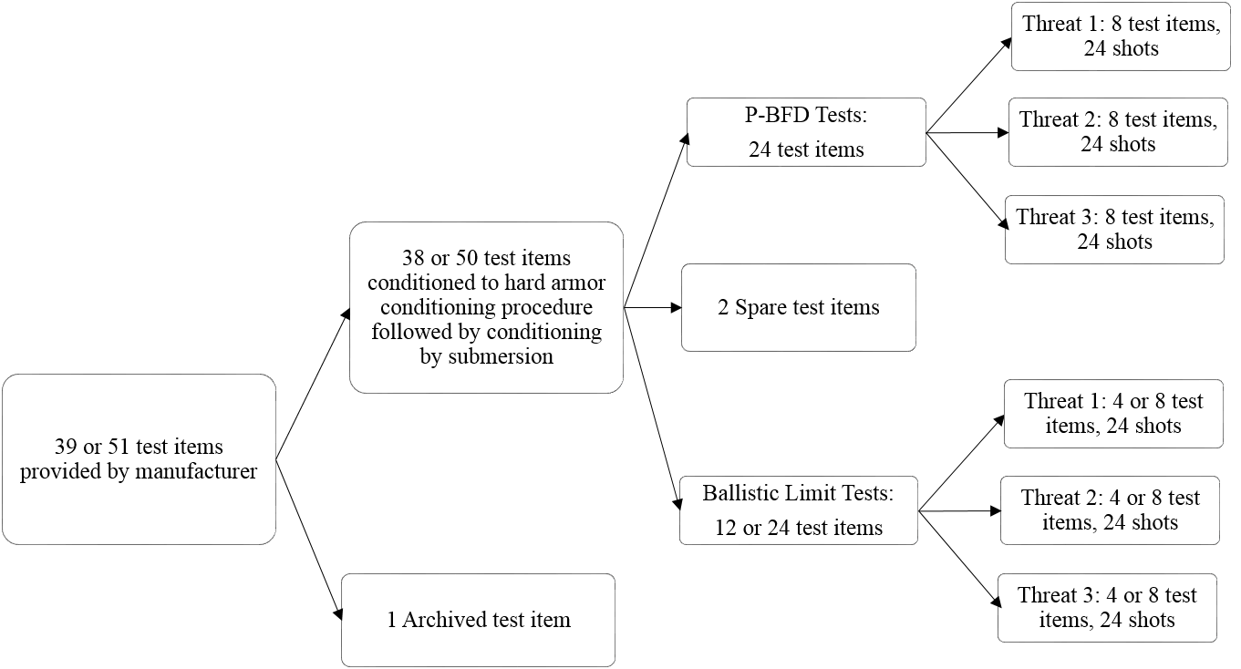

**Figure 3. NIJ RF2: Distribution and utilization hard armor (including ICW) test items**

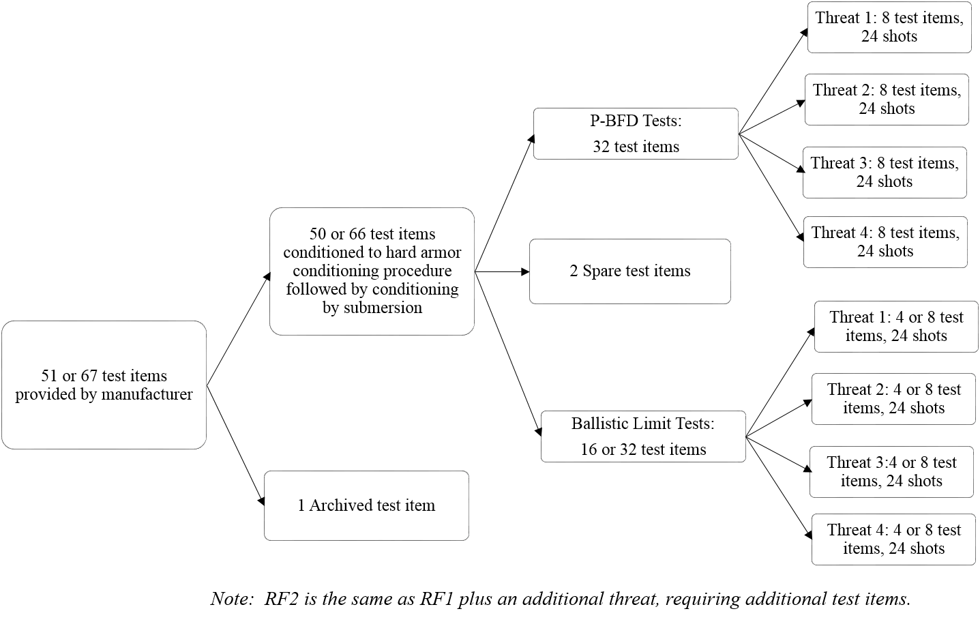

**Figure 4. NIJ RF3: Distribution and utilization of hard armor (including ICW) test items**

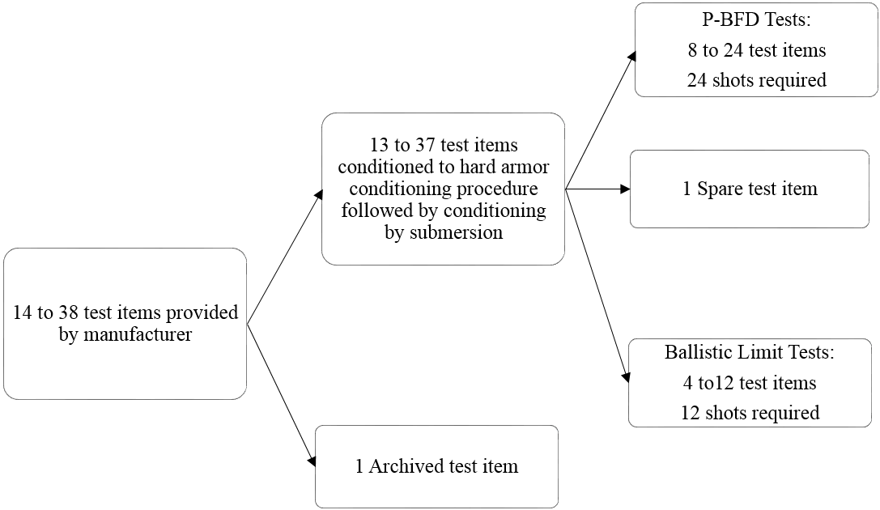

1. **Hard Armor: Procedure for Visual Examination of Labeling, Workmanship, and Construction**
   1. Verify the group of test items for correct quantity and sizes.
   2. Examine the group of test items for variations in appearance, materials, and manner of construction.
   3. Weigh each test item.
   4. Examine each test item exterior to determine whether workmanship requirements are met.
   5. Examine the test item label text to determine whether the content requirements are met.
   6. Examine the label of a single spare test item and perform a manual peel test to determine whether requirements are met.
   7. Prior to conditioning by the hard armor conditioning procedure, photograph at least one test item.
   8. Perform the label permanence and durability test as specified in Annex G.
   9. Following conditioning, examine the test items for visible damage due to conditioning and photograph any test items showing such damage.
   10. Following ballistic testing, examine the workmanship of each test item as described below to determine whether the requirements are met:
       1. Cut open one side of the test item and peel back material enough to allow viewing of subcomponents. Document the construction of the ballistic panel (e.g., material description, thickness of layered subcomponents, presence of coatings) to assess whether all test items are visually similar.
   11. Document the relevant details for each test item.
2. **Hard Armor: Ballistic Test Requirements and Procedures**
   1. Hard armor shots required
      1. For P-BFD testing to RF1 or RF2, 24 fair hits per test threat are required, and three shots are required per test item.
      2. For P-BFD testing to RF3, 24 fair hits per test threat are required, and one to three shots are required per test item.
      3. For Ballistic Limit testing to RF1 or RF2, 24 fair hits per test threat are required, and three shots are required per test item.
      4. For Ballistic Limit testing to RF3, 12 fair hits per test threat are required, and one to three shots are required per test item.
   2. Hard armor P-BFD test requirements
      1. The fair hit requirements shall be as specified in ASTM E3107-17a, with the following exceptions:
         1. Minimum shot-to-edge distances may be decreased at the request of the supplier.
         2. All edge shots shall meet the shot-to-edge distance requirements but shall be located not more than the shot-to-edge distance plus 0.75 in (19 mm) from the edge of the test item. The shot placement shall be on the test item strike face as shown in Figure 5. For each test item, shots 2 and 3 shall be moved to different locations within the band.
         3. When the measured velocity is not within ± 30 ft/s (± 9.1 m/s) of the reference velocity, but all other requirements are met, the shot shall be considered a fair hit if either:
3. the velocity is less than the minimum allowed and the shot results in a complete penetration, a BFD measurement > 44.0 mm, or both

or

1. the velocity is greater than the maximum allowed and results in a partial penetration and BFD measurement ≤ 44.0 mm.

Figure 5. Shot Placement

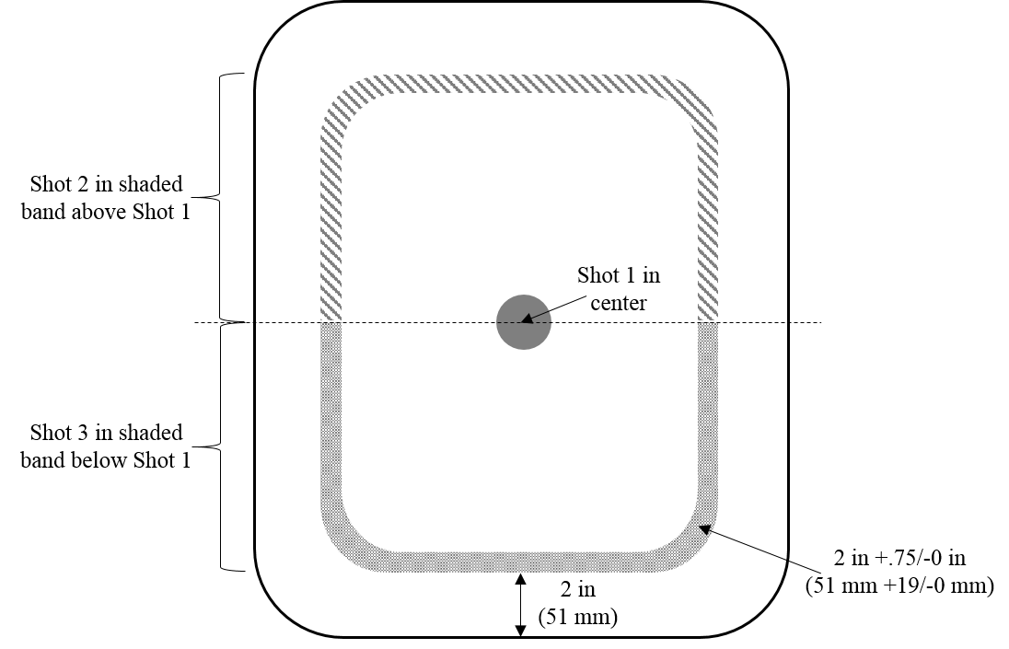

* + 1. When a shot is determined to be an unfair hit, any preceding shots on that test item shall be included in the data set, and the test series shall be continued on a spare test item. This occurrence shall be documented.
    2. The duration of the ballistic testing of each test item shall be no more than 30 minutes from the time the first shot is fired until the last shot is fired. If the time limit is exceeded, any preceding shots on that test item shall be included in the data set, and the test series shall be repeated on a spare test item. This occurrence shall be documented.
  1. All shots shall be taken at 0° angle of incidence.
  2. Hard armor BFD measurements
     1. For NIJ RF1, NIJ RF2, and NIJ RF3, BFD measurements shall be taken for shots 1 and 2 on each test item and shall be performed as specified in ASTM E3068.
  3. Hard armor P-BFD test procedure
     1. Mark shot locations on the test items per ASTM Standard E3107-17a, Section 11.
     2. Condition the test items as specified in Section 10.3.4 of this standard.
     3. Prepare and verify the clay block as specified in ASTM standard E3004.
     4. Mount the test item on the clay block as specified in ASTM Standard E3107-17a, Section 12.
     5. Shoot the test item per ASTM Standard E3107-17a, Section 13.
     6. Measure the BFD for all shots. Measurements shall be made as specified in ASTM E3068.
     7. Record the result (i.e., complete penetration or partial penetration) and other required data.
     8. Repeat steps 12.5.4 through 12.5.7 until all shots have been taken on the test item.
     9. Repeat steps 12.5.4 through 12.5.8 until the test series is complete.
     10. Perform the clay block verification per ASTM Standard E3004, Section 6.6.
  4. Hard armor ballistic limit test requirements
     1. The ballistic limit test requirements from Section 9.5 of this standard apply.
     2. Ballistic limit minimum penetration results for NIJ RF1 and NIJ RF2 shall be six complete penetrations, 12 partial penetrations, and six additional outcomes (either partial penetration or complete penetration).
        1. When the ballistic limit is sufficiently high that achieving the velocity necessary to perforate the test item is difficult or impossible, the test laboratory shall document that this situation has occurred. In such cases, the test series will be considered acceptable when a minimum of 12 shots has been taken even if the minimum number of complete penetrations is not achieved, unless specified elsewhere.
     3. Ballistic limit minimum penetration results for NIJ RF3 shall be three complete penetrations, six partial penetrations, and three additional outcomes (either partial penetration or complete penetration).
        1. When the ballistic limit is sufficiently high that achieving the velocity necessary to perforate the test item is difficult or impossible, the test laboratory shall document that this situation has occurred. In such cases, the test series will be considered acceptable when a minimum of 12 shots has been taken even if the minimum number of complete penetrations is not achieved, unless specified elsewhere.
  5. Hard armor ballistic limit test procedure
     1. Mark shot locations on the test items following the shot spacing requirements.
     2. Condition the test items as specified in Section 10.3.4 of this standard.
     3. Prepare and verify the clay block as specified in ASTM standard E3004 and remove the plywood backing.
     4. Mount the test item on the clay block as specified in Annex I.
     5. Perform the steps of Annex I Ballistic Limit Procedure, replacing the clay block as needed.
     6. Record each shot outcome (i.e., complete penetration or partial penetration), the corresponding measured velocity for each shot, and other required data.

1. **Test Report**
   1. The test laboratory shall develop a test report that meets the requirements of ISO/IEC 17025 and the referenced ASTM standards.
   2. All data and required calculated values shall be included in the test report.

# **Annex A (Mandatory): Procedure for Soft Armor Conditioning by Tumbling**

### Scope

### This procedure applies only to the conditioning of soft body armor test items via temperature, humidity, and tumbling exposure prior to ballistic resistance testing.

### The purpose is to subject test items to conditions intended to provide some indication of the test item ability to withstand conditions of heat, moisture, and mechanical wear (folding and abrasion) that might be encountered during wear.

1. **Test item preparation**
   1. Test items shallbe conditioned at controlled ambient as defined in ASTM E3078 for at least 24 hours prior to this procedure. This may be achieved in a controlled laboratory environment, or if conditions in the laboratory deviate from those specified, a chamber may be used to create these conditions.
   2. The test items shall be stored flat prior to and following this procedure. Note: Stacking of test items is permitted.

### Laboratory Configuration and Test Equipment

### Environmental chamber

### The environmental chamber shall be capable of achieving and maintaining the required temperature and humidity within the specified tolerances for the duration of the test.

### The environmental conditioning temperature shall be 65 ºC ± 2 °C (149 ºF± 3.6 °F).

### The environmental conditioning relative humidity shall be 80% ± 5%.

### Tumbling Apparatus

* + 1. A rotating drum shall be used to generate the tumbling action and shall have a rotation rate of 5.0 rpm ± 1.0 rpm. The drum rotation rate may be varied within the given tolerance to achieve the necessary number of rotations and the rotation rate shall not exceed the specified tolerance.
    2. The drum shall be constructed from stainless steel.
    3. The tumbling apparatus shall maintain tolerances of temperature, humidity, and revolutions per minute specified in this section.
    4. The rotating drum shall meet the following dimensional requirements:
       1. Internal diameter: 32 3/4 in ± 1/4 in(832 mm ± 6 mm)
       2. Internal depth: 25 5/8 in ± 1/4 in (651 mm ± 6 mm)
       3. The drum shall have four fins (i.e., ribs) running the full depth of the drum spaced at 90º intervals about the circumference. Each fin shall be 4 1/2 in ± 1/8 in (114 mm ± 3 mm) high. The top edge of each fin shall be rounded with a minimum diameter of 3/4 in ± 1/8 in (19 mm ± 3 mm). The base of each fin shall not be thinner than 3/4 in (19 mm) and shall not be wider than 3.0 in (76 mm).
       4. The rotating drum shall have smooth inner surfaces with no sharp edges, no rough spots, and no burrs.

### The rotating drum shall have sufficient openings to allow air flow such that the air inside the drum remains within the specified tolerances for temperature and humidity. In order to achieve this, the drum wall shall be perforated.

### Environmental chamber and tumbling apparatus monitoring

* + 1. The monitoring equipment shall include measurement and recording device(s), independent from the chamber and tumbling apparatus controllers.

### The monitoring equipment shall provide and allow documentation of temperature and relative humidity measurements inside the environmental chamber.

### The laboratory shall monitor and document:

* Time and date at beginning and for each time the rotation count is recorded
* Temperature
* Relative humidity
* Revolution rate
* Rotation count

### The humidity chamber shall be designed in a manner that minimizes condensation coming into contact with the test items to the extent possible.

### Conditioning Procedure

### Duration

### The conditioning duration shall be 240 hours ± 1 hour.

* + 1. The drum shall be rotated through 72,000 ± 1,500 complete rotations during the test.
    2. Figure 1 shows acceptable conditioning procedure end points given the combination of time and drum rotation. The procedure is complete and may be stopped when time and drum rotation fall within the box shown in Figure 1.

### The conditioning procedure is detailed below:

* + 1. Verify the apparatus maintains conditions within the tolerances specified at periodic intervals throughout the conditioning activity.
    2. Unless otherwise specified, continuously measure and document the analog temperature and relative humidity during the procedure. Conduct digital measurements at intervals of 10 minutes or less.

### Figure 1: Criteria for the end of the conditioning activity.

240 hours and 72,000 rotations

* + 1. Use only instrumentation with the selected environmental conditioning chamber that meets the accuracies, tolerances, etc., described herein.
  1. Load the test items into the tumbler, one at a time, such that test items are positioned arbitrarily to each other (e.g., not in an orderly stack).
  2. Initiate the conditioning process.
  3. At least once per working shy , observe the test items in the chamber using a viewing port or remote camera system to determine if the test items are tumbling freely.
     1. If any test item experiences an unfair tumbling condition, such as being trapped between the rotating and static portions of the tumbler, then that test item shall be removed from the tumbler and inspected. Any damage to that test item shall be documented, and the test item shall be marked to indicate that it is not to be subjected to ballistic testing. That test item shall then be flattened and returned to the tumbler to keep the load in the tumbler constant.
  4. Monitor the tumble count and calculate the rate to ensure that the tumbling requirements are continuously met.
  5. At the end of the conditioning process, power down the apparatus, and remove the test items from the tumbler within 30 minutes of cessation of tumbling.

**Note:** Ideally, removal from the tumbler should be completed within minutes for the purpose of ensuring that the test items are removed before they cool to room temperature.

* 1. Following conditioning by tumbling, examine the test items for visible excessive wrinkling or damage due to conditioning. Photograph and otherwise document any test items showing such damage.
  2. Stack the test items on a flat surface in controlled ambient conditions.
  3. Place the most wrinkled test items on the bottom, straightening and smoothing them as much as possible. Then stack remaining test items on top of the most wrinkled test items to help press out the wrinkles. Test items shall remain stacked for at least 12 hours.
     1. If these procedures are not sufficient to return the test items to a condition that is acceptable for ballistic testing, additional smoothing procedures, described in Section 6, may be necessary.
  4. When it is necessary to ship the test item to a ballistic testing laboratory, package the test items securely to prevent them from becoming folded, wrinkled, or moved about in the container during shipment. The stacked orientation should be preserved with the flattest test items on top and more wrinkled test items on bottom to improve the chances that the test items will be flat when they reach the ballistic testing facility.
  5. Test items shall be stored at the ballistic testing facility under controlled ambient conditions for at least 12 hours prior to any ballistic testing.
  6. The documentation required in section 7 shall be provided to the ballistic testing laboratory.

1. **Environmental Chamber Door Opening Guidelines**
   1. Prior to opening the chamber or entering a walk-in chamber, reduce the humidity in the chamber prior to reducing the temperature to avoid generation of condensation in the tumbler.
   2. Stop the drum rotation.
   3. The amount of time that the conditioning procedure is paused shall be made up at the end of the protocol.
2. **Opening a Test Item for Additional Smoothing**
   1. If necessary, and after all other attempts to flatten one or more test items have been exhausted, then the affected test items may be warmed in an environmental chamber, with conditions of 1 hour ± 10 minutes at 45 °C and 50% relative humidity, with the same tolerances of temperature and relative humidity as specified in Section 3.1. Only the affected test items should be placed in the chamber for rewarming.
   2. The preceding stacking procedure shall be repeated in an effort to flatten the test items. If this is necessary, then describe what was done in detail in the test report. This rewarming may only be performed one time on each batch of test items.
   3. If necessary, and after all other attempts to flatten a test item have been exhausted, the test item may be removed from its carrier and the test item panel cover may be slit to assist in flattening the test item.
      1. Horizontally slit only the test item panel cover (not the ballistic panel) with a razor blade near the bottom of the test item.
      2. Fold the test item panel cover back to access the part of the test item that requires flattening.
      3. Immediately mark the strike face of the ballistic material to ensure that it will be reinserted with the correct orientation.
      4. To reduce the possibility of an incorrect reinsertion of the ballistic material inside of the test item cover, if possible, keep the test item partially inside of the test item panel cover to help maintain its original orientation.
      5. Flatten the ballistic material, including unfolding any corners or edges that may have become folded or dog-eared.
      6. Re-insert the ballistic material through the opening in the panel cover, reversing the steps that were necessary for removal.
3. **Documentation of the conditioning activity**
   1. Temperature record
   2. Humidity record
   3. Tumble count and rate as a function of time
   4. Statement that the test items have been prepared according to this procedure and are suitable for ballistic testing
   5. Notes and observations

# **Annex B (Mandatory): Equipment and Procedure for Conditioning by Submersion**

Equipment

The armor submersion equipment shall consist of a water bath sufficiently sized to allow at least one test item of the largest template size to hang vertically, without any folds or bends, with the top edge of the test item at least 4in (~102 mm) below the surface of the water, and with at least 2in (~51) mm clearance around the test item.

The water in the bath shall be clean and shall be either potable tap or demineralized water. The water shall be replaced anytime there are visible impurities in the water. The water temperature shall be 70 °F + 5 °F/-10 °F.

Procedure

Each test item shall be hung vertically in the water bath for 30 min (+ 5 min/- 0 min) with the top edge of the test item positioned 4.0 in ± 1.0 in (100 mm ± 25 mm) () below the water surface. For test items that are buoyant, weights shall be attached to the bottom edge with clothes pins or similar clips to allow the test item to hang vertically. After removing the test item from the water, it shall be hung vertically to drip dry for 10 min (+ 5 min/- 0 min) before mounting on the clay block for ballistic testing.

# **Annex** **C (Mandatory): Hard Armor Conditioning Procedure**

ASTM E3078 is applicable for the conditioning of hard armor test items. Test items shall be subjected sequentially to the two procedures from ASTM E3078 listed below:

1. Section 13, Impact Durability Pre-conditioning
2. Section 14, Impact Durability Conditioning Procedure for Torso Front and Back Plates

These procedures detail the equipment and laboratory configuration requirements.

No other procedures from ASTM E3078 shall be applied to the test items.

# **Annex D. (Mandatory) BFD Measurements**

When any BFD measurement exceeds 44 mm (1.73 in), then there shall be a 95% confidence that 80% of all BFD depths will be 44 mm (1.73 in) or less. This requirement can be verified using a statistical tolerance limit. It is expected that a stated portion of the entire population of all BFD measurements will lie at or below the statistical upper tolerance limit. To achieve this, the population of BFD measurements is assumed to be normally distributed, and the upper tolerance limit, BFDU, must be ≤ 44 mm (1.73 in). The upper tolerance limit is defined below:

Equation 1: ${BFD}_{U}={BFD}_{ave}+k_{1}s$

BFDave is calculated as shown below:

Equation 2: ${BFD}_{ave}=\frac{1}{N}\sum_{i=1}^{N}{{BFD}_{i}}$

*N* is the number of BFD measurements, and BFDi are the individual BFD measurements. The sample standard deviation, *s*, is calculated as shown below:

Equation 3: $s=\sqrt{\frac{1}{N-1}\sum_{i=1}^{N}{{({BFD}_{i}-{BFD}_{ave})}^{2}}}$

The approximate k factor, *k1*, for a one-sided tolerance interval can now be calculated as shown below:

Equation 4: $k_{1}=\frac{z_{1-p}+\sqrt{{z^{2}}_{1-p}-ab}}{a}$

Here, *z*1-p is the normal distribution critical value that is exceeded with a probability of 1-p. The factors *a* and *b* are defined below:

Equation 5: $a=1-\frac{{z^{2}}_{1-γ}}{2(N-1)}$

Equation 6: $b={z^{2}}_{1-p}-\frac{{z^{2}}_{1-γ}}{N}$

Here, *z*1-γ is the normal distribution critical value that is exceeded with a probability of 1-γ.

For the analysis of BFD measurements according to the requirements of this standard, the probability that no BFD measurement exceeds 44 mm (1.73 in) must be at least 80%, so p = 0.80, and the required confidence is 95%, so γ=0.95. The critical values for the normal distribution can be calculated or obtained from tables in statistical textbooks. For this case, they are:

*z*1-γ = *z*0.05 = 1.645; *z*1-p = *z*0.20 = 0.842

Table 1 below provides some k1 values based on the number of BFD measurements.

Table 1. k1 Values Based on Number of BFD Measurements

|  |  |
| --- | --- |
| **Number of BFD Measurements** | **k1** |
| 12 | 1.568 |
| 13 | 1.528 |
| 14 | 1.494 |
| 15 | 1.464 |
| 16 | 1.438 |
| 17 | 1.415 |
| 18 | 1.394 |
| 19 | 1.375 |
| 20 | 1.358 |
| 21 | 1.342 |
| 22 | 1.328 |
| 23 | 1.315 |
| 24 | 1.303 |

# **Annex E (Mandatory): Analysis of Ballistic Limit Data**

Once the ballistic limit testing has been completed, the test results shall be analyzed for each test threat by performing a regression to estimate the armor’s performance over a range of velocities. In particular, the analysis shall attempt to estimate the velocity where the probability of complete penetration becomes reasonably small. In general, a logistic regression can be used for this purpose; however, other probability distributions and regression methods may be used when one can be shown to better estimate the performance of a particular armor model.

The logistic regression may be performed on the data using the method of maximum

likelihood to estimate the logistic parameters ${\hat{β}}_{0}$ and ${\hat{}}_{1}$, which are the estimated *logistic*

*constant* and the estimated *velocity coefficient*, respectively. These parameters define the shape of the S-shaped logistic curve, which is defined as:

Equation 1: $\left(v\right)=\frac{e^{{}_{0} +v{}_{1}}}{1+e^{{}_{0} +v{}_{1}}}$

Here, *π*(*v*) is the is the probability of a complete penetration occurring at velocity, *v*. From the estimated logistic parameters, the ballistic limit can be determined as:

Equation 2: ${\hat{V}}_{50}= \frac{-{\hat{β}}_{0}}{{\hat{}}_{1}}$

In addition, the velocity at which the probability of a complete penetration is *x*%, ${\hat{V}}_{x}$, can be determined as:

Equation 3: ${\hat{V}}_{x}= \frac{\ln\left(\frac{x}{1-x}\right)-{\hat{β}}_{0}}{{\hat{}}_{1}}$

The estimated logistic parameters for a conditioned armor and its ballistic limit can be determined in the same method; however, care should be exercised when the analysis is performed on a relatively small data set, as the reliability of the estimated complete penetration probability will be poor for small data sets.

# **Annex** **F (Mandatory): Test Item Size Templates**

This standard specifies five template sizes for testing soft armor test items:

1. NIJ-C-1 (smallest)
2. NIJ-C-2 (small)
3. NIJ-C-3 (medium)
4. NIJ-C-4 (large)
5. NIJ-C-5 (largest)

The dimensions of the templates are shown in the figures on the following pages.

detailed template showing sizing for body armor and dimensions

Diagram showing sizing template for small armor sample

Sizing template for medium armor samples

sizing template for large armor samples

Sizing template for largest armor samples

# **Annex G. (Mandatory) Test Item Label Inspection and Durability Test**

**Test Item Label Content Requirements**

The label shall be permanently attached to the face of the panel. The label shall contain the following information (an example is provided in Figure 1):

Figure 1. Example Test Item Label

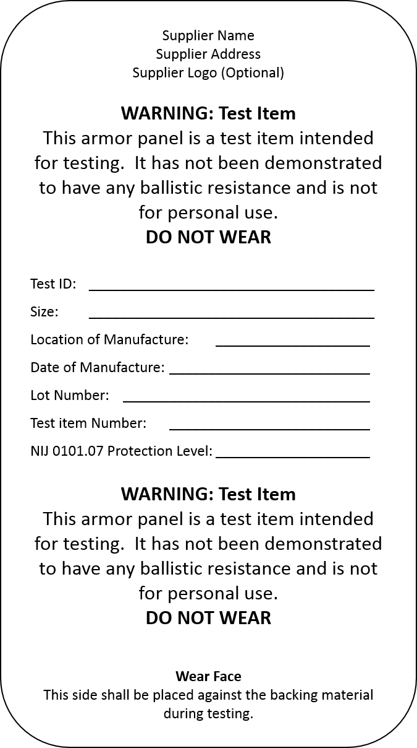

* Name, registered trademark, or other identification of the supplier.
* The rated level of protection and reference to this edition of the standard (e.g., NIJ HG1 in accordance with NIJ Standard-0101.07).
* A test ID number or model designation that uniquely identifies the armor design for testing purposes.
* The test item template size.
* A number or serial number that uniquely identifies each test item.
* Location of manufacture.
* The date of manufacture.
* Identification of the proper orientation of the ballistic panel (i.e., strike face or wear face).
* A warning in larger type than the rest of the type on the label that clearly emphasizes the warning, stating that the ballistic panel is a test item that has not yet been demonstrated to provide ballistic resistance and that the armor panel is not intended to be worn. Printing color changes are acceptable but cannot be substituted for the type size requirement herein.

**Armor Carriers with Non-removable Ballistic Panels**

Ballistic panels that are non-removable from the armor carrier shall, in addition to the label required for the ballistic panel, have a label on the armor carrier that is in conformance with the test item label requirements, unless the ballistic panel is so constructed that its label is not covered by the armor carrier.

**Test Item Label Permanency and Durability**

All test item labels shall be sufficiently permanent and durable so that they will remain securely attached to the ballistic panel or armor carrier. The durability of the test item label markings shall be checked with the following procedure:

1. Rub by hand a representative area of the label text for approximately 15 seconds with a 100% knit cotton cloth soaked with distilled water. Within the 15 seconds, make 30 passes with only enough pressure to ensure contact between the cloth and the surface of the label.
2. Rub the same area by hand for an additional 15 seconds with a 100% knit cotton cloth soaked with denatured alcohol (methylated spirit). Within the 15 seconds, make 30 passes with only enough pressure to ensure contact between the cloth and the surface of the label.
3. Finally, rub the same area by hand for an additional 15 seconds with a 100% knit cotton cloth soaked with isopropyl alcohol. Within the 15 seconds, make 30 passes with only enough pressure to ensure contact between the cloth and the surface of the label.

# **Annex H. (Mandatory) Soft Armor Designed for Female Wearers**

1. **Location of Shaping Features**

The technician shall determine the locations of stitches, seams, folds, and other shaping features that can be felt through the test item panel cover. If overlaps of material exist in the test item, the technician shall note the direction of overlap of the subcomponents of the test item. These features shall be marked on the carrier.

1. **Shot location and angle marking**

The technician shall follow the guidelines below for clearly marking the six intended shot locations and angles directly on the carrier for each test item:

1. Shot location markings for angled shots shall indicate the angle of incidence for that shot as well as the direction from which the shot will impact the test item.
2. The shot patterns listed in Tables 1 and 2 of Annex H, Section 6 are for guidance purposes only and are subject to modification by the technician after observing test results.
3. Typically, the shot location pattern for the first test item will follow the guidance provided below. The shot locations for subsequent test items should be modified as necessary based on observed results.
4. No shot location shall be marked directly on a portion of material that is made up of more layers due to overlapping regions of material.
5. It may be necessary to replicate a shot pattern from an individual test item. If any of the conditions below are observed during testing, the shot pattern on that test item shall be replicated on the subsequent test items:
   1. When a complete separation in a section of the overlap region greater than the diameter of the bullet is observed, then that shot’s location, angle of incidence, and direction shall be replicated on subsequent test items.
   2. A particular shot location exhibited a BFD greater than 42 mm. (If the BFD on multiple shots exceeds 42 mm, the deepest indentation shall be replicated.)
   3. A BFD that is 10 mm higher than the average of the other two BFDs is measured for a given test item.
6. **P-BFD Testing**

Shots shall be taken according to ASTM Standard E3107-17a with the following modifications:

#### Edge shot pattern modifications

1. Marking of edge shots shall be varied from test item to test item unless one or more of the scenarios described in Annex H, Section 2, item 5 above are encountered.
2. The requirement to vary the shot pattern shall not supersede any requirement listed in Annex H, Section 2 above.
3. Because NIJ-C-1 sized test items do not have wing components, the shot location markings are not required to conform to the pattern shown in Figure 2 of ASTM E3107-17a. It may be necessary to invert the triangle formed by shots 1, 2 and 3 because placing shots 2 and 3 alongside a neck scoop allows the full 6-shot sequence to be marked on the test item.

### Rules for Cluster shots

### Shot 4

* 1. First test item of a given size
     1. Shot 4 shall be used to challenge the apex of either the left or right bust cup.
     2. For hybrid designs where multiple stitch patterns are used throughout the layup, the strike face stitch pattern shall be used to determine shot placement.
     3. For test items with bust cups formed by vertical seams, the shot shall be marked 12.7 mm to 25.4 mm (½ in to 1 in) away from the apex by moving it diagonally at approximately a 45° angle upward and toward the centerline of the test item. See Figure H1 for an example of shot markings. The offset distance shall increase if necessary to move the shot off any overlapping material that is a component of the seam. In this case, the shot shall be marked immediately adjacent to the overlap of material. This shot shall be angled toward the outside of the test item (i.e., away from the vertical centerline).

Figure H1. Example Shot Markings

Examples of shot markings on a plate. Shows distances and angles

* + 1. For test items with a horizontal seam design, the shot shall be marked immediately adjacent to the overlap of material. For example, where the overlap forms a step on the strike face of the test item, the shot shall be placed on the low side of that step. This shot shall be angled toward the edge of the test item considered to be the neck and shoulder edge.

See Figure H2 for examples of shot placement in regions of overlap.

Figure H2. Examples of Shot Placement in Regions of Overlap

|  |  |
| --- | --- |
| Diagram showing shot placement tha tis close to overap in armor | Diagram showing shot placement tha tis close to overap in armor |

* 1. Second test item of a given size
     1. Unless overridden by the need to replicate an earlier shot, shot 4 on test item 2 shall:
        1. Challenge the other bust cup apex.
        2. Be in the opposite direction than specified for the previous test item (e.g., if shot 4four on test item 1one was toward the edge of the test item, then shot 4four on test item 2two shall be toward the centerline).
        3. Strike at a different angle of incidence than was used to challenge the previous test item.
     2. The same modifications listed in Annex H, 3) above for horizontal and vertical seams shall be followed.
  2. Third and fourth test items of a given size
     1. Shot 4 shall be used to challenge the intermammary cleft region.
     2. The default position shall be at the center point between the bust cup apex with approximately a 12.7 mm (½ in) offset to the outside edge. The direction of this offset shall change between test items 3 and 4. For test items where this position represents an overlap in material, the shot shall be offset to the nearest point on the test item where no overlap exists.
     3. Shot 4 shall be marked to be taken towards the inside of the test item.
     4. Shot 5
  3. Shot 5 shall be marked approximately 3.5 in (89 mm) below the shot marking for shot 4 following the surface of the test item. It shall be shifted slightly to the left or right to avoid marking both shots along the same vertical line.
  4. For smaller test items, it may be necessary to consider the placement of shots 5 and 6 simultaneously.
  5. The marking of the placement for shot 5 may be altered by rotating the shot placement “triangle” around the origin of shot 4, ensuring that shot 5 does not impact a double thickness of material and that it is marked within the fair hit shot-to-edge distance.
  6. Shot 5 shall be aimed in the same direction as shot 4 (i.e., toward the left, right, top, or bottom of the test item).
     1. Shot 6
  7. For the first test item of a given size in the test series, the sixth shot shall be marked approximately 89 mm (3.5 in), following the surface of the test item, from shot 4 and shot 5 such that shots 4, 5, and 6 will impact within a projected 100 mm (4 in) circle.
  8. The positioning of shot 6 shall be such that it does not strike an area of double thickness due to overlapping sections of material.
  9. With a horizontal arch stitch pattern, it may be necessary to consider the positioning of shots 5 and 6 at the same time to meet all requirements of this document.
  10. Shot 6 shall be at 0° angle of incidence.

### Shooting the test item

### For shots 1, 2 and 3, attempt to use straps to hold the test item near the intended point of impact flat against the clay block. If the test item cannot be flattened onto the clay block due to material stiffness, then construct a suitable applique to fill in the air gap. The BFD measurement device shall be zeroed on the intended point of impact in such cases.

### Shots 4, 5 and 6 shall utilize appropriately sized appliques meeting the requirements of ASTM E3086 – 17. Appliques shall be replaced as necessary to support the test item.

### Post shot inspection of test items

Inspect the test item immediately following each shot for any signs of possible weakening or damage resulting from the impact. In addition, once a test item of a given size has received all six shots, the test item shall be inspected to determine how it performed.

### Summary tables

**Note:** These tables provide summary information only. Please refer to the above sections for specific language related to each bit of information provided in these tables.

Table 1. Strike face with Vertical Stitch Patterns (i.e., darted and princess cut)

|  |  |  |  |  |
| --- | --- | --- | --- | --- |
| **Shot #** | **Test item 1** | **Test item 2** | **Test item 3** | **Test item 4** |
| Shot 1 | Follow edge shot placement rules | Follow edge shot placement rules | Follow edge shot placement rules | Follow edge shot placement rules |
| Shot 2 | Follow edge shot placement rules | Follow edge shot placement rules | Follow edge shot placement rules | Follow edge shot placement rules |
| Shot 3 | Follow edge shot placement rules | Follow edge shot placement rules | Follow edge shot placement rules | Follow edge shot placement rules |
| Shot 4 | Apex 1 - Offset Angle 1 toward the centerline | Apex 2 - Offset Angle 2 away from the centerline | Centered on test item with ½” offset Angle 1 toward the centerline | Centered on test item with ½” offset  Angle 2 toward the centerline |
| Shot 5 | 3.5” below Shot 4 Angle 2 toward the centerline | 3.5” below Shot 4 Angle 1 away from the centerline | 3.5” below Shot 4 Angle 2 toward the centerline | 3.5” below Shot 4 Angle 1 toward the centerline |
| Shot 6 | At 0° angle of incidence | At 0° angle of incidence | At 0° angle of incidence | At 0° angle of incidence |

Table 2. Strike face with Horizontal Stitch Patterns

|  |  |  |  |  |
| --- | --- | --- | --- | --- |
| **Shot #** | **Test item 1** | **Test item 2** | **Test item 3** | **Test item 4** |
| 1 | Conforming to edge shot placement rules | Conforming to edge shot placement rules | Conforming to edge shot placement rules | Conforming to edge shot placement rules |
| 2 | Conforming to edge shot placement rules | Conforming to edge shot placement rules | Conforming to edge shot placement rules | Conforming to edge shot placement rules |
| 3 | Conforming to edge shot placement rules | Conforming to edge shot placement rules | Conforming to edge shot placement rules | Conforming to edge shot placement rules |
| 4 | Apex 1 - Offset Angle 1 toward the top | Apex 2 - Offset Angle 2 toward the bottom | Centered on test item with ½” offset  Angle 1 toward the top | Over center air gap, offset Angle 2 toward the bottom |
| 5 | 3.5” below Shot 4  Angle 2 toward the top | 3.5” below Shot 4 Angle 1 toward the bottom | 3.5” below Shot 4 Angle 2 toward the top | 3.5 inches below Shot 4 Angle 1 toward the bottom |
| 6 | At 0° angle of incidence | At 0° angle of incidence | At 0° angle of incidence | At 0° angle of incidence |

**Annex I. Ballistic Limit Test Method**

This test method was excerpted from ASTM WK52176, Standard Test Method for Collection of Vx Ballistic Limit Data for Ballistic-resistant Torso Body Armor and Shoot Packs (not yet published.)

1. **Terminology**
   1. *applique,* n *–* athree-dimensional item molded from backing material that is shaped and sized for testing or conditioning a nonplanar test item.
      1. *Discussion –* Some appliques are designed for the purpose of filling the entire space behind a nonplanar test item; other appliques are designed to assess features of a nonplanar test item. (ASTM Practice E3086)
   2. *angle of incidence*, n *–* the angle between the test threat line of aim and the line normal to a reference plane based on the front surface of the backing assembly or witness panel. (adapted from ASTM Terminology E3005)
   3. *ballistic limit*, n *–* a measure of an item’s ballistic resistance to complete penetration expressed as a velocity associated with some probability of perforation.
      1. *Discussion* – The item may be a test item, material, shoot pack, body armor, or other ballistic-resistant product.
   4. *test series*, n *–* the set of all shots necessary to obtain the required number of fair hits on a single test item or the set of all shots necessary over multiple test items to generate the required data.
   5. *warmer round*, n *–* a projectile fired from a receiver or firearm, prior to testing, to warm the test barrel.
2. **Test Equipment and Apparatus**
   1. The ballistic test range shall meet the requirements of ASTM Specification E3062.
      1. The method for measuring yaw may be with a yaw card, flash radiography, high speed video, or photography.
   2. When clay blocks are required to be used as backing assemblies behind test items, they shall meet the requirements of ASTM Specification E3004.
3. **Test Requirements**
   1. Each ballistic impact shall meet the requirements listed below to be considered a fair hit.
      1. The test threat shall impact the test item at an angle ≤ 5° from the intended angle.
      2. The test threat shall have yaw verified to be ≤ 3° for rifle threats or ≤5° for fragment and handgun threats. Yaw shall be checked for every test threat shot.
         1. The yaw measurement equipment shall be positioned perpendicular to the projectile line of flight. The yaw measurement equipment shall be securely mounted and anchored to maintain its required position and alignment.
         2. When photographic means are used to assess the projectile yaw angle, the assessment shall be made as close as practical to the strike face of the test item but not more than 305 mm (12 in) from the front of the strike face.
         3. When yaw cards are used to assess the projectile yaw angle, unless specified elsewhere, the cards shall be positioned between 51 mm (2 in) and 305 mm (12 in) from the front of the strike face of the test item.
      3. The test threat shall impact the test item no closer to the edge of the test item than the minimum shot-to-edge distance. The measurement for shot-to-edge distance shall be taken from the center of the projectile impact to the nearest edge of the ballistic material in the test item.

Note – Procedures for determining the edge of the test item should be specified in other standards or specifications.

* + 1. For intended edge shots, the test threat shall impact the test item no further from the edge than the maximum shot-to-edge distance.
    2. The test threat shall impact the test item no closer to a prior impact than the minimum shot-to-shot distance. The measurement for shot-to-shot distance shall be taken from the center of one projectile impact to the center of another.

Note – When assessing whether a particular impact location meets the minimum shot-to-shot distance requirements, the shot-to-shot distances should be measured from that impact location to all prior impact locations.

* 1. When warmer rounds are necessary, a test threat shall be fired through the projectile firing system to determine the exact point of impact. Additional test threats shall be fired as required until the proper alignment and a stable velocity have been achieved.

1. **Mounting and Positioning of Soft Armor Test Items on a Clay Block**
   1. The test item shall be positioned on a clay block such that the entire test item is supported. When the test item exceeds the size of the clay block, backing fixture extensions shall be installed coplanar with the backing material surface to allow the test item to be fully supported.
      1. Appliques needed for testing nonplanar soft armor test items shall be specified in other standards and specifications as necessary.
   2. The test item shall be held in contact with the clay block (and appliques if present) and secured using approximately 51 to 76 mm (2 to 3 in) wide elastic straps, held closed by hook-and-loop fasteners. Two vertical and three horizontal straps shall be positioned such that they do not interfere with the impact points on the test item. Figure I1 shows examples of strapping arrangements.

Figure I1. Examples of Strapping Arrangements

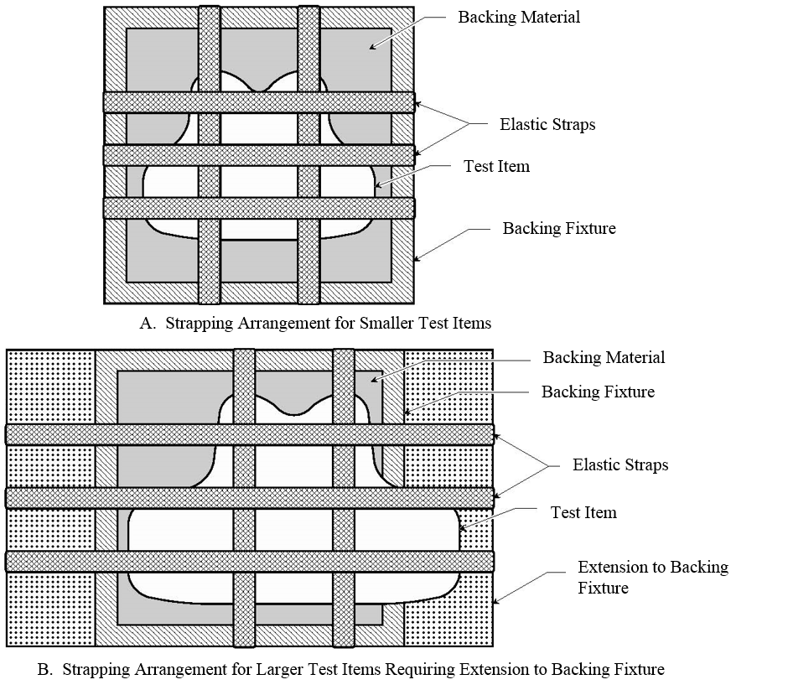

* 1. The clay block shall be positioned to achieve proper bullet impact location and angle (for example, angle of incidence, obliquity) of the test threat. For any shots requiring a nonzero angle of incidence, the clay block shall be rotated to achieve the appropriate angle.
  2. Between test threat impacts, the test item shall be manipulated by hand so that any wrinkles or bunching in the test item (caused by a previous shot) are smoothed out.
     1. No effort shall be made to recover any bullets trapped in the test item until the test series is complete.

**Note:** Slight manipulation of a bullet is allowed if the bullet will interfere with subsequent shots.

* + 1. The test item shall be repositioned on the backing material such that the test item is supported by smooth backing material for a distance of no less than 3 in (76 mm) in all directions around the next shot location.
    2. Instructions related to striking the backing material between shots shall be specified by other standards and specifications.

1. **Mounting and Positioning of Hard Armor Test Items on a Clay Block**
   1. The test item shall be positioned on a clay block such that the entire test item is supported.
   2. Testing of nonplanar hard armor test items on a clay block requires the use of appliques between the test item and the clay block.

**Note:** Testing of planar hard armor test items does not require the use of appliques.

* + 1. The applique shall conform to the wear face of the test item and create a planar surface for the test item to contact the surface of the clay block.

**Note:** Practice E3068 specifies how to create appliques for nonplanar armor intended for females.

* + 1. The applique shall be formed such that it completely fills the space between the test item and the clay block surface. The applique shall be the minimum thickness required to completely fill the space without preventing contact between the test item edges (or corners) and the surface of the clay block (for example, a multi-curve plate should have at least four points of contact between its edges and the surface of the clay block). See Figure I2 for an example of a test item with an applique installed.

Figure I2. Example of test item with applique installed

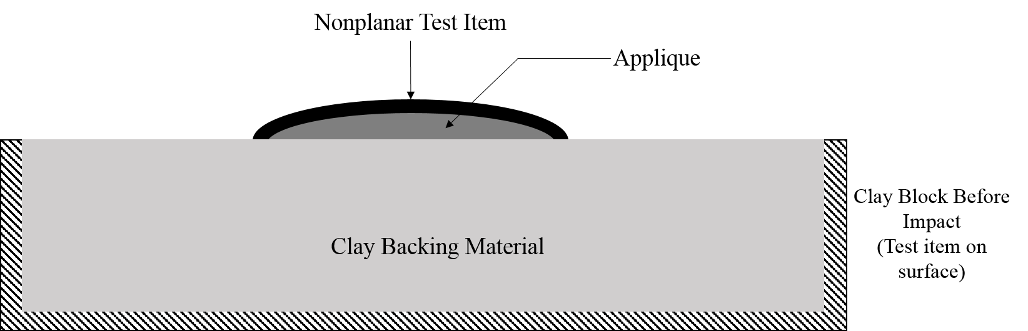

**Note:** A mold is necessary to create an appropriate applique sized for a specific test item, and it is possible that the hard armor could serve as the mold. Other standards and specifications may provide guidance for creating the mold and the applique, and for conditioning the applique prior to use. Some testing requires that the hard armor be tested with soft armor or a shoot pack (i.e., in conjunction with armor). In those cases, the hard armor shall be placed appropriately in contact with the soft armor or a shoot pack (placed on the front or inserted).

* + 1. The applique shall be placed in intimate contact with the clay block prior to testing, and a modicum of force shall be applied to hold the applique in position.
       1. When necessary to further secure the applique to the clay block, hand form conditioned clay into a long, thin strip. Place the strip around portions of the perimeter of the applique at the interface with the clay block, and press the clay strip into the interface to ensure that the applique remains adhered to the clay block during testing.
       2. Care is required to ensure that the shape of the applique is not significantly changed during affixing it to the clay block.
  1. The test item shall be positioned on a clay block (with or without an applique installed, as appropriate) such that the entire test item is supported, as shown in Figure 12.
  2. The test item shall be held in contact with the clay block and secured using approximately 51 to 76 mm (2 to 3 in) wide elastic straps, held closed by hook-and-loop fasteners. Vertical and horizontal straps shall be positioned such that they do not interfere with the impact points on the test item.
  3. The clay block shall be positioned to achieve proper bullet impact location and angle of incidence of the test threat. For any shots requiring a nonzero angle of incidence, the clay block shall be rotated to achieve the appropriate angle.
  4. Between test threat impacts, any soft armor backing shall be manipulated by hand so that any wrinkles or bunching in the test item (caused by a previous shot) are smoothed out. No effort shall be made to recover any bullets trapped in the test item until the test series is complete.

**Note:** Slight manipulation of a bullet is allowed if the bullet will interfere with subsequent shots.

1. **Ballistic Limit Procedure**
   1. Test procedure requirements
      1. A complete test series for the ballistic limit consists of individual ballistic tests being conducted on a number of individual test items. The conditions that constitute the dividing line between a partial penetration and a complete penetration shall be specified in other standards and specifications.
      2. The velocity of the first shot and subsequent velocity increments shall be specified in other standards and specifications.
      3. The angles of incidence for all shots shall be 0°.
      4. For every shot, verify that the shot was a fair hit (per Section 9 of this standard), taking the following steps:
         1. The difference between the velocity readings from each independent instrument shall be compared as specified in ASTM Specification E3062.
         2. The shot spacing shall be assessed to determine if shot-to-edge, shot-to-shot, and shot-to-clay block edge distances meet specified requirements.
         3. If the shot is determined to be unfair, another shot shall be taken on that test item in a location that meets shot spacing requirements. If there is not sufficient room to take an additional shot, then other standards or specifications shall specify the appropriate course of action.
   2. Steps
      1. Mount the test item on a clay block as described in either Section 4 or Section 5 of this annex (as appropriate).
      2. Fire the first test threat at the test item.
      3. When the first shot results in a complete penetration, subsequent shots shall be taken in accordance with the flowchart in Figure 13.
      4. When the first shot results in a partial penetration, subsequent shots shall be taken in accordance with the flowchart in Figure 14.
      5. Repeat the above steps until either the required number of shots or the maximum number of shots that can be placed on the test item has been reached. For a test item of size that does not allow the required number of shots, the firing sequence shall be continued on additional test items until the required number of shots is reached. The number of shots required depends on the protection capability claimed for the test item, and unless specified elsewhere, the requirements in Table 11 shall be followed.
      6. After each sequence of required shots, a new sequence shall be performed until the total required number of shots for the test series has been reached.
      7. When the ballistic limit is sufficiently high that achieving the velocity necessary to perforate the test item is difficult or impossible, the test laboratory shall document this situation has occurred.
         1. In such cases, the test series will be considered acceptable even if the minimum number of complete penetrations is not achieved, unless specified elsewhere.

**Figure I3. Flowchart for complete penetration result on first shot**

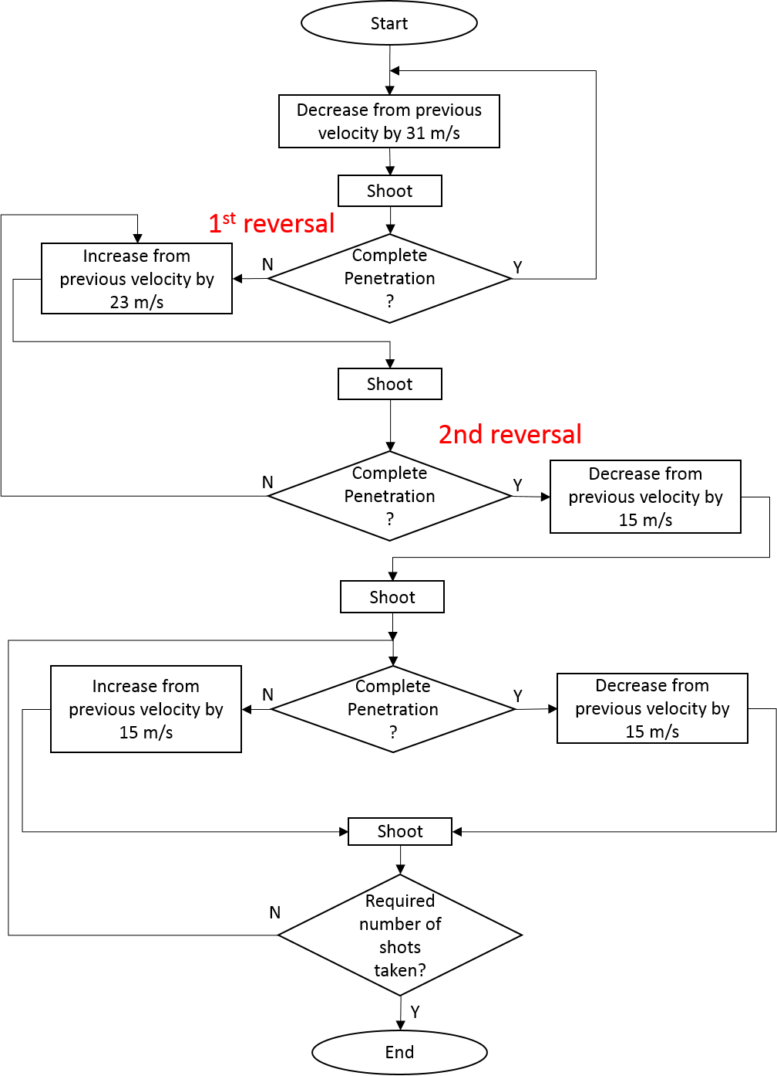

**Figure I4. Flow chart for partial penetration result on first shot**

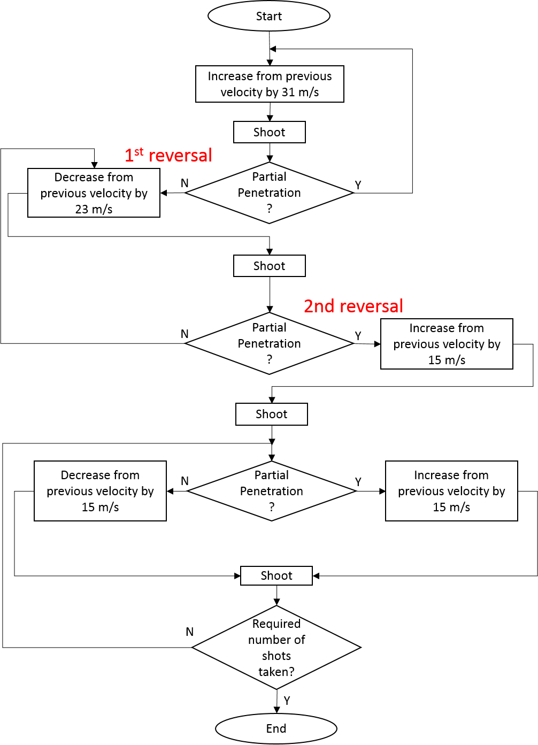

**Table 11. Requirements for Number of Test Items, Shots, and Results**

|  |  |  |
| --- | --- | --- |
| **Protection Capability** | **Required Number of Test Items Per Threat** | **Minimum Number of Shots Required** |
| Handgun | 10 | 120 |
| Rifle | 8 | 24 |
| Armor-Piercing Rifle | 4 – 12 | 12 |

1. **Test Report**
   1. A test report shall be produced and shall meet the requirements of ISO/IEC 17025, and at least the following shall be included:

* Test item information: detailed description of test items, number of test items, details of any conditioning prior to ballistic testing
* Identification and description of test threat
* Description of projectile firing system
* Number of shots per test item and per test series
* Shot pattern
* For each shot:
  + shot number and location
  + angle of incidence, angle of obliquity, or both
  + intended velocity and measured velocity
  + shot result (i.e., partial penetration, complete penetration)
  + fair hit or unfair hits and the cause of any unfair hits
  1. Additional information may be included in the test report.

1. NIJ Standard 0101.06*, Ballistic Resistance of Body Armor*, National Institute of Justice, U.S. Department of Justice, Washington, DC, July 2008, <https://www.ncjrs.gov/pdffiles1/nij/223054.pdf>.
2. “Subcommittee E54.04 on Personal Protective Equipment (PPE),” ASTM International, West Conshohocken, PA, <https://www.astm.org/COMMIT/SUBCOMMIT/E5404.htm>.
3. Reprinted, with permission, from E3005-15 Standard Terminology for Body Armor, copyright ASTM International, 100 Barr Harbor Drive, West Conshohocken, PA  19428. A copy of the complete standard may be obtained from ASTM, [www.astm.org](https://na01.safelinks.protection.outlook.com/?url=http%3A%2F%2Fwww.astm.org&data=02%7C01%7Ccasandra.robinson%40nist.gov%7Ce151a42aa10b4296a31508d538326f1c%7C2ab5d82fd8fa4797a93e054655c61dec%7C1%7C0%7C636476711623138014&sdata=alYx8J3dOBXdmLkkho46vJ%2BdR21l5%2Fa4HyNyRqfNW0Q%3D&reserved=0).